INTERCOVID 2022
A prospective cohort study in pregnancy and the neonatal period

International Fetal and Newborn Growth
Consortium for the 21st Century

DATA COLLECTION MANUAL

Version 1.0
2nd February 2022

Contents
General Guidelines 3
Study Entry Form (COV) 4
COVID-19 Related Questions (CRQ) 7
Maternal Referral/Admission Form (MRA) 10
Pregnancy and Delivery Form (DEV) 21
Intensive Care Form (ICU) 41
Newborn Follow-up Form (NFU) 43
Neonatal Abnormality Form (NAB) 49
Baby Care Form (BCF) 51
Adverse Event (AE) 54

General Guidelines

General Points

Much of the information needed for this form can be collected from the medical records. The
information that is not available in the records should be obtained by direct interview with the
mother or the attending staff.

When completing the forms:

- A ballpoint pen should be used to complete the forms and the writing should be legible.
- Do not write on the forms except in the white data boxes. Where there is the option, place a ‘X’ in boxes that correspond to your answer. Where values need to be written, please write numbers clearly.
- If there is an error made in writing, it must be crossed out, and the correct answer written outside the box and initialled. Correction fluids should not be used.
- The person completing the form should fill in his/her name, signature and the date at
the bottom of each form.
- After completion, the form should be given to the local research coordinator for data
entry at regular periods (to be decided locally).
- It is up to each institution to organize the local arrangements to operationalize this
process.

Study Entry Form (COV)

Form Header
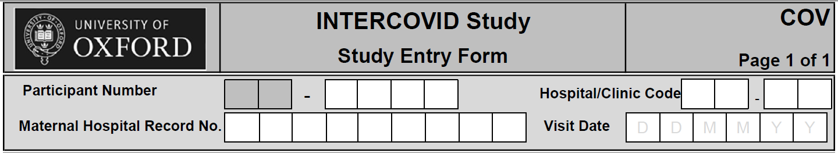
Participant Number: this is the identification number assigned to each woman. The first two digits correspond to your site code, the last four digits are the unique number assigned to the participant.

Hospital/Clinic Code: The first two digits are the site code (same as the first two digits of the participant number). The last two numbers are code that corresponds to your hospital or clinic.

Maternal Hospital Record No.: This number is the hospital/clinic’s own internal reference number for the woman; it can be used to help identify the woman and link the information on this form with her medical records.

Visit date: This is the date that the woman attended the hospital for care.

Section 1: During this pregnancy

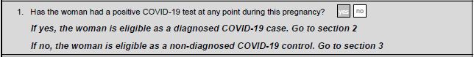

- Has the woman had a positive COVID-19 test at any point during this pregnancy?

Place an X in the box marked ‘YES’ if the woman has had a positive COVID-19 test during this pregnancy. This can be from a PCR, LAMP (loop-mediated isothermal amplification) or rapid antigen test. This woman is eligible as a case. Go to section 2.

Place an X in the box marked ‘NO’ if the woman has not had a positive COVID-19 test during this pregnancy. This woman is eligible as a control. Go to section 3.

Section 2: Diagnosed with COVID-19: eligible case

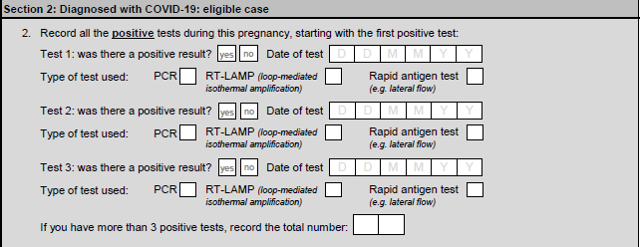

2. Record all the positive tests during this pregnancy starting with the first positive test:

Was the result positive?

Place an X in the appropriate box given the test result. If she is positive for COVID-19, place an X in the box marked ‘YES’. If the test result is negative for COVID-19, this result should not be recorded here, only record positive results.

Date of the test

Record the date of the test for COVID-19 was performed in the format dd-mm-yy, e.g. ‘20th May 2010’ should be written ‘20-05-10’.

Type of test used:

Place an X in the appropriate box given the testing method.

If you have more than three positive tests, record the total number:

If the woman has tested positive for COVID-19 on more than three occasions, please record the total number of positive tests she has had, including the 3 already listed. For example, if she had 5 tests in total, even if three of these have their full details recorded, enter ‘05’.

Section 3: Non-diagnosed with COVID-19: eligible controls

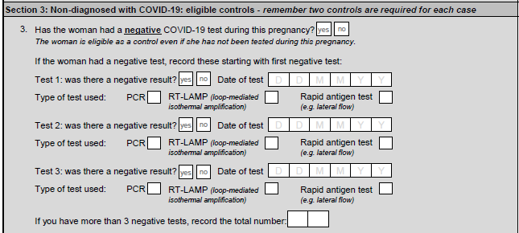

3. Record all the negative tests during this pregnancy starting with the first negative test:- if the woman has never had a COVID test during this pregnancy, then she is still eligible as a ‘control’.

Was the result negative?

Place an X in the appropriate box given the test result. If she is negative for COVID-19, place an X in the box marked ‘YES’. If the test result is positive for COVID-19 the results should be recorded in section 2, this section only records negative results.

Date of the test

Record the date of the test for COVID-19 was performed in the format dd-mm-yy, e.g. ‘20th May 2021’ should be written ‘20-05-21’.

Type of test used:

Place an X in the appropriate box given the testing method.

If you have more than three negative tests, record the total number:

If the woman has tested negative for COVID-19 on more than three occasions, please record the total number of negative tests she has had, including the 3 already listed. For example, if she had 5 tests in total, even if three of these have their full details recorded, enter ‘05’.

COVID-19 Related Questions (CRQ)

Form Header
Participant Number: this is the identification number assigned to each woman.

Hospital/Clinic Code: The first two digits are the site code (same as the first two digits of the participant number). The last two numbers are code that corresponds to your hospital or clinic.

Maternal Hospital Record No.: This number is the hospital/clinic’s own internal reference number for the woman; it can be used to help identify the woman and link the information on this form with her medical records.

Visit date: This is the date that the woman attended the hospital for care.

Section 1: During this pregnancy

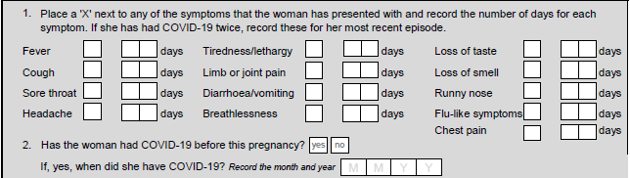

- Does the woman have any of these symptoms? Write the number of days of each symptom:

Place an X in the box if the woman displays any of the symptoms and they have recently started. For example, if the woman suffers with migraines and is currently experiencing a migraine, do not place an X next to headache. Record the number of days she had each symptom.

- Has the woman had COVID-19 before this pregnancy?

If the woman has ever tested positive for COVID-19 at any point before this pregnancy, please place a X in the box marked ‘YES’. If the woman has not tested positive for COVID prior to this pregnancy, place an X in the box marked ‘NO’.

If yes, when did she have COVID-19?

Record the date and month that the woman had COVID-19.

Section 2: Vaccination

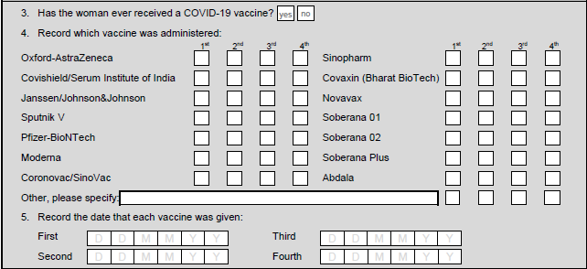

- Has the woman ever received a COVID-19 vaccine?

If the woman has received a COVID-19 vaccine, place a X in the box marked ‘YES’ and continue to question 4.

If the woman has not received a COVID-19 vaccine, place a X in the box marked ‘NO’. Skip to Section 3.

- Record which vaccine was administered.

Using the list of vaccines, record which was administered for each vaccine dose.

If it is unknown which vaccine was administered, in the ‘Other, please specify’ box, record ‘Don’t know’ and record which doses are unknown.

- Record the date each vaccine was given.

Record the date of each vaccination in format dd-mm-yy, e.g. ‘20th May 2021’ should be written ‘20-05-21’.

If the exact date of the vaccination is unknown, please record the month and year in the format XX-05-21.

Section 3: Neonate

- Has virological testing for COVID-19 been carried out on the neonate (e.g. PCR)?

Place an X in the box marked ‘YES’ if the neonate has been tested for COVID-19 using virological antigen testing, for example by PCR.

Place an X in the box marked ‘NO’ if the baby has not been tested for COVID-19 using a virological antigen test.
If yes was the result positive?

Place an X in the appropriate box given the test result. If the neonate is positive for COVID-19, place an X in the box marked ‘YES’. If the test result is negative for COVID-19, place an X in the box marked ‘NO’.

Date of the test

Record the date of the test for COVID-19 was performed in the format dd-mm-yy, e.g. ‘20th May 2021’ should be written ‘20-05-21’.

You can record up to three tests, if there are more than three positive tests, record the earliest three.

- Has antibody testing for COVID-19 been carried out on the neonate (e.g. serology)?

Place an X in the box marked ‘YES’ if the neonate has been tested for COVID-19 using antibody testing, for example by serology.

Place an X in the box marked ‘NO’ if the neonate has not been tested for COVID-19 using an antibody test.

If yes was the result positive?

Place an X in the appropriate box given the test result. If the neonate is positive for COVID-19, place an X in the box marked ‘YES’. If the test result is negative for COVID-19, place an X in the box marked ‘NO’.

Date of the test

Record the date of the test for COVID-19 was performed in the format dd-mm-yy, e.g. ‘20th
May 2021’ should be written ‘20-05-21’.

Maternal Referral/Admission Form (MRA)

General instructions

Complete this form if, at any stage during her pregnancy, a woman is enrolled in the INTERCOVID Study in the antenatal period, either as:

Antenatal case: If she has been admitted or referred to hospital during antenatal care and is not expected to give birth during this admission; OR

Antenatal non-case recruited for corresponding antenatal cases: if the woman attends the hospital as above or for antenatal care.

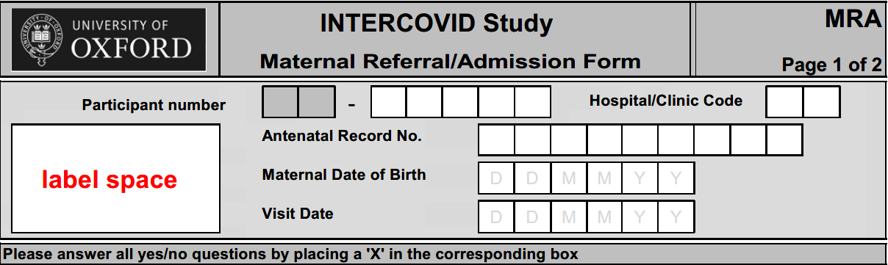
Form Header

Participant Number: This is the identifier given to each woman in the study and should match that on the COVID form.
Hospital/Clinic Code: Enter the code that corresponds to the hospital or clinic where the woman receives her routine antenatal care and was screened for the study.
Antenatal Record No.: This number is the hospital/clinic’s own internal reference number for the woman; it can be used to help identify the woman and link the information on this form with her medical records.
Maternal Date of Birth: Enter the woman’s date of birth in the format dd-mm-yy, e.g. ‘17th April 1990’ should be written ‘17/04/90. Make every effort to obtain her date of birth in full. If, however, she knows only the year or month-and-year of her birth, enter this known information and replace the unknown details with ‘xx’.
Visit Date: Enter the date of this visit in the format dd-mm-yy, e.g. ‘20th April 2020’ should be written ‘20/04/20.
Please answer all yes/no questions by placing a ‘X’ in the corresponding box.

Section 1: Pregnancy status
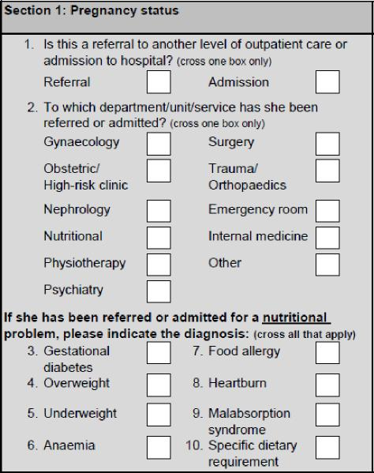
- Is this a referral to another level of outpatient care or admission to hospital? Place a ‘X’ in the corresponding box. Cross one box only.
If the mother is a control and just continuing routine care, select “referral”
If the mother is being sent home to self-isolate/quarantine, select “referral”.
- To which department/unit/service has she been referred or admitted? Place a ‘X’ in the corresponding box. Cross one box only from the following:
- Gynaecology;  - Obstetric/High-risk clinic;  - Nephrology;  - Nutritional;  - Physiotherapy;  - Psychiatry; | - Surgery;  - Trauma/Orthopaedics;  - Emergency room;  - Internal medicine;  - Other.

Select ‘Other’ IF:
- the mother is a control and just continuing routine care
- if the woman is being sent home to self-isolate/quarantine
- the department/unit/service cannot be classed as one of the first 10 options

If she has been referred or admitted for a nutritional problem, please indicate the diagnosis.
Indicate the relevant diagnoses by placing an ‘X’ in the box next to all that apply from the list below:
- Gestational diabetes (defined as any degree of glucose intolerance with onset or first recognition during pregnancy)
- Overweight
- Underweight
- Anaemia
- Food allergy
- Heartburn
- Malabsorption syndrome
- Specific dietary requirement

Section 2: Lab information (if requested during admission/referral)

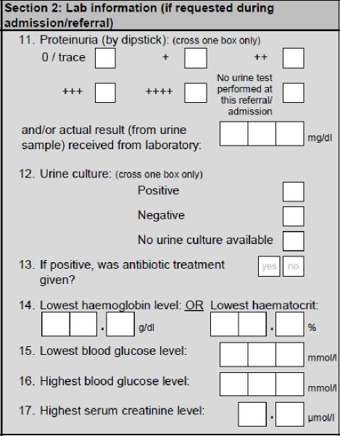
Please complete only the results of lab tests that have been done during this referral or admission. If the tests have not been done during the referral, leave the field blank.
- Proteinuria
Obtain the results of the urinalysis from the lab report for this referral/admission.
If proteinuria is reported from the dipstick, cross the option corresponding to the number of ‘+’ in the box.
If proteinuria is reported in the lab results, enter the actual value in milligrams/ decilitre (mg/dl) in the corresponding box. If the results are not available, leave the field blank.
- Urine culture
Cross one box only.
Place a ‘X’ next to ‘Positive’ if the urine culture showed evidence of a urinary tract infection.
Place a ‘X’ next to ‘Negative’ if the urine culture showed no evidence of a urinary tract infection.
Place a ‘X’ next to ‘No urine culture available’ if the test was not carried out.
If ‘Negative’ or ‘No urine culture available’, leave the response to Question 13 blank, and skip to Question 14.
- If positive, was antibiotic treatment given?
Place a ‘X’ in the box marked ‘YES’ if antibiotic treatment was given after the positive test result.
Place a ‘X’ in the box marked ‘NO’ if the positive urine culture result was not treated.
- Lowest haemoglobin level OR Lowest haematocrit
If her haemoglobin level or haematocrit was measured during referral/admission, obtain the results from the lab. In the corresponding box enter the lowest haemoglobin level recorded during the referral/admission, in grams/decilitre (g/dl), or the lowest haematocrit result as a percentage (%), to 1 decimal place.
If not available, leave the field blank.
- Lowest blood glucose level
If her blood glucose level was measured during referral/admission, obtain the results from the lab. In the corresponding box enter the lowest blood glucose level recorded during the referral/admission, in millimoles/litre (mmol/l), with no decimal places.
If not available, leave the field blank.
- Highest blood glucose level
If her blood glucose level was measured during referral/admission, obtain the results from the lab. In the corresponding box enter the highest blood glucose level recorded during the referral/admission, in millimoles/litre (mmol/l), with no decimal places.
If not available, leave the field blank.
- Highest serum creatinine level
If her serum creatinine level was measured during referral/admission, obtain the results from the lab. In the corresponding box enter the highest serum creatinine level recorded during the referral/admission, in micromoles/litre (μmol/l), to 1 decimal place.
If not available, leave the field blank.

Section 3: Clinical diagnosis for this admission or referral
Important: This section refers only to diagnoses that are not directly related to pregnancy. If the diagnosis is related to pregnancy, see Section 4.
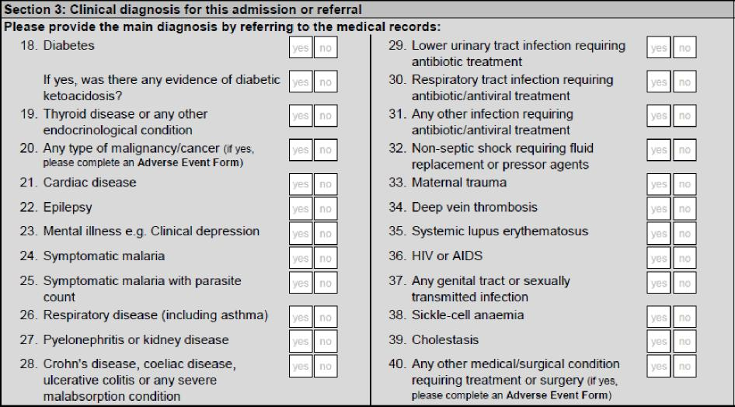
Please provide the main diagnosis by referring to the medical records. For each condition:
Place a ‘X’ in the box marked ‘YES’ if during this referral/admission she has been diagnosed with or treated for that condition.
Place a ‘X’ in the box marked ‘NO’ if during this referral/admission she has not been diagnosed with or treated for that condition.
- Diabetes
(any type, woman previously known to be diabetic before this pregnancy). If the woman developed diabetes during this pregnancy and had no previous history of diabetes, do not cross ‘YES’ here but instead refer to Question 42 (‘Gestational diabetes’) in Section 4.
If yes, was there any evidence of diabetic ketoacidosis?
Place a ‘X’ in the box marked ‘YES’ if there was any evidence of diabetic ketoacidosis.
Place a ‘X’ in the box marked ‘NO’ if there was no evidence of diabetic ketoacidosis.
- Thyroid disease or any other endocrinological condition
(Examples: hypo- or hyper-thyroidism, parathyroidism (PTH), Addison’s disease, adrenal gland disorders, hypophysitis). Malignant thyroid nodules should be classed as a type of malignancy/ cancer (Question 20).
- Any type of malignancy/cancer (including leukaemia or lymphoma). If yes, complete further information in an Adverse Event Form.
- Cardiac disease (Examples: arrhythmias, murmurs, valve diseases, atherosclerosis, atrial fibrillation, sarcoma, pericarditis, cardiomyopathy, etc.)
- Epilepsy (any episode)
- Mental illness e.g. Clinical depression (excluding mild depression without treatment). Include all forms of mental illness requiring treatment. Examples: clinical depression, schizophrenia, bipolar disorder, obsessive-compulsive disorder (OCD), generalised anxiety disorder.
- Symptomatic malaria (any episode)
- Symptomatic malaria with parasite count. If she has shown symptoms of malaria, only select this option if the presence of malaria has been confirmed by means of a parasite count.
- Respiratory disease (including asthma). Other examples: chronic bronchitis, emphysema.
- Pyelonephritis or kidney disease – pyelonephritis is an inflammation of the kidney and upper urinary tract that usually results from non-contagious bacterial infection of the bladder (cystitis) or other urinary infections.
- Crohn’s disease, coeliac disease, ulcerative colitis or any severe malabsorption condition
- Lower urinary tract infection requiring antibiotic treatment (e.g. cystitis)
- Respiratory tract infection requiring antibiotic/antiviral treatment (e.g. bacterial pneumonia)
- Any other infection requiring antibiotic/antiviral treatment
- Non-septic shock requiring fluid replacement or pressor agents
- Maternal trauma (a serious or critical bodily injury, wound or shock)
- Deep vein thrombosis
- Systemic lupus erythematosus (a chronic inflammatory collagen disease affecting connective tissue)
- HIV or AIDS
- Any genital tract or sexually transmitted infection (e.g. syphilis, gonorrhoea, trichomoniasis, genital warts, condyloma acuminate, candidiasis)
- Sickle-cell anaemia
- Cholestasis (a condition where bile cannot flow from the liver to the duodenum)
- Any other medical/surgical condition requiring treatment or surgery. If yes, complete further information in an Adverse Event Form.

Section 4: Pregnancy-related diagnosis for this admission or referral
Important: This section refers only to diagnoses that are related to pregnancy. If the diagnosis is not related to pregnancy, see Section 3.
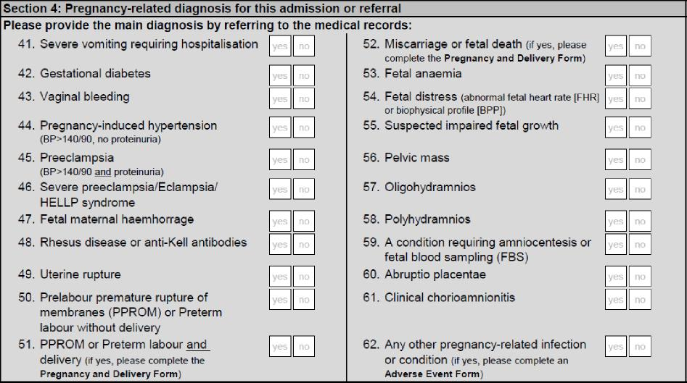
Please provide the main diagnosis by referring to the medical records. For each condition:
Place a ‘X’ in the box marked ‘YES’ if during this referral/admission she has been diagnosed with or treated for that condition.
Place a ‘X’ in the box marked ‘NO’ if during this referral/admission she has not been diagnosed with or treated for that condition.
- Severe vomiting requiring hospitalisation
- Gestational diabetes (defined as any degree of glucose intolerance with onset or first recognition during pregnancy). NB If the woman was previously known to be diabetic before this pregnancy, do not cross ‘YES’ here but instead refer to Question 18 (‘Diabetes, thyroid disease or any other endocrinological condition’) in Section 3.
- Vaginal bleeding
- Pregnancy-induced hypertension (blood pressure >140/90, no proteinuria; develops after 20 weeks’ gestation in a previously normotensive pregnancy)
- Preeclampsia (blood pressure >140/90 and proteinuria)
Preeclampsia is defined as high blood pressure 140/90 mmHg or greater, or an increase of 30mmHg systolic or 15mmHg diastolic over baseline values on at least two occasions 6 or more hours apart, that develops after 20 weeks’ gestation in a previously normotensive pregnancy, and proteinuria (presence of excessive protein substance, chiefly albumin, in the urine).
- Severe preeclampsia/Eclampsia/HELLP syndrome
Severe preeclampsia is diagnosed when blood pressure is ≥160mmHg systolic and/or ≥110mmHg diastolic on two occasions, between 4 and 168 hours apart, or if the first measurement was immediately followed by treatment with an antihypertensive, either of these scenarios being associated with the presence of proteinuria.
Eclampsia is defined as the occurrence of convulsions and/or coma unrelated to her cerebral conditions in a woman with signs and symptoms of pre-eclampsia. Seizures are of grand mal type and may first appear before labour, during labour, or up to 48 hours postpartum.
HELLP syndrome is a group of symptoms that occur in pregnant women who have pre-eclampsia or eclampsia and who also show signs of liver damage and abnormalities in blood clotting. It is characterised by: Haemolysis, EL (elevated) liver enzymes and LP (low platelet) count.
- Fetal maternal haemorrhage
- Rhesus disease or anti-Kell antibodies. Rhesus disease – also known as isoimmunisation or RH – can occur when the mother is Rh negative and the baby is Rh positive. The transfer of anti-Kell antibodies from the mother to the fetus across the placental barrier can cause severe anaemia by interfering with the early proliferation of red blood cells.
- Uterine rupture. Complete uterine rupture is a catastrophic event where a full-thickness tear develops, opening the uterus directly into the abdominal cavity; it requires rapid surgical attention to safeguard maternal and infant outcomes. Occult or incomplete rupture is where a surgical scar separates but the visceral peritoneum stays intact; it is usually asymptomatic and does not require emergency surgery.
- Prelabour premature rupture of membranes (PPROM) or Preterm labour without delivery – PPROM is rupture of the membranes before labour has begun; preterm labour is initiation of labour before 37⁺⁰ weeks.
- PPROM or Preterm labour and delivery – PPROM is rupture of the membranes before labour has begun; preterm labour is initiation of labour before 37⁺⁰ weeks. If yes, complete the Pregnancy and Delivery Form.
- Miscarriage or fetal death. If yes, complete the Pregnancy and Delivery Form.
- Fetal anaemia (suggested by very low haematocrit or haemoglobin concentration for gestational age)
- Fetal distress (abnormal fetal heart rate (FHR) or biophysical profile (BPP))
- Suspected impaired fetal growth
- Pelvic mass (enlargement or swelling in the lower abdomen or pelvic region)
- Oligohydramnios (a decreased amount of amniotic fluid)
- Polyhydramnios (an excessive amount of amniotic fluid)
- A condition requiring amniocentesis or fetal blood sampling (FBS)
- Abruptio placentae (i.e. placental abruption) refers to the partial or complete separation of the normally located placenta after the 20th week of gestation and prior to birth. The normal placenta separates from the uterus prematurely and blood collects between the placenta and the uterus.
- Clinical chorioamnionitis (an inflammation of the fetal membranes – chorion and amnion – due to a bacterial infection)
- Any other pregnancy-related infection or condition. If yes, complete further information in an Adverse Event Form.

Section 5: Medications and treatment
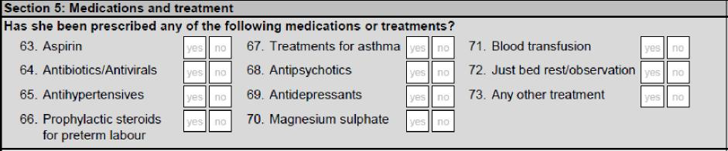
Has she been prescribed any of the following medications or treatments? For each medication or treatment:
Place a ‘X’ in the box marked ‘YES’ if she has been prescribed that medication or treatment during this referral/admission.
Place a ‘X’ in the box marked ‘NO’ if she has not been prescribed that medication or treatment during this referral/admission.
- Aspirin
- Antibiotics/Antivirals (e.g. penicillin)
- Antihypertensives
- Prophylactic steroids for preterm labour
- Treatments for asthma
- Antipsychotics
- Antidepressants
- Magnesium sulphate
- Blood transfusion
- Just bed rest/observation (no treatment required)
- Any other treatment
Section 6: Final outcome

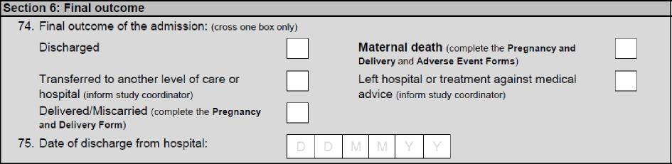
- Final outcome of the admission
Place a ‘X’ in the corresponding box. Cross one box only from the following list:
- Discharged;
- Transferred to another level of care or hospital (inform the study coordinator);
- Delivered/Miscarried. Include in this category fetal death and miscarriage. Complete the Pregnancy and Delivery Form in all cases.
- Maternal death. Complete the Pregnancy and Delivery and Adverse Event Forms.
- Left hospital or treatment against medical advice (inform the study coordinator).
- Date of discharge from hospital
Enter the date that the woman left the hospital/referral clinic in the format dd-mm-yy, e.g. ‘21st May 2020’ should be written ‘21-05-20’.
Section 7: Next appointment
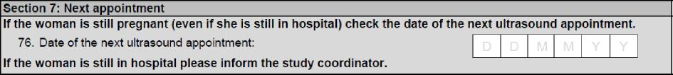
- If the woman is still pregnant (even if she is still in hospital) check the date of the next ultrasound appointment.

Pregnancy and Delivery Form (DEV)

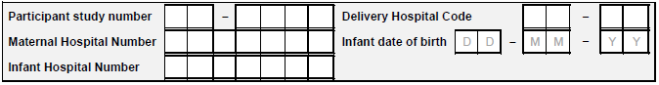

The unique Participant Subject Number should be pre-printed on each form.

Delivery Hospital Code. It should be the site code (first two digits) followed by the numbers 01.

Maternal Hospital Record Number. This number may be provided by the hospital and can be
used if needed to help identify the woman.

Infant date of birth. This should match the date recorded in question 110 of this form.

Infant Hospital Record Number. This number may be provided by the hospital and can be
used if needed to help identify the infant.

Section 1: Demographic, socioeconomic and nutritional characteristics

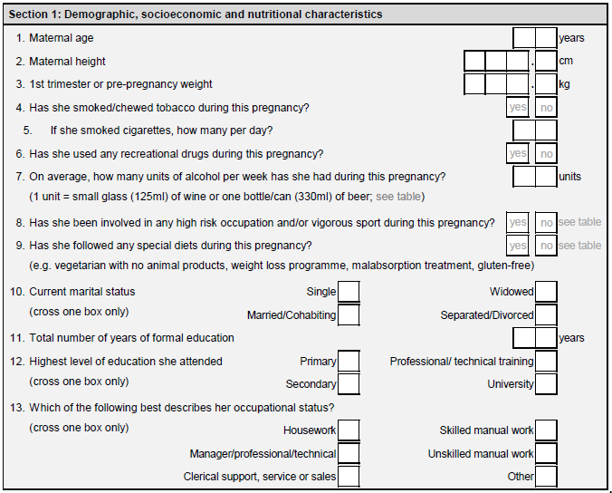
1. Maternal age (years)
Write the age of the woman in completed years; that is, the age at the time of her last birthday. If you are working from medical records, calculate the age from her date of birth.

2. Maternal height (cm)
Take the woman’s height. Please follow the instructions in the Anthropometry Handbook.

Write the woman’s height in centimetres (cm) to 1 decimal place. Example: a height of 152.8cm should be written as 152.8cm and not rounded up to 153cm.

3. 1st trimester or pre-pregnancy weight (kg)
Take the woman’s first trimester weight from her medical record. If unavailable, ask the
women her approximate weight before pregnancy. If she only knows her weight in lbs you
will need to convert it into kilograms.

Write the woman’s weight in kilograms (kg) to 1 decimal place. Example: a weight of
60.4kg should be written as 60.4kg, not rounded down to 60kg or up to 60.5kg.

4. Has she smoked or chewed tobacco during this pregnancy?
Place a ‘X’ in the box marked ‘YES’ if the woman reports smoking cigarettes/cigars/shisha or chewing tobacco during her pregnancy.

Place a ‘X’ in the box marked ‘NO’ if the woman HAS NOT smoked/chewed tobacco
during her pregnancy.

5. If she has smoked cigarettes, approximately how many cigarettes per day?
Write the average number of cigarettes that the woman smokes per day. If her smoking
habits have changed during the pregnancy, write the maximum that she was smoking at
any time point. For example, if she smoked 20/day for the first 5 months and then cut
down to ten, write 20.

If she has chewed tobacco, write how many times per day.

For shisha, one puff = 1/2 cigarette. A whole pipe = 15

6. Has she used any recreational drugs during her pregnancy?
Recreational drugs include heroin, methadone, cocaine, amphetamines, hallucinogens,
cannabis and benzodiazepines.

Place a ‘X’ in the box marked ‘YES’ if the woman has used ANY of the recreational drugs
listed during her pregnancy.

Place a ‘X’ in the box marked ‘NO’ if she HAS NOT.

7. On average, how many units of alcohol per week has she had during this pregnancy?
Write the average number of units of alcohol that the woman has been drinking per week.
One unit of alcohol is equivalent to a small glass (125ml) of wine, a bottle/can (330ml) of
beer or a 25ml measure of whisky, gin, vodka, rum, pisco, tequila, schnapps, ouzo, baijiu
or similar

8. Has she been involved in any high-risk occupation and/or vigorous or contact sports during her pregnancy?
Here is a list of possible high-risk activities:
Place a ‘X’ in the box marked ‘YES’if the woman was involved in any of the high-risk
activities listed below during her pregnancy.

Place a ‘X’ in the box marked ‘NO’ if she DID NOT take part in ANY activity listed below
during her pregnancy.

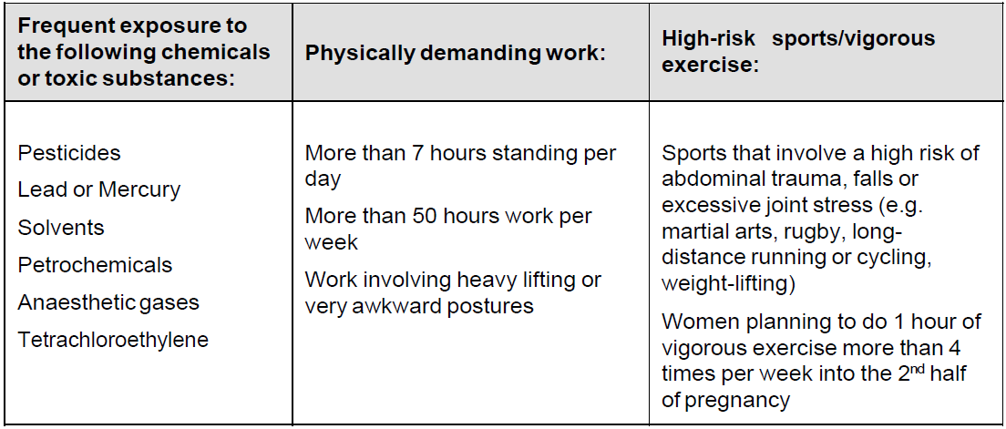

9. Has she followed any special diets during her pregnancy, e.g. vegetarian with no
animal products, weight-loss reduction program, gluten-free diet?
Vegetarian with ‘no animal products’ is defined as a diet that does not include any of the following foods: meat, fish, milk, cheese, yoghurt, eggs, gelatine.

Simple vegetarianism (no meat or fish) does not constitute a special diet.

A gluten-free diet is defined as no wheat, oats, barley or rye products (bread, pasta, breakfast cereals etc.)

Place a ‘X’ in the box marked ‘YES’ if the woman follows an extreme diet.

Place a ‘X’ in the box marked ‘NO’ if the woman does not follow an extreme diet.

10. Marital Status
Cross only the ONE box that best applies to the woman.

Place a ‘X’ next to Single if the woman has NEVER been married and does NOT live
with a partner,
Place a ‘X’ next to Married/cohabiting if the woman is married or living with a partner
Place a ‘X’ next to Widow if the woman’s partner has died.
Place a ‘X’ next to Separated/divorced if the woman HAS been married but is now
separated or divorced and NOT living with another partner.

11. Total number of years of formal education
In the corresponding box, please enter the total number of years that the woman attended formal education (including primary school, secondary school, post school (college and university level) and any other intermediate levels in the formal school system). This definition of school does not include Bible or Koranic school or short courses like typing or sewing. However, it does include technical or vocational training beyond primary school level, such as long-term courses in mechanics or secretarial work. One year of part-time education = 0.5 years. Round up to the nearest whole year.

Example: If she attended primary school from age 5 to 11 (6 years) and then secondary school from age 11 to 16 (5 years) then her total number of years of formal education is 11.

12. Highest level of education she attended?
Cross the ONE box that best applies to the woman.
- Primary School (Age 5-11 or similar)
- Secondary School (Age 11-16 or 11-18 in some cases)
- Professional/technical training (Vocational training/qualification e.g. Plumber/Electrician/ Teacher training)
- University (Undergraduate or postgraduate degree e.g. Ba/BSc/Ma/MSc/MD/PhD)

13. Which of the following best describes her occupational status?
Cross the ONE box that best applies to the woman.

See the occupational classification scheme in Appendix 1 for clarification as to which
occupations fall under each category.

Section 2: Medical History

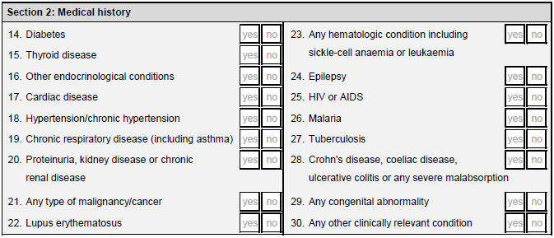

Prior to this pregnancy, had she ever been diagnosed with or treated for any of the
following medical conditions? Cross all boxes that apply

14. Diabetes (any type)
15. Thyroid Disease (any type)
16. Other endocrinological conditions (examples - Addison’s disease, adrenal gland
disorders, hypo- or hyperthyroidism)
17. Cardiac disease (examples - arrhythmias, murmurs, valve diseases, atherosclerosis, atrial fibrillation, pericarditis, cardiomyopathy etc.)
18. Hypertension/chronic hypertension with treatment (defined as 140/90 or greater. Include in this category women who have been treated for hypertension.)
19. Chronic respiratory diseases (including chronic asthma). Do not include childhood
asthma that is no longer present or very mild cases/allergies.
20. Proteinuria or kidney disease or chronic renal disease (The presence of excessive
protein substance, chiefly albumin, in the urine)
21. Any type of malignancy/cancer
22. Lupus Erythematosus (a chronic inflammatory collagen disease affecting connective
tissue)
23. Any haematologic condition including sickle cell anaemia or leukaemia. (If a woman knows that she is a heterozygous carrier of the sickle cell trait, do not exclude her)
24. Epilepsy (any type)
25. HIV or AIDS
26. Malaria (any episode)
27. Tuberculosis
28. Crohn’s disease, Coeliac disease or ulcerative colitis or any severe malabsorption
Condition
29. Any congenital abnormality or genetic disease (examples – cystic fibrosis, congenital
heart defects. Do not include very mild abnormalities such as extra digits, skin tags, hare
lips, colobomas).
30. Any other clinically relevant condition (any other significant medical or surgical
problem judged by the attending staff as a serious condition requiring special care, that
does not fall into one of the categories above)

Section 3: Gynaecological history

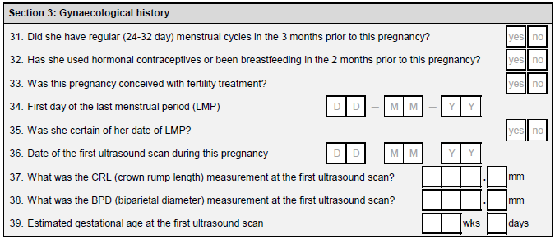

31. Did she have regular (24-32 day) menstrual cycles in the 3 months prior to this
pregnancy?

Regular menstrual cycles are defined as 24-32 days between the first day of one
menstrual period and the first day of the next menstrual period.

Place a ‘X’ in the box marked ‘YES’ if she DID have regular cycles in the 3 months prior
to her pregnancy.

Place a ‘X’ in the box marked ‘NO’ if she DID NOT have regular cycles in the 3 months
prior to her pregnancy.

32. Did she use hormonal contraceptives or been breastfeeding in the 2 months prior
to her pregnancy?
Place a ‘X’ in the box marked ‘YES’ if she DID use hormonal contraception or breastfeed
in the 2 months prior to this most recent pregnancy.

Place a ‘X’ in the box marked ‘NO’ if she HAS NOT used hormonal contraceptives and/or
been pregnant and/or breastfed in the in the 2 months prior to this most recent
pregnancy.

33. Was her pregnancy conceived with fertility treatment?
Place a ‘X’ in the box marked ‘YES’ if the woman conceived using ANY FORM of with
fertility treatment, including ovulation stimulation injections or similar.

Place a ‘X’ in the box marked ‘NO’ if she conceived naturally, without any form of fertility
treatment, ovulation stimulation injections or similar.

34. First day of the last menstrual period (LMP)
dd-mm-yy, e.g. 20th may 2010 = 20-05-10.
Use the laminated calendar as a memory aid to help the woman remember her LMP.
Write the date in the corresponding box.
35. Was she certain of the date of the LMP?
Place a ‘X’ in the box marked ‘YES’ if the woman is CERTAIN of the date on which she
began her last menstrual period.
Place a ‘X’ in the box marked ‘NO’ if she is NOT CERTAIN or expresses any doubt over
this date.

36. Date of first ultrasound scan.
First ultrasound scan is defined as any obstetric ultrasound scan after 9 weeks. If the
woman had an ultrasound scan earlier than 9 weeks, take the first scan as being the first
scan after 9 weeks gestation. From the notes, write down the date of the woman’s first
ultrasound scan (if applicable) in the format dd/mm/yy, e.g. 20th May 2010 = 20/05/10. If
the woman has not had an ultrasound scan during this pregnany, leave this box blank.

37. What was the CRL (Crown Rump Length) measurement at the first ultrasound?
Obtain this measurement form the medical record or ultrasonographer’s notes. Enter the
CRL measurement in millimeters. If this information is not available, for example if the
woman did not have an early dating scan, please leave the boxes blank.

38. What was the BPD (Biparietal Diameter) measurement at the first ultrasound?
Obtain this measurement form the medical record or ultrasonographer’s notes. Enter the
BPD measurement in millimeters. If this information is not available, for example if only
the CRL was measured at the first scan, please leave the boxes blank.

39. Estimated gestational age from first ultrasound scan.
From the notes, write down the gestational age estimated by CRL in weeks and days at
the woman’s first ultrasound (dating) scan. If the woman has not had an ultrasound scan
during this pregnancy, leave this box blank.

Section 4: Obstetric History

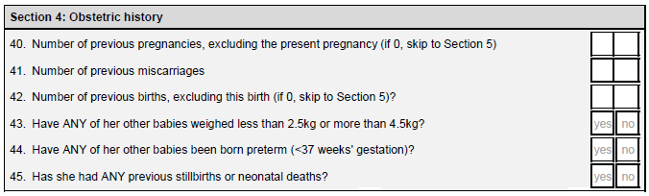

40. Number of previous pregnancies, excluding the present pregnancy. (If 0, skip to
section 5)
Important: do not include this most recent pregnancy (that she has just delivered).

Enter the number of previous pregnancies in the box. For 0, enter 00; for 1, enter 01, etc.
Include all known pregnancies, including those that ended in miscarriage or abortion.

Example, if, prior to this most recent pregnancy, she had one successful pregnancy, one
abortion and one miscarriage, enter 03 in the box.

41. Number of previous miscarriages
Enter the number of previous miscarriages in the box. For 0, enter 00; for 1, enter 01, etc.
Do not include any terminations.

42. How many previous births, excluding this birth, has she had? (If 0, go to section 5)
Important: do not include this most recent birth

A birth is defined as a delivery after 24 weeks, regardless of outcome. Thus, include any
still-born infants in the value.

Example: if she had 3 previous births, one of which was a stillbirth, enter 03 in the box.

43. Have ANY of her other babies weighed less than 2.5kg or more than 4.5kg?
Do not include the baby that has just been delivered.

Place a ‘X’ in the box marked ‘YES’ if she HAS previously had a low birth weight
(<2500g) or high birth weight (>4500g) baby.

Place a ‘X’ in the box marked ‘NO’ if she has NOT previously had a low birth weight
(<2500g) or high birth weight (>4500g) baby.

44. Have ANY of her other babies been born preterm (<37+0 weeks of gestation)?
Do not include the baby that has just been delivered.

<37 weeks gestation = <259 days since the last menstrual period.

Place a ‘X’ in the box marked ‘YES’ if she HAS previously had a preterm baby.

Place a ‘X’ in the box marked ‘NO’ if she has NOT previously had a preterm baby.

45. Have you had ANY previous stillbirths or neonatal deaths?
Do not include this most recent delivery if it was a stillbirth/neonatal death.

A stillbirth is defined as giving birth to a baby born dead after 24 weeks of gestation.
A neonatal death is defined as a death within 28 days of a live birth after 24 weeks of
gestation.

Place a ‘X’ in the box marked ‘YES’ if any of the woman’s previous pregnancies have
resulted in stillbirth or neonatal death.

Place a ‘X’ in the box marked ‘NO’ if she has had NO previous pregnancies resulting in
stillbirth or neonatal death.

Section 5: Clinical conditions

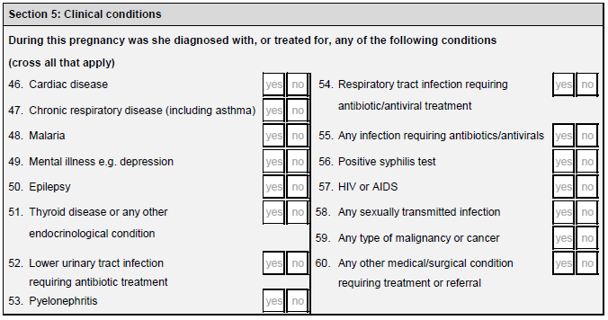

In each box:

Place a ‘X’ in the box marked ‘YES’ if the woman was EVER been diagnosed with or
treated for each condition listed above during this most recent pregnancy.

Place a ‘X’ in the box marked ‘NO’ if the woman was NEVER diagnosed with or treated
for each condition listed above in any previous pregnancy.

If she is uncertain whether she has had one or more of the conditions listed during this
pregnancy, consult her medical records/doctor in charge. If there is no mention of the
condition, assume that she has not had it and place a ‘X’ in the box marked ‘NO’.

46. Cardiac disease (any type)
47. Chronic respiratory disease (including chronic asthma) Do not include mild asthma
not requiring treatment or temporary use of an inhaler due to seasonal allergies.
48. Malaria (any type)
49. Mental illness (examples: depression, bipolar disorder, schizophrenia, general anxiety
disorder). Do not include mild depression not requiring treatment.
50. Epilepsy (any type of seizure/episode)
51. Thyroid disease or any other endocrinological condition (examples - Addison’s
disease, adrenal gland disorders, hypo- or hyper-thyroidism)
52. Lower urinary tract infections requiring antibiotic treatment
53. Pyelonephritis defined as an inflammation of the kidney and upper urinary tract that
usually results from non-contagious bacterial infection of the bladder (cystitis) or other
urinary infections.
54. Respiratory tract infection requiring antibiotic/antiviral treatment
55. Any other infections requiring antibiotic/antiviral treatment.
56. Positive syphilis test
57. HIV or AIDS
58. Any sexually transmitted infections. (Examples: gonorrhea, Chlamydia)
59. Any type of malignancy or cancer.
60. Any other medical/surgical condition requiring treatment or referral

Section 6: Pregnancy specific conditions

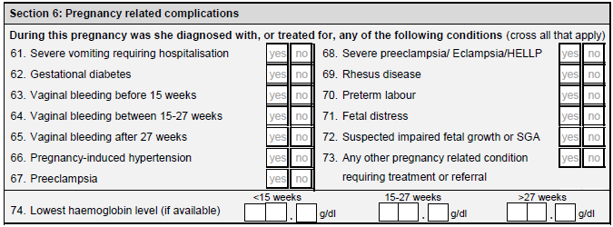

During this pregnancy was she diagnosed with or treated for any of the following
conditions (cross all that apply)

61. Severe vomiting requiring hospitalization
62. Gestational diabetes is a condition in which women without previously diagnosed diabetes exhibit high blood glucose levels during pregnancy.
63. Vaginal bleeding before 15 weeks
64. Vaginal bleeding at 15-27 weeks
65. Vaginal bleeding after 27 weeks
66. Pregnancy-induced hypertension high blood pressure 140/90 or greater that develops
after 20 weeks gestation in a previously normotensive pregnancy.

67. Preeclampsia
Preeclampsia is defined as high blood pressure 140/90 or greater, or an increase of 30mmHg systolic or 15 mmHg diastolic over baseline values on at least two occasions six or more hours apart that develops after 20 weeks gestation in a previously normotensive pregnancy, and proteinuria.

68. Severe preeclampsia/Eclampsia/HELLP syndrome
Severe preeclampsia is diagnosed when blood pressures are ≥160 mmHg systolic and/or ≥110 mmHg diastolic on two occasions, at least 4 hours but not more than 168 hours apart, or if the first measurement was immediately followed by treatment with an antihypertensive, either of these scenarios being associated with the presence of proteinuria.

Eclampsia is defined as the occurrence of convulsions and/or coma unrelated to her cerebral conditions in women with signs and symptoms of pre-eclampsia. Seizures are of grand mal type and may first appear before labour, during labour or up to 48 hours postpartum.

HELLP syndrome is a group of symptoms that occur in pregnant women who have preeclampsia
or eclampsia and who also show signs of liver damage and abnormalities in blood clotting. It is characterised by: Haemolysis, EL (elevated) liver enzymes and LP (low platelet) count.

69. Rhesus Disease also known as RH- isoimmunisation can occur when the mother is Rh negative and the baby is Rh positive.

70. Preterm labour. Initiation of labour before 37+0 weeks (both with and without delivery)
71. Fetal distress (antepartum)
72. Suspected impaired fetal growth or small for gestational age
73. Any other pregnancy related condition requiring treatment or referral
74. Lowest haemoglobin level (if available).
For each of the following gestational ages enter the lowest Hb result (if available). If not
available, leave blank.
<15 weeks
15-27 weeks
>27 weeks

Section 7: Nutritional supplements/medications
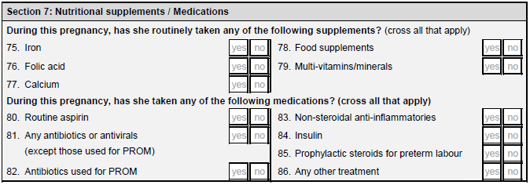
During this pregnancy, has she routinely taken any of the following nutritional
supplements? (please cross as many as apply)
Cross ‘Yes’ for those supplements that the woman has taken routinely and ‘No’ for those that
she has not. Routinely is defined as for more than one month. For example, do not cross
‘YES’ for a woman who has received a one-off supplement of iron.
75. Iron
76. Folic acid
77. Calcium
78. Food supplements
79. Multi-vitamins/minerals
During this pregnancy, has she routinely taken any of the following medications?
(please cross as many as apply)
Cross ‘Yes’ for those treatments that the woman has been given routinely and ‘No’ for those that she has not. Routinely is defined as for more than one month. For example, do not cross ‘YES’ for a woman who has taken aspirin for occasional headaches.

80. Routine aspirin
81. Any antibiotics or antivirals (except those used for PROM) e.g. penicillin
82. Antibiotics used for PROM (e.g. prophylactic antibiotics)
83. Non-steroidal anti-inflammatories e.g. ibuprofen
84. Insulin
85. Prophylactic steroids for preterm labour
86. Any other treatment

Section 8: Delivery
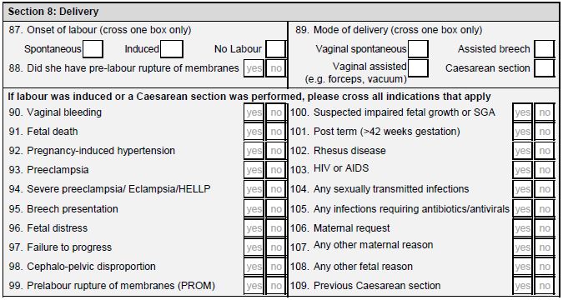
87. Onset of labour
Spontaneous is defined as the spontaneous initiation of labour even if she has any augmentation later during labour.
Induced is defined as the initiation of uterine contractions before the spontaneous onset of labour, with the aim of accomplishing vaginal delivery.

No labour refers to the woman when she has an elective Caesarean section without labour

If the reply is either Induced or No Labour, please ensure that you complete questions 89-110.

If the reply is Spontaneous, you do not need to complete questions 89-110.

88. Did she have pre-labour rupture of membranes (PROM)

Prelabour Rupture Of Membranes (PROM) (sometimes described as ‘premature rupture of membranes’) is the point diagnosis of the rupture of the sac membranes prior to labour/start of painful contractions, independently of gestational age.

Place a ‘X’ in ‘YES’ if she had prelabour rupture of membranes

Place a ‘X’ in ‘NO’ if she did not have prelabour rupture of membranes

89. Mode of delivery
Please cross ONE box that best applies

Vaginal spontaneous is defined as delivery that did not require any special intervention. Episiotomy is considered a normal delivery.

Vaginal assisted is defined as delivery assisted with forceps or vacuum. Vacuum extraction uses a suction cup that is placed over the baby’s head, which allows the physician to pull the child through the birth canal.

Assisted breech or breech extraction

Caesarean Section (including elective, intrapartum and emergency C-sections)

If labour was induced or a Caesarean section was performed, please cross indications that apply.

Please take the indications directly from the medical records. In cases of uncertainty, check with the attending midwife/doctor. Please cross as many indications as apply.

For each indication:
Place a ‘X’ in the box marked ‘YES’ if the indication is written in the medical record as a main
reason for induction or Caesarean section.

Place a ‘X’ in the box marked ‘NO’ if the indication is NOT written in the medical record as
a main reason for induction or Caesarean section.

90. Vaginal bleeding
91. Fetal death (or suspected fetal death)
92. Pregnancy-induced hypertension (see definition p. 13)
93. Preeclampsia (see definition p.13)
94. Severe Preeclampsia/Eclampsia/HELLP syndrome (see definition p.14)
95. Breech presentation (feet first)
96. Fetal Distress
97. Failure to progress (this diagnosis given to a woman who does labour does not follow a
normal pattern and is severely prolonged)
98. Cephalo-pelvic disproportion (when the baby’s head is too big to fit through the
mother’s pelvis)
99. Prelabour reupture of membranes (PROM)
100. Suspected impaired fetal growth or small for gestational age
101. Post term (>42 weeks)
102. Rhesus disease
103. HIV or AIDS
104. Any sexually transmitted infections (example: Herpes)
105. Any infection requiring antibiotic/antiviral treatment
106. Maternal request
107. Any other maternal reason
108. Any other fetal reason
109. Previous Caesarean section

Section 9: Newborn outcome and care
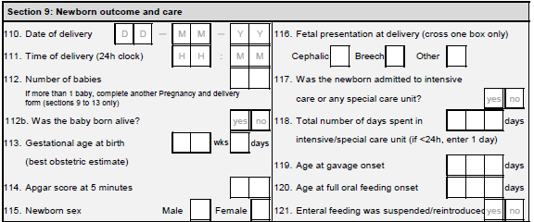
110. Date of Delivery
Please write the date of delivery in the format dd-mm-yy. For example the 20th May
2010 should be written 20-05-10.

111. Time of Delivery (24 hour clock)
Please write the time of delivery using the 24 hour clock, for example 8:15pm is
written as 20:15

112. Number of babies
Please write the number of babies that the woman delivered (whether alive or not).

If this was a multiple pregnancy, continue this form by completing the details of the
first baby to be delivered. Then, get a new form, complete the header with the same
study subject number, and complete sections 9, 10, 11, 12 and 13 for the second
baby delivered. If more than 2 babies were delivered, repeat this process for
each additional birth.

112b. Was the baby born alive?

Place a X in the box marked ‘YES’ if the baby was born alive. This means that they were either breathing or had a pulse when born.

Place a X in the box marked ‘NO’ if the baby was not born alive. This means that they were not breathing or had a pulse when born.

113. Gestational age at birth (based on best obstetric estimate)
Please obtain the best obstetric estimate (also known as clinical estimate) of the
gestational age at birth. The best clinical obstetric estimate is based on all clinical and
ultrasound data that were available to the attending staff (as they interpret it) and
should be written in the medical records. Write the estimated gestational age at birth
in weeks and days.

114. Apgar score at 5 minutes
Please write the Apgar score (range 1-10) at 5 minutes in the corresponding box.

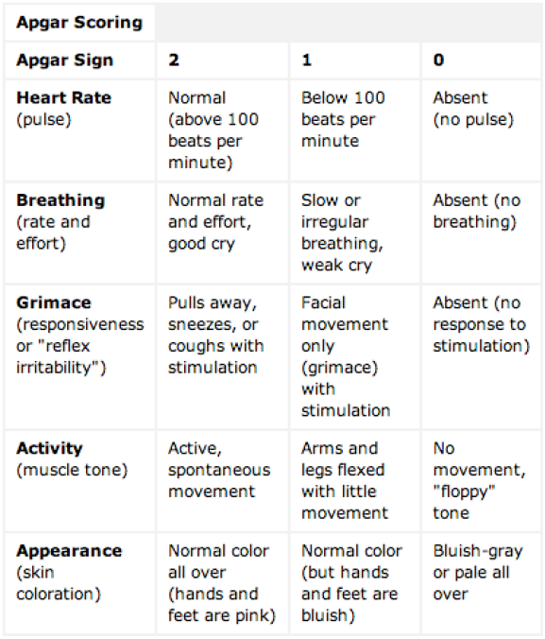
115. Newborn sex
Please place a ‘X’ in the box that corresponds to the infant’s sex.
If the sex is undifferentiated or undeterminable, please leave blank.

116. Fetal presentation at delivery
Cephalic (Head first)
Breech (Feet first)
Other (Any other fetal presentation at delivery, e.g. Arm first)

117. Was the newborn admitted to intensive care or any special care unit?
Place a ‘X’ in the box marked YES if the newborn was admitted to intensive care, special care, or any other non-routine form of care.
Place a ‘X’ in the box marked NO if the newborn was not admitted to intensive care, special care, or any other non-routine form of care and skip to question 121.

118. Total amount of days spent in intensive care or special care unit (if less than 24
hours, please enter 1 day)
Enter the total number of days spent in intensive care, special care, or any other form of non-routine care, rounded to the next whole day. For example, if the infant spent 1 day and 6 hours in the NICU, write 2 in the box.

119. Age at gavage onset
Enter the postnatal age (in complete days) at which gavage feeding was first introduced.
It includes gavage feeding administrated via an oro-gastric or naso-gastric tube either
intermittently or continuously.

120. Age full oral feeding onset
Enter the postnatal age (in complete days) at which full oral feeding was first started,
excluding non-nutritive sucking (mother pumps first and then places the baby to the
breast).

121. Enteral feeding was suspended/reintroduced
Place a ‘X’ in the box marked YES if enteral feeding had to be suspended (initiating or
reinitiating parenteral feeding) and later reintroduced before hospital discharge.

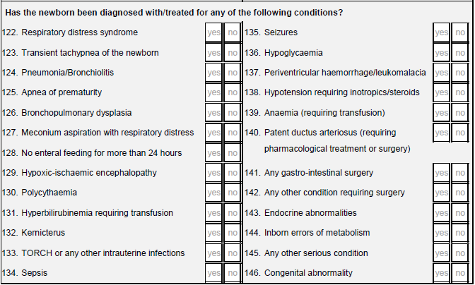

Was the newborn diagnosed with or treated for any of the following conditions before
hospital discharge?

Please take the diagnoses directly from the medical records. In cases of uncertainty, check
with the attending neonatologist. Please cross as many neonatal diagnoses as apply.
For further clarification on the definitions of the diagnoses, or information for when interacting
with the neonatologist, please see Appendix 2 (this will be updated once the definitions are
received from the Neonatal Group).

122. Respiratory distress syndrome
123. Transient tachypnea of the newborn
124. Pneumonia/Bronchiolitis
125. Apnoea of prematurity
126. Broncopulmonary dysplasia
127. Meconium aspiration with respiratory distress
128. No oral feeds for more than 24 hours
129. Hypoxic-ischemic encephalopathy
130. Polycythaemia
131. Hyperbilirubinemia requiring transfusion
132. Kernicterus
133. TORCH and/or other intrauterine infections
134. Sepsis
135. Seizures
136. Hypoglycemia
137. Periventricular hemorrhage/leukomalacia
138. Hypotension requiring ionotrophic treatment or steroids
139. Anaemia (requiring transfusion)
140. Patent ductus arteriosus (requiring pharmacological treatment or surgery)
141. Any gastro-intestinal surgery
142. Any other condition requiring surgery
143. Endocrine abnormalities
144. Inborn errors of metabolism
145. Any other serious condition
146. Congenital abnormality

Section 10: Newborn Anthropometry
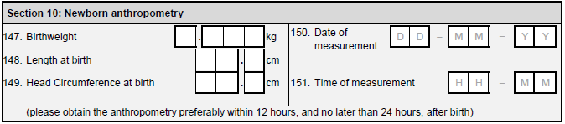
The anthropometric measurements of the infant need to be taken as soon as possible after birth
(preferably within 12 hours, and no later than 24 hours after birth), following the instructions in the
Anthropometry Handbook.

147. Birthweight (g)
148. Length at birth (cm)
149. Head Circumference at birth (cm)
150. Date of measurement written in the format day-month-year. Example 20th May 2018 is written as 20-05-18.
151. Time of measurement written using the 24-hour clock. Example 5:15 in the morning is written as 5:15 whereas 5:15 in the afternoon is written as 17:15.

Section 11: Morbidities/treatments during hospitalisation
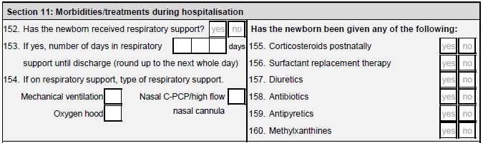
152. Has the newborn received respiratory support?
Place a ‘X’ in the box marked ‘YES’ if the newborn has received, AT ANY TIME,
respiratory support.

153. If yes, number of days in respiratory support until discharge (round up to the next
whole day)
Write the number of days that the newborn was in respiratory support up to the day of hospital discharge. Round up the nearest whole day. Examples: 12 hours should be recorded as 1 day; 36 hours should be recorded as 2 days.

154. If on respiratory support, type of respiratory support.
Cross only the ONE box that best applies to the type of respiratory support received by the newborn.

Has the newborn been given any of the following:
Cross all boxes that apply
155. Corticosteroids postnatally
156. Surfactant replacement therapy
157. Diuretics
158. Antibiotics
159. Antipyretics
160. Methylxanthines
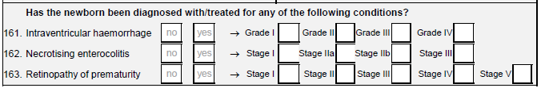
Has the newborn been diagnosed with/treated for any of the following conditions?
161. Intraventricular haemorrhage
If the answer is YES, place an X in the box corresponding to the grade of the intraventricular haemorrage.

162. Necrotising enterocolitis
If the answer is YES, place an X in the box corresponding to the grade of the necrotising enterocolitis.

163. Retinopathy of prematurity
If the answer is YES, place an X in the box corresponding to the grade of the necrotising
retinopathy of prematurity.

Section 12: Newborn Outcomes
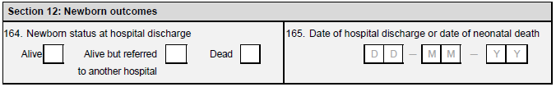
164. Newborn status at hospital discharge
Place an X in the box that corresponds to the newborn status at discharge.

165. Date of neonatal discharge (or date of death)
If the infant is discharged from hospital (i.e. no longer requires any special care) but the mother remains in hospital/special care, the date of neonatal discharge is the date that the baby leaves special care, even if it remains in hospital so as to be with the mother. Please write the date in the format dd-mm-yy. For example, 20th May 2010 should be written 20-05-10.

Section 13: Feeding Practices at hospital discharge
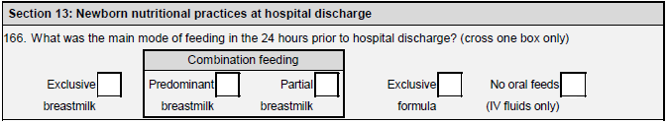
166. What was the main mode of feeding at hospital discharge? (cross one box only)
This question relates to the main mode of feeding in the 24 hours prior to hospital discharge.
Please use the definitions below:
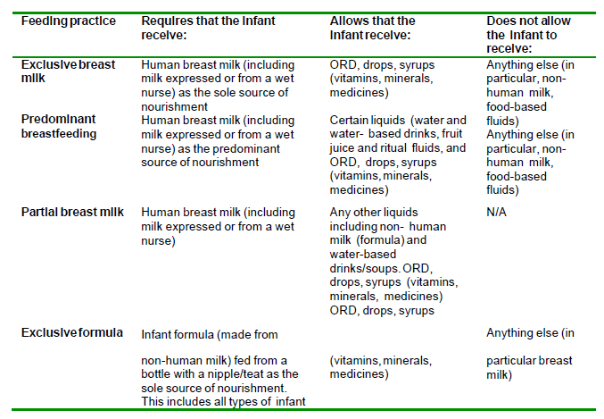

Section 14: Maternal Outcomes
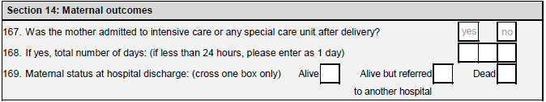
167. Was she admitted to intensive care or any special care after delivery?
Place a ‘X’ in YES if the mother was admitted to any ‘special care.’ Special care is defined as any form of care that is non-routine following delivery. Do not include those who were kept in the recovery room following caesarian section if this is the routine practice in your institution. Include those that gave birth in a high-risk delivery ward and were kept there following delivery for more than 2 hours. Answer question 154.

Place a ‘X’ in NO if the mother continued with the routine postnatal procedure. Go to question 155.
168. Total amount of days she was in intensive care or special care.
Please write the number of days that the woman spent in special care, rounded to the
nearest whole day.

169. Maternal status at hospital discharge
Cross the box that best applies to the status of the mother at hospital discharge

Comments
This section allows you to enter comments specific to questions in the form. Please be brief, and
identify the question that the comment refers to with a q followed by the question number; example: "q146. head circumference at birth not available in medical records".

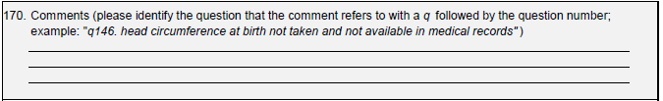

Intensive Care Form (ICU)

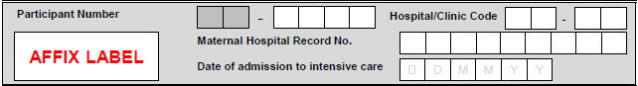
Participant Number: This is the identifier given to each woman in the study and should match that on the COVID form.
Hospital/Clinic Code: Enter the code that corresponds to the hospital or clinic where the woman receives her routine antenatal care and was screened for the study.
Maternal Hospital Record No.: This number is the hospital/clinic’s own internal reference number for the woman; it can be used to help identify the woman and link the information on this form with her medical records.
Date of admission to intensive care: Enter the date of this visit in the format dd-mm-yy, e.g. ‘20th April 2020’ should be written ‘20/04/20.
Please answer all yes/no questions by placing a ‘X’ in the corresponding box.
Section 1: Actions
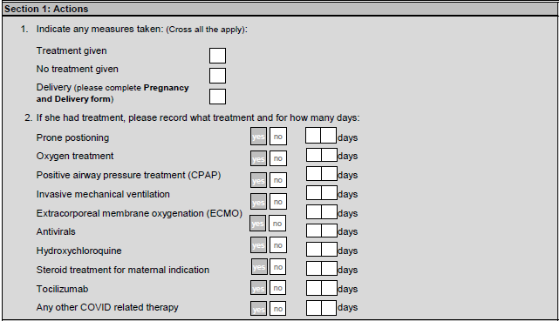
- Indicate any measures taken:
Place a ‘X’ in the box marked ‘Treatment given’ if appropriate and complete Q2.
Place a ‘X’ in the box marked ‘No treatment given’ if no treatment was given. Go to Q3.
Place a ‘X’ in the box marked ‘Delivery’ if the baby was delivered as a result of being in intensive care.
- If she has treatment, please record what treatment and for how many days?
For each treatment, record if the woman received it or not, and if she received it, record the number of days of treatment she received.
Prone positioning
Oxygen treatment
Positive airway pressure treatment (CPAP)
Invasive mechanical ventilation
Extracorporeal membrane oxygenation (ECMO)
Antivirals
Hydroxychloroquine
Steroid treatment for maternal indication
Tocilizumab
Any other COVID-19 related therapy

Section 2: Maternal Outcome
3. What was the outcome of the intensive care admission?
Place an X in the box that corresponds to the maternal outcome.

Section 3: Additional information
Please record any additional information you feel is relevant to the woman’s care.

Newborn Follow-up Form (NFU)

Form Header

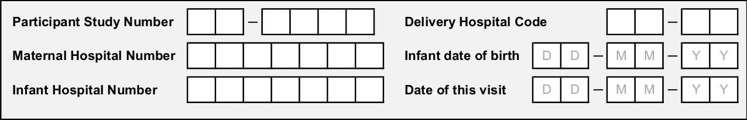

Participant Study Number. This is the identification number assigned to the woman. The first two digits correspond to your country code, the last five digits are the unique number assigned the participant.
Delivery Hospital Code. It should be the site code (first two digits) followed by the numbers 01.
Maternal Hospital Record Number. This number may be provided by the hospital and can be used if needed to help identify the woman.
Infant date of birth. Enter the infant’s date of birth in the format dd-mm-yy. For example, the 20th May 2010 should be written 20-05-10.
Infant Hospital Record Number. This number may be provided by the hospital and can be
used if needed to help identify the infant.

Section 1: Status of the neonate

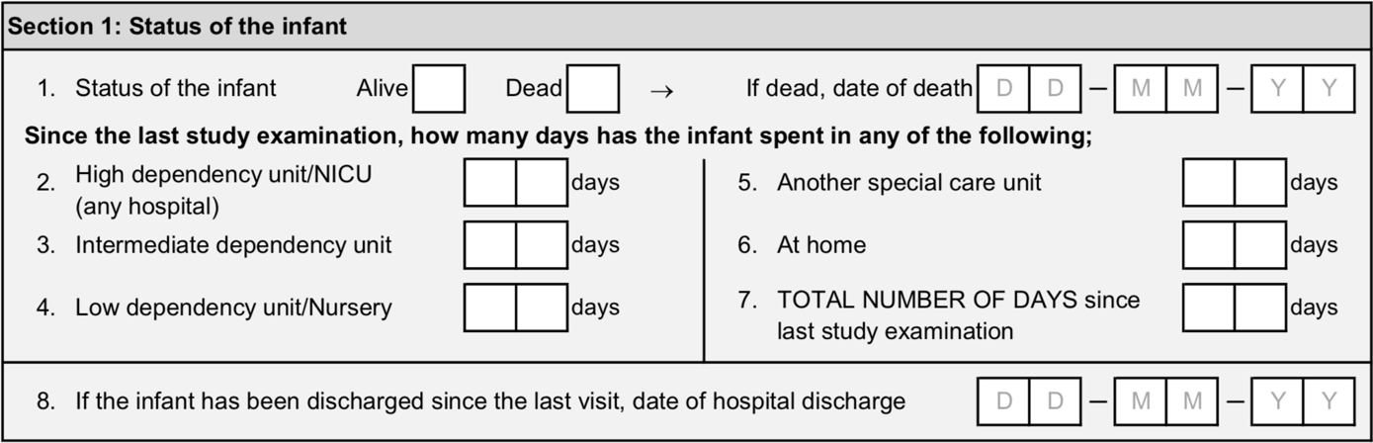

- Status of the infant

Place a ‘X’ in the box marked ‘ALIVE if the infant is currently alive.
Place a ‘X’ in the box marked ‘DEAD’ if the infant died.
If dead, date of death. If the infant died, enter the date of death in the format dd-mm-yy. For example, the 20th May 2010 should be written 20-05-10.
Since the last study examination, how many days has the infant spent in any of the following;
Enter the total number of days spent in each of the following since the last study examination or since birth (in case of the first follow-up visit), rounded to the next whole day. For example, if the infant spent 1 day and 6 hours in the NICU, write 2 in the box.
- High dependency unit/NICU
- Intermediate dependency unit
- Low dependency unit/Nursery
- Another special care unit
- At home
- TOTAL NUMBER OF DAYS since the last study examination
- If the infant has been discharged since the last visit, date of hospital discharge. Enter the date of discharge if the infant has been discharged since the last visit. Write the date in the format dd-mm-yy. For example, the 20th May 2010 should be written 20-05-10.

Section 2: Status of the mother

- Where is the mother?

Place a X in the box marked ‘STILL IN HOSPITAL’ if the mother is currently hospitalized.
Place a X in the box marked ‘AT HOME/WITH FAMILY’ if the mother was discharged.
Place a X in the box marked ‘DEAD’ if the mother died.

Section 3: Feeding Practices
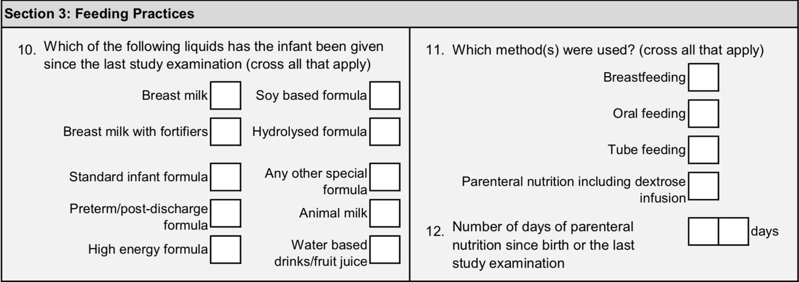

- Which of the following liquids has the infant been given since the last study examination (cross all that apply)

Place a ‘X’ in all the boxes that apply.

- Which method(s) were used? (cross all that apply)
Place a ‘X’ in all the boxes that apply.
- Number of days of parenteral nutrition since birth or the last study examination.

Enter the total number of days in which the infant was given parenteral nutrition since birth (in case of the first follow-up visit) or since the last study examination, rounded to the next whole day. For example, if the infant received parental nutrition for 1 day and 6 hours, write 2 in the box.

Section 4: Neonate anthropometry
NB Information required for this section must be obtained following the anthropometry protocol (https://globalhealthtrainingcentre.tghn.org/intergrowth-21st-course-maternal-fetal-and-newborn-growth-monitoring/ )
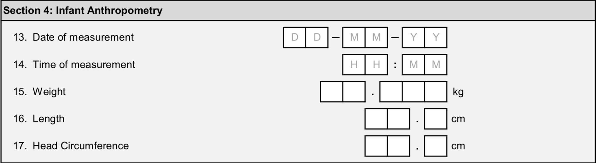
- Date of measurement. Enter the date of measurement in the format dd-mm-yy. For example, the 20th May 2020 should be written 20-05-20.

- Time of measurement. Enter the time of measurement using the 24-hour clock. For example, ‘8:15pm’ should be written as ‘20:15’.

- Weight (in kilograms (kg), to 3 decimal places)

- Length (in centimetres (cm), to 1 decimal place)

- Head circumference (in centimetres (cm), to 1 decimal place)

Section 5: Morbidities/treatments
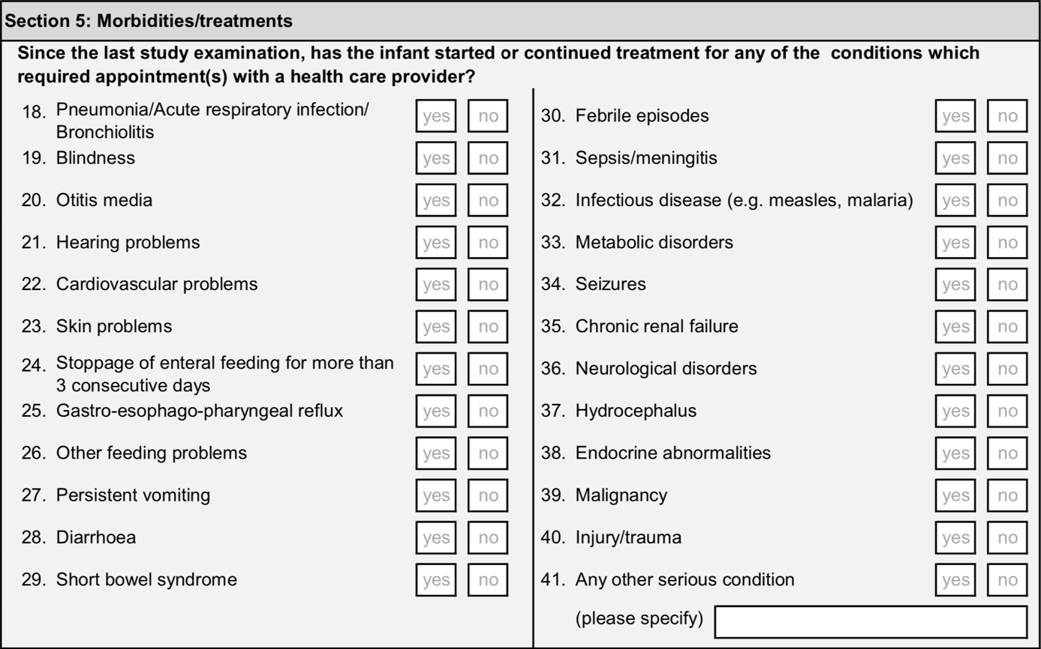
Since the last study examination, has the infant been diagnosed with/treated for any of conditions which required appointment(s) with a health care provider?
For each condition:
Place a ‘X’ in the box marked ‘YES’ if the infant was diagnosed with or received any treatment for that condition.
Place a ‘X’ in the box marked ‘NO’ if the infant was not diagnosed with and received no treatment for that condition.
- Pneumonia/Acute respiratory infection/Bronchiolitis
- Blindness
- Otitis media
- Hearing problems
- Cardiovascular problems
- Skin problems
- Stoppage of enteral feeding for more that 3 consecutive days
- Gastro-esophago-pharyngeal reflux
- Other feeding problems
- Persisting vomiting
- Diarrhoea
- Short bowel syndrome
- Febrile episodes
- Sepsis/meningitis
- Infectious disease (e.g. measles, malaria)
- Metabolic disorders
- Seizures
- Chronic renal failure
- Neurological disorders
- Hydrocephalus
- Endocrine abnormalities
- Malignancy
- Injury/trauma
- Any other serious condition (please specify). Specify every other serious condition not included in the list provided.

Since the last study examination which treatments have been given?
For each medication or treatment:
Place a ‘X’ in the box marked ‘YES’ if the infant has been prescribed that medication or treatment since the last study examination.
Place a ‘X’ in the box marked ‘NO’ if the infant has not been prescribed that medication or treatment since the last study examination.
- Analgesics
- Antacids
- Haematinics
- Anticonvulsants
- Antiemetics
- Anti-inflammatory agents
- Antibiotics
- Antipyretics
- Antitussive or expectorant drugs
- Blood transfusions
- Bronchodilators
- Diuretics
- Glucocorticoids
- Oxygen
Section 6: Next examination

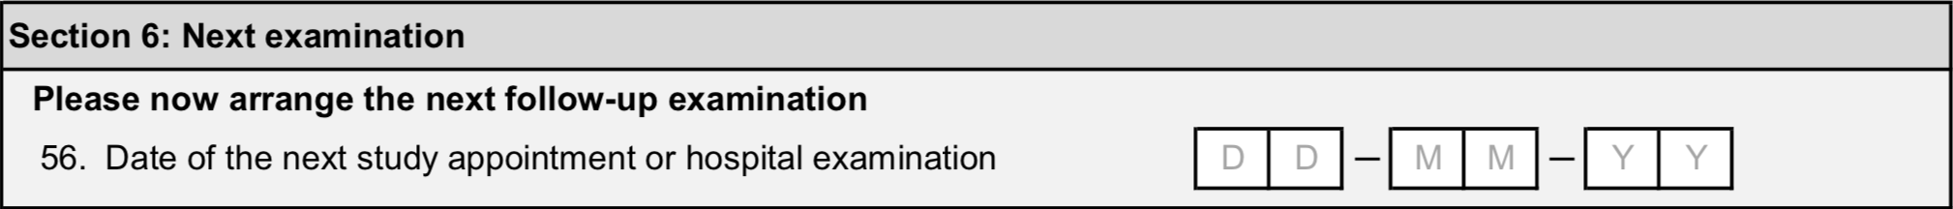
- Date of the next appointment or hospital examination. Enter the date of the next study appointment in the format dd-mm-yy. For example, the 20th May 2020 should be written 20-05-20.

Neonatal Abnormality Form (NAB)

Form Header
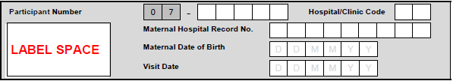
Participant Study Number. This is the identification number assigned to the woman. The first two digits correspond to your country code, the last five digits are the unique number assigned the participant.
Delivery Hospital Code. It should be the site code (first two digits) followed by the numbers 01.
Maternal Hospital Record Number. This number may be provided by the hospital and can be used if needed to help identify the woman.
Visit date: Record the date the abnormality is detected.
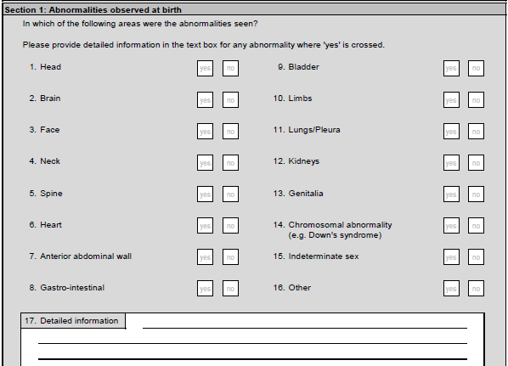
In which of the following areas were the abnormalities seen?
Place a X in the ‘YES’ box for each area where an abnormality detected.
Place a X in the ‘NO’ box for areas where abnormalities are not detected.
17. Detailed information:
Record detailed information on the abnormality detected.

18. Final diagnosis
Record the final diagnosis given to the neonate.

Baby Care Form (BCF)

Form Header
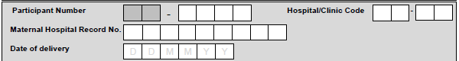

Participant Study Number. This is the identification number assigned to the woman. The first two digits correspond to your country code, the last five digits are the unique number assigned the participant.
Delivery Hospital Code. It should be the site code (first two digits) followed by the numbers 01.
Maternal Hospital Record Number. This number may be provided by the hospital and can be used if needed to help identify the woman.
Date of delivery. Enter the date of delivery in the format dd-mm-yy. For example, the 20th May 2010 should be written 20-05-10.

Section 1: Actions
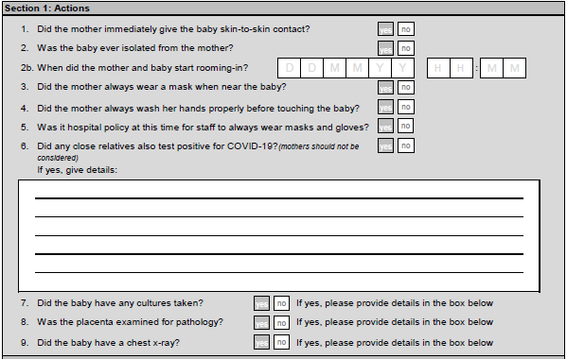

- Did the mother immediately give the baby skin-to-skin contact?
Place a X in the ‘YES’ box if skin-to-skin contact was given to the baby immediately.
Place a X in the ‘NO’ box if skin-to-skin contact was not given to the baby immediately.

- Was the baby ever isolated from the mother?
Place a X in the ‘YES’ box if the baby was ever isolated from the mother.
Place a X in the ‘NO’ box if the baby was not ever isolated from the mother.

2b. When did the mother and baby start rooming-in?
Record the date and time that the mother and baby started sharing a room.
Record the date in the format dd/mm/yy and the time in the format HH:MM using a 24 hour clock. For example 2:25pm would be recorded as 14:25.

- Did the mother always wear a mask when near the baby?
Place a X in the ‘YES’ box if the mother always wore a mask when with her baby.
Place a X in the ‘NO’ box if the mother did not always wear a mask when with her baby.

- Did the mother always wash her hands properly before touching the baby?
Place a X in the ‘YES’ box if the mother always washed her hands before touching her baby.
Place a X in the ‘NO’ box if the mother did not always wash her hands before touching her baby.

- Was it hospital policy at this time for staff to always wear masks and gloves?
Record if it was hospital policy to wear masks and gloves when this baby was being cared for.

- Did any close relatives also test positive for COVID-19?
Record ‘YES’ if any of the mother/baby’s close relatives also tested positive for COVID. This does not include the mother or the baby. For example, please record if the baby’s father or siblings were COVID positive
If yes, please provide details of who tested positive for COVID-19.

- Did the baby have any cultures taken?
If yes, mark the box appropriately and record details of the cultures including the type and results in the additional information box.
- Was the placenta examined for pathology?
If yes, place an X in the box marked ‘YES’ and record details of the pathology report in the additional information box.

- Did the baby have a chest x-ray?
If yes, place an X in the box marked ‘YES’ and record details of the X-ray and in the additional information box.

Section 2: Additional information

Please record all details of any cultures taken, any placenta pathology and chest x-ray results. You can also record any information relevant to the care of the baby.

Adverse Event (AE)

In the case that the woman has a health condition which needs further explanation please complete an adverse event form. This includes if:
- She has been diagnosed with any type of malignancy/cancer
- She had a medical condition requiring treatment or surgery during her pregnancy
- If she died during her pregnancy
For each adverse event record the following details:
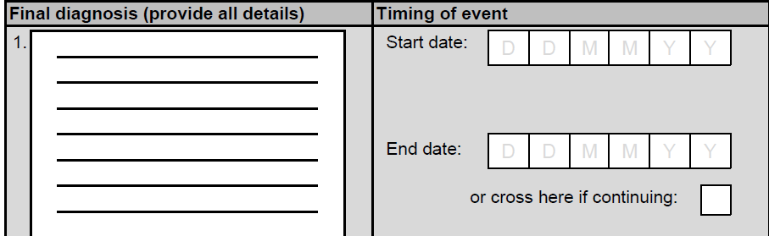
- Final diagnosis
Record the final diagnosis providing as much detail as possible.

- Timing of event
Record the start date of the adverse event in the format ddmmyy.
If treatment has ended and the woman has recovered, record the end date of the event.
If the woman is still undergoing treatment, enter a X in the box to indicate treatment is ongoing.
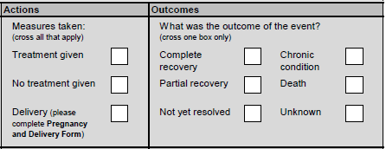
- Actions
Place a ‘X’ in the box marked ‘Treatment given’ if any treatment was given.
Place a ‘X’ in the box marked ‘No treatment given’ if no treatment was given.
Place a ‘X’ in the box marked ‘Delivery’ if the baby was delivered as a result of the adverse event.
- What was the outcome of the event?
Place a X next to the appropriate box.
Appendix 1. Occupational classification scheme
Housework (including care of child(ren)/care of elderly relative)
Manager/Professional/Technical
◻ Chief executives, senior officials and legislators and associated professionals
◻ Administrative and commercial managers and associated professionals
◻ Health professionals and associated professionals
◻ Teaching professionals and associated professionals
◻ Business and administration professionals and associated professionals
◻ Information and communications technology professionals and technicians
◻ Legal, social and cultural professionals
◻ Production and specialized services managers
◻ Hospitality, retail and other services managers
◻ Science and engineering professionals
Clerical/Sales/Services
◻ General and keyboard clerks
◻ Customer services clerks
◻ Numerical and material recording clerks
◻ Other clerical support workers
◻ Service and sales workers
◻ Personal service workers
◻ Sales workers
◻ Personal care workers e.g. care home worker
◻ Protective services workers
Skilled Manual Worker
◻ Market-oriented skilled agricultural, forestry, fishing and hunting workers
◻ Subsistence farmers, fishers, hunters and gatherers
◻ Craft and related trades workers
◻ Building and related trades workers, excluding electricians
◻ Metal, machinery and related trades workers
◻ Handicraft and printing workers
◻ Electrical and electronic trades workers
◻ Food processing, wood working, garment and other craft and related trade workers
◻ Stationary plant and machine operators
◻ Assemblers
◻ Drivers and mobile plant operators
Unskilled Manual Worker
◻ Cleaners and helpers
◻ Agricultural, forestry and fishery labourers
◻ Labourers in mining, construction, manufacturing and transport
◻ Food preparation assistants
◻ Street and related sales and service workers
◻ Refuse workers and other elementary workers
Other
◻ Student
◻ Redundancy/unemployed

Appendix 2. Definitions Of Neonatal Morbidities

Transient Tachypnea of Newborn (TTN)
TTN is a parenchymal lung disorder characterized by pulmonary edema resulting from
delayed resorption and clearance of fetal alveolar fluid.

The onset of TTN is usually at the time of birth and within two hours after delivery with tachypnea being the most prominent clinical feature. Characteristic findings on chest radiograph support the diagnosis and include increased lung volumes, and prominent vascular markings, with fluid in the interlobar fissure. In order to make the diagnosis, other conditions (such as pneumonia, respiratory distress syndrome, pneumothorax, etc) must be ruled out.

Symptoms of TTN usually last for 12 to 24 hours, but may persist as long as 72 hours in severe cases. Infants rarely require supplemental oxygen, but if required they usually respond to oxygen therapy. When oxygen is needed, usually concentrations less than 40 percent are sufficient to achieve adequate oxygenation.

REFERENCE
Guglani, L et al. “Transient Tachypnea of the Newborn.” Pediatr. Rev. 2008; 29;e59-e65

Respiratory Distress Syndrome (RDS)
An infant is determined to have respiratory distress syndrome if each of the following is true:
Requires O2 at 6 hours of life continuing to age 24 hours
Demonstrates clinical features within age 24 hours
Has need for respiratory support to age 24 hours, AND
Has an abnormal chest x-ray within age 24 hours consistent with surfactant deficiency
OR
Has received surfactant therapy within the first 24 hours of life
REFERENCE

Fanaroff AA, Stoll BJ, Wright LL, et al; NICHD Neonatal Research Network. Trends in neonatal morbidity and mortality for very low birth weight infants. Am J Obstet Gynecol 2007;196:147.e1-147.e8

Bronchopulmonary Dysplasia (BPD)
1) Chronic supplemental oxygen needs for >28 days (28 days oxygen need based BPD)

OR

2) Chronic supplemental oxygen needs at either PMA of 36 weeks or discharge from hospital whichever come first (36 weeks Oxygen need based BPD)

REFERENCE

Pascal M. Lavoie, Chandra Pham, Kerry L .Jang. Heritabilty of Bronchopulmonary Dysplasia, defined according to consensus statement of National Institute of Health.Pediatrics.2008; 122:479-485.

Meconium Aspiration Syndrome
Meconium Aspiration Syndrome (MAS) is defined as respiratory distress in an infant born through meconium stained amniotic fluid (MSAF), whose symptoms cannot be otherwise explained. This disorder may be life threatening complicated by respiratory failure, pulmonary air leaks and persistent pulmonary hypertension.

REFERENCE

Fanaroff AA. Meconium aspiration syndrome: historical aspects. J Perinatol.2008; 28:3-7

Retinopathy of Prematurity (ROP)
ROP a developmental vascular retinopathy occurs only in the incompletely vascularized retina of premature infants, leading to a wide range of outcomes from normal vision to blindness. For a diagnosis of ROP to be documented we need a confirmed diagnosis by an ophthalmologist in the notes according to the staging criteria below;

Staging of ROP:
Stage1: Demarcation line separating the avascular retina anteriorly from the vascularized retina posteriorly, with abnormal branching of small vessels immediately posterior.

Stage 2: Intraretinal ridge; the demarcation line has increased in volume, but proliferative tissue remains intraretinal.
Stage 3: Ridge with extraretinal fibrovascular proliferation.
Stage 4: Partial retinal detachment
Stage 5: Total retinal detachment.
REFERENCES

International Committee for the classification of Retinopathy of Prematurity “The international classification of Retinopathy of Prematurity Revisited” Arch Ophtalmol 2005;123:991-999.

M.Subhani, Adriann Coombs, Pamela Weber, Corina Gerontis. Screening guidelines for Retinopathy of Prematurity: The needs for revision in Extremely Low Birth Weight Infants.Pediatrics.2001; 107:656-659

Periventricular Leukomalacia
Damage to the deep white matter (WM) in the centrum semiovale is the main characteristic feature of PVL. The damage may vary from punctuate areas of hemorrhage & necrosis to more extensive injuries including cystic changes, scarring, hypomyelination / demyelination, and even hemorrhagic infarction of the white matter.

REFERENCE

De Vries LS, Eken P, Dubowitz LMS. The spectrum of leukomalacia using cranial ultrasound. Behav Brain Res 1992;49:1-6

Apnea of Prematurity
Clinically significant apnea in infants is defined as breathing pauses that last for > 20 seconds or for > 10 seconds if associated with bradycardia (e.g. < 80 beats per minute) or oxygen desaturation (e.g. O2 saturation of < 80-85 % ).

REFERENCE

Finer N, Higgins R, Kattwinkel J, Martin RJ. Summary Proceedings From the Apnea-of-Prematurity Group. Pediatrics 2006;117;S47-S51.

Hypoxic Ischemic Encephalopathy (HIE)
Hypoxic Ischemic Encephalopathy (HIE) of the newborn is “a clinically defined syndrome of disturbed neurological function in the earliest days of life in the term infant, manifested by difficulty with initiating and maintaining respiration, depression of tone and reflexes, sub normal level of consciousness and often seizures.

REFERENCE

Nelson KB, Leviton A. How much of neonatal encephalopathy is due to birth asphyxia? Am J Dis Child 1991

Birth Asphyxia
Apgar score ≤ 5 or a continued need for resuscitation at 10 minutes

OR

Acidosis (defined as any occurrence of umbilical-cord, arterial, or capillary pH of <7.00 or
base deficit of ≥16 mmol per liter) within 60 minutes after birth.

Moderate-to-severe encephalopathy (indicated by lethargy, stupor, or coma) and either hypotonia, abnormal reflexes (including oculomotor or pupillary abnormalities), an absent or weak suck, or clinical seizures.

Abnormal background activity of at least 30 minutes’ duration or seizures on amplitude integrated electroencephalography.

REFERENCE

Denis V. Azzopardi, Brenda Strohm, A. David Edwards, Leigh Dyet, Henry L. Halliday, Edmund Juszczak, Olga Kapellou, Malcolm Levene, Neil Marlow, Emma Porter, Marianne Thoresen, Andrew Whitelaw and Peter Brocklehurst for the TOBY Study Group. Moderate Hypothermia to Treat Perinatal Asphyxial Encephalopathy. N Engl J Med 361;14:1349-1358

Postnatal Infection (Sepsis)
Neonatal sepsis is a clinical syndrome of systemic illness accompanied by bacteremia occurring in the first month of life.

Late onset sepsis defined as 1 or more positive blood cultures obtained after 3 days of age from infants with clinical features of sepsis

Since culture positive sepsis is relatively rare, a physician documented episode of sepsis would suffice.

REFERENCES

Infectious disease: In Gomella TL, Cunningham MD( eds): a LANGE Clinical manual. Neonatology: Management, procedures, on Call Problems Diseases and Drugs.5th ed. McGraw Hill, 2004.p434-440.

M Gary Karlowickz, E Stephen Buescher Fulminant Late Onset Sepsis in a intensive neonatal care unit, 1987-1997, and the impact of avoiding empiric vancomycin therapy. Pediatrics.2000; 106:1387-1390

Intraventricular Hemorrhage (IVH)
A diagnosis of IVH should be based on a documentation of IVH based on Ultrasonographic findings conducted by a qualified ultrasonographer/ultrasonologist.

Intraventricular hemorrhage is graded by the classification of Papile et al on
ultrasonographic examination as follows:
Grade1: Blood in the periventricular germinal matrix regions or germinal matrix hemorrhage.
Grade2: Blood within the lateral ventricular system without ventricular dilatation.
Grade3: Blood acutely distends the lateral ventricles.
Grade4: Blood within ventricular system and parenchyma

REFERENCE
Papile LA, Burstein J, Burstein R, Koffler H. Incidence and evolution of subependymal and intraventricular hemorrhage: a study of infants with birth weights less than 1,500 gm. J
Pediatr 1978;92(4):529-34.

Necrotizing Enterocolitis (NEC)

A diagnosis and staging of Necrotizing enterocolitis (NEC) should be based on a clinical
documentation by treating clinician based on the following criteria:

Stage1: Suspected
- History of perinatal stress
- Systemic signs of ill health: temperature instability, lethargy, apnea
- Gastrointestinal manifestations: poor feeding, increased volume of gastric aspirates, vomiting, mild abdominal distension, faecal occult blood (no fissure)

Stage2: Confirmed
- Any of the features of stage 1 plus:
- persistent occult, or gross gastrointestinal bleeding, marked abdominal distension
- abdominal radiograph: intestinal distension, bowel wall oedema, unchanging bowel loops, pneumatosis intestinalis, portal vein gas.

Stage3: Advanced
- Any of features of stages 1 or 2 plus:
- Deterioration in vital signs, evidence of shock or severs sepsis, or marked gastrointestinal hemorrhage
- Abdominal radiograph shows any of features of stage 2 plus pneumoperitoneum

REFERENCE

Gastrointestinal disorder: In Roberton’s R Text book of Neonatology (3rded). Churchill Livingstone. 1999, p752.

Polycythemia
Polycythemia in term infant is the presence of a venous hematocrit more than 65% or a venous hemoglobin concentration in excess of 22 gm/dl.

REFERENCE

Phibbs RH:Neonatal polycythemia. In Rudolph AB (ed): Pediatrics, 16th ed. Newyork: Appleton Century Crofts, 1997.

Anemia requiring transfusion
There is no consensus on definition of Anemia of Prematurity.

Shown below is the criteria for transfusion taken from US and Canadian collaborative study. Patients are transfused in a volume of 15ml/kg, administered over 2-3 hours.
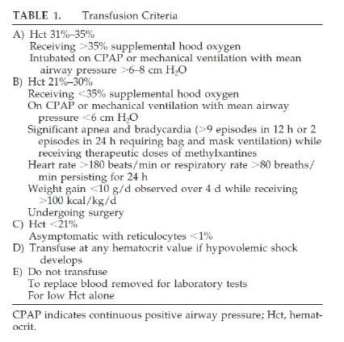
Table 1 adapted from Donato et al. Pediatrics. 2000;105(5):1066-72.

REFERENCE

Donato H, Vain N, Rendo P, Vivas N, Prudent L, Larguía M, Digregorio J, Vecchiarelli C, Valverde R, García C, Subotovsky P, Solana C, Gorenstein A. Effect of early versus late administration of human recombinant erythropoietin on transfusion requirements in premature infants: results of a randomized, placebo-controlled, multicenter trial. Pediatrics. 2000;105(5):1066-72.

Acute Bilirubin Encephalopathy
A clinical syndrome in the presence of severe hyperbilirubinemia, of lethargy, hypotonia, and poor suck, which may progress to hypertonia (with opisthotonus and retrocollis) with a high- pitched cry and fever and eventually to seizures and coma.

Chronic Bilirubin Encephalopathy
The clinical sequelae of acute encephalopathy with athetoid cerebral palsy with or without seizures, developmental delay, hearing deficit, occlumotor disturnances, dental dysplasia and mental deficiency.

REFERENCE

Guidelines for detection, management and prevention of hyperbilirubinemia in term and late preternm newborn infants (35 or more week’s gestation).Canadian Pediatric Society. Pediatr Child Health.2007; 12:1-12

Hypotension in Neonates
Hypotension is a blood pressure (B.P) >2 standard deviations below normal for age. For infants who are <30 weeks gestation, a mnemonic that is helpful in remembering BP is that the mean BP should be at least the same number as gestational age. For example, a 23 week infant should have a mean BP of 23 mmHg.

REFERENCE

Hypotension and shock in Gomella TL, Cunningham MD (eds): a LANGE clinical manual, neonatology: 5th ed. McGraw Hill 2004

Hypoglycemia
A normal range for neonatal hypoglycemia has not been properly defined, and there is controversy over safe blood glucose concentration. The World Health Organization designates a blood glucose “operational threshold”<2.6 mmol/L or 46.8 mg/dl as requiring treatment and make no distinction between preterm and term infants.

REFERENCE

Division of Child Health and Development and Maternal and Newborn Health/Safe Motherhood, Hypoglycemia of the Newborn. Review of the literature. World Health Organization.Geneva.1997.1-55

Inborn Error of Metabolism
Inborn errors of metabolism comprise a large class of genetic diseases involving disorders
of metabolism. The majority are due to defects of single genes that code for enzymes that
facilitate conversion of various substances (substrate) into others (products). In most of
the disorders, problems arise due to accumulation of substances which are toxic or
interfere with normal function, or to the effects of reduced ability to synthesize essential
compounds.

Inborn errors of metabolism are now often referred to as congenital metabolic diseases
or inherited metabolic diseases, and these terms are considered synonymous.

REFERENCE

Charles Scriver, Beaudet A.L, Valle D, Sly, WS, Vogeistein, B Kinzler. K.W. The online
Metabolic and molecular bases of inherited disease. Newyork: McGraw Hill 2001

