

Call for Proposal - Expanding the CEPI Centralized Laboratory Network

Webinars for the labs - transcript

____________________________________________________________________

With a wide range of COVID-19 vaccine development platforms and extensive variability between laboratory assays, comparison of results for vaccine trials can be challenging. The Coalition for Epidemic Preparedness Innovations (CEPI) has established a global network of laboratories to centralize testing and enable comparison of immunological responses generated by the various COVID-19 vaccine candidates. The CEPI Centralized Laboratory (CL) Network has the goal to enable key immunogenicity and efficacy endpoint evaluation, to support COVID-19 vaccine developers in the pathway towards licensure and to help the identification of immune correlates of protection. The laboratories currently included in the CEPI CL Network are shown in Figure 1.

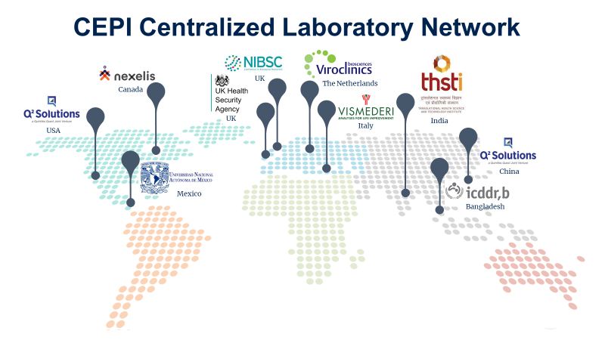

**Figure 1:** Overview of the CEPI Centralized Laboratory Network

Six qualified assays were included to evaluate humoral and cellular immune responses following vaccination. The humoral response analysis includes the evaluation of binding (S-,RBD-,N-ELISA) and neutralizing antibodies (wild type virus neutralization assay and pseudovirus neutralizing assay). Cell mediated immunity is measured by ELISPOT assay, which detects production of IFN-γ and IL-5 to SARS-CoV-2 Spike protein peptides.

The CEPI CL Network is a global resource, committed to provide testing support to all COVID-19 vaccine developers in order to facilitate standardized measurement of immune responses to vaccines . We have so far received sample analysis requests from 35 vaccine developers and allocated more than 21.500 samples for testing.

CEPI is currently supporting the development of multiple vaccines against these high-risk pathogens, identified on the World Health Organization R&D Blueprint as having epidemic potential or as a major public health risk, as part of its $3.5bn plan to minimize or even eradicate future deadly disease threats.

Providing the tools to harmonize the assessment of epidemic and pandemic vaccines will allow researchers and regulators to evaluate the most promising vaccine candidates quickly and accurately - a key part of the process needed to support CEPI’s ambitious goal to reduce the vaccine development timeline to 100 days. The CEPI Centralized Laboratory Network is part of this plan to invest and scale critical research innovations which underpin rapid vaccine testing, advance in innovations so vaccine testing is cheaper and faster, push for collaboration and solutions which will enable a faster system-wide response and coordinate a scalable on-demand testing network.

The extension of scope requires additional laboratories to join the centralized group, with CEPI today opening a [Call for Proposals](https://cepi.net/get_involved/cfps/?learn-more-7099=5&swcfpc=1) to identify laboratories worldwide able to assess these vaccines undergoing clinical testing. CEPI is particularly eager to receive applications from laboratories capable of performing such testing in South America, Africa, and Oceania – regions where the centralized network does not currently have laboratories.

CEPI is looking for additional laboratories to:

1. Expand the CL Network for Covid-19 testing to include laboratories in South America, Africa and Oceania regions
2. Expand the CL Network to develop new assays for other viruses, including CEPI priority pathogens, (open to any laboratory worldwide)

All Laboratories are invited to apply to the next open Call for Proposal from 22nd November 2021 to 28th February 2022. Apply filling in and submitting the [Application template](https://view.officeapps.live.com/op/view.aspx?src=https%3A%2F%2Fcepi.net%2Fwp-content%2Fuploads%2F2021%2F11%2FCEPI_CfP_Centralized-Lab-Application-template.docx&wdOrigin=BROWSELINK) to [centralizedlab@cepi.net](mailto:centralizedlab@cepi.net)

Applicants must meet the following minimum eligibility criteria:

* have the ability to perform one or more vaccine-relevant immunological assays for human and/or animal samples.
* have the ability to perform those assays testing immunity CEPI priority pathogens and new emerging pathogens.
* have experience with immunological assay(s) development.
* demonstrate experience in tech transfer the assay(s) to and from other laboratories and be willing to share protocols.
* be able to perform studies under GLP/GCLP conditions or a quality system that assures data quality and integrity.
* be willing to work with CEPI to collaboratively design the most relevant immunological assays for the purpose.
* be able and willing to prioritize CEPI work over other on–going projects.
* support preclinical and clinical programmes to ensure protocols and ethics applications for trials are aligned with the analytical plans.

All applications will be reviewed based on the following evaluation criteria:

* Applicant competencies, experience and track record.
* Adequate capacity for the studies.
* Ability to prioritize analysis of samples from CEPI vaccines trials over any other on-going projects.
* Appropriate quality systems in place.
* Proven ability to maintain sufficient reagent stocks.
* Appropriate project management capabilities.
* Proven record of receiving samples from multiple geographical locations.
* Ability to work in a network of international labs to harmonize protocols, reagents and data.
* Competitive pricing.

The application will be reviewed by CEPI internal experts and external experts.

Lab-specific support for instrumentation and software might be available. CEPI may offer support for additional technical staff to not-for-profit organizations. CEPI will fund assay development, tech transfer, key reagents procurement and sample testing.

**Resources**

* More info on the CEPI Centralized Lab: [Enabling Sciences • Epidemic Preparedness Innovations (tghn.org)](https://epi.tghn.org/covax-overview/enabling-sciences/central-lab-network/)
* The CfP is published on the CEPI website: [Calls for Proposals](https://cepi.net/get_involved/cfps/)
* CEPI priority pathogens: [Priority diseases – CEPI](https://cepi.net/research_dev/priority-diseases/)
* Any further question? Reach out to [centralizedlab@cepi.net](mailto:centralizedlab@cepi.net)