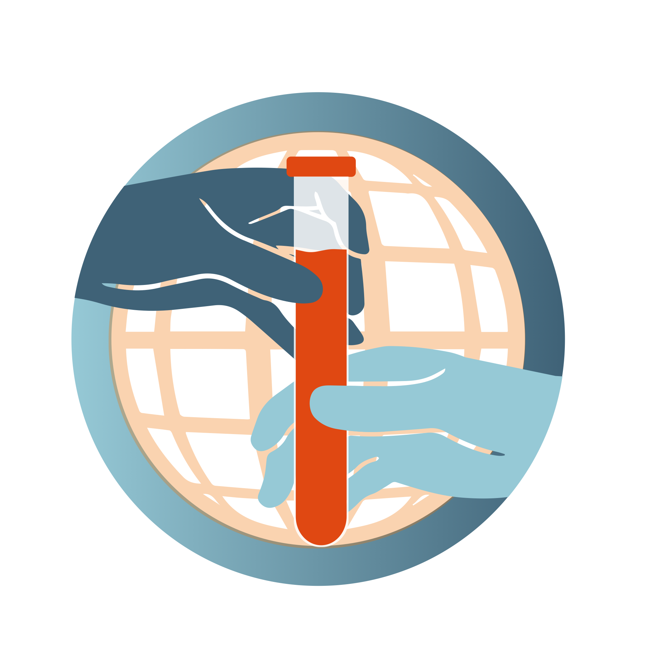
Biorepositories for the Public Good:
Partnering for Response to the Pandemics of the Future
CONCEPT
- Empower individual and regional sites to collect, retain and share quality specimens for advancing research, diagnostics, vaccines, and therapeutics for infectious diseases of high concern.
- Coalesce as a federated virtual biorepository partnership with members finding solutions to access high-quality materials for public health needs
- Achieve goal through a trusted and sustainable system committed to equitable access and benefits sharing

APPROACH
- Stepwise approach from inception to realization through building a coalition of partners (Previous webinar)
- Develop working groups (This webinar workshop)
  - Prioritize specimen and data types for a virtual biorepository
  - Solutions to barriers in accessing specimens and data
  - Identify benefits to users and contributors under a sustainable plan
- Operationalize coalition model (Future implementation)
  - Pilot in volunteer sites
  - Harmonize sample sharing mechanisms
  - Provide access to benefits sharing
  - Test a sustainable and equitable business model
BACKGROUND
Access to well-characterized quality specimens and associated data is a key barrier for research and development of medical countermeasures. There are existing resources that provide samples, but most have limited access or are collections of convenience and not fully representative of biological and geographical breadth. Our purpose is to align with current initiatives at the WHO, CEPI, FIND, NIH, PATH, EVA-G, and the public health and research community to facilitate sample and resource sharing at critical response periods to emerging pathogens and infectious diseases of public health interest. Most accessible samples are collected for existing programs or projects, few are collected with the intent to share broadly to advance research, diagnostics, vaccines, and therapeutics for infectious diseases of high concern.

An open-source, trusted, enduring resource of quality samples remains unrealized, and the need is evident each time a new outbreak emerges (Zika in 2016, COVID-19 in 2020). A system that targets locally owned prospective or existing well-annotated collection of quality samples, if realized, can fill this gap, and allow for rapid development of diagnostic and therapeutic countermeasures.

This workshop takes the next step to our previous discussion in December 2020, and our grass-roots approach to building a federated, locally owned coalition of willing partners to explore key requirement for creating a sustainable a Virtual Biorepository (VB). In this workshop we will seek participants’ input on:
- Lessons learned from sample exchange and biorepository experience during Dengue, Zika epidemics and COVID-19 pandemic response
  - What types of samples should be prioritized to store, share, and accrue?
  - What should be the minimal quality standards and criteria for these samples and associated data?
  - How should the many COVID-19 collections that now exist be made accessible?
- Identifying solutions to barriers that may interfere with timely access and benefits sharing to users and providers alike
  - How should specimens and data be collected and harmonized?
  - What are possible solutions to legal and regulatory challenges that impede timely sharing such as: local laws, shipping, and benefit sharing policies like the Nagoya protocol?
  - How to be responsive to the needs of different stakeholders (commercial and academic and other)?
- Operationalizing a federated sample sharing system where ownership is maintained and sustained
  - Can we identify the benefits and advantages for sample providers? For users?
  - What are some successful models of equitable sharing and governance structure retaining local ownership?
  - What should be some of the key features of VB system to ensure sustainability?

We need you to email us at vbiorepository@ucdenver.edu so that we can include you in our contact list and join our effort.

