CHN PB-SAM 005: CHAIN PB-SAM WHOLE STOOL & RECTAL SWAB PROCESSING SOP

Purpose

The purpose of this SOP is to describe the standard procedures involved in processing and storing of study whole stool samples and rectal swabs.

Responsibility

This SOP applies to any study laboratory staff. It is the responsibility of those users to follow the guidelines stipulated herein.

The Principal Investigator (through the study coordinator when applicable) retains the overall responsibility of implementation of these standard procedures.

The study laboratory coordinator is responsible for answering questions you may have about the content of this SOP and any other relevant study documentation. Please contact the study laboratory coordinator through your site lab-coordinator.

Main CHAIN PB-SAM laboratory coordinator: Caroline Tigoi (email: ctigoi@kemri-wellcome.org)
or (rmusyimi@kemri-wellcome.org)

Abbreviations/Definitions

SOP Standard Operating Procedure
PI Principal Investigator

Materials
- Fecal collection containers
- Non-absorbent plastic surface
- Wooden spatula
- Patient Sample labels
- Sample storage vials (2.0 ml)
- -80 ºC freezer
- Polycarbonate freezer boxes

Methods
- General considerations
  - Samples collected from patients in this study will be for study-specific analyses.
  - Specimens collected for various tests.
  - Correct specimen collection bottles and correct request forms must always be used and verified at each collection.
  - Ensure all samples should be labelled by Country code, collection time point, (see Site Specific Collection Schedule (appendix 7.2), specimen type (F1, F2, F3 or F4), Patient ID and date of collection. For example: 10-A0-F1-XXX-12/10/14. Add a red sticker to the tubes if caregivers do not consent to international shipping of samples.
  - Ensure that tubes marked with a red sticker are stored in a separate freezer box that is clearly labeled (Fecal not for shipment). These samples will be retained at the site as they have no consent for international shipping.
  - Keep samples on ice, with ice packs at all times.
  - For stool, storage cryovials should be at least 2/3 full (i.e. 1.5 ml of stool).
  - If the volume of stool is insufficient, the aliquots F1 and F2 have priority.
  - Store each aliquot in separate 2-inch polycarbonate (Nalgene 10 x 10 system) freezer box. Samples are destined for different analytic sites for specific analyses and are to be separated at this stage to facilitate an efficient pre-transportation process.
  - Each freezer box should be labeled on the top and on the side using printed cryo labels. The label should contain a unique number letter combination (see sample freezer box storage log – Appendix 7.3).

- Sample rejection criteria
The following criteria will be enforced as rejection criteria for stool and rectal swabs
  - Insufficient – stool less than 1gm, request for a repeat sample. If not obtained, store what was brought earlier
  - Incomplete data – Request clinical team or courier to fill in missing metadata
  - Missing sample - notify clinical team or lab manager
  - Two or more samples with the same specimen number on tube but different numbers in CRF and the vice versa – Reject, discard and notify lab manger and clinical team. Fill in sample rejection form.

- Whole Stool Processing
  - Ensure all fecal collection containers have been correctly labeled, by comparing the sample to the Sample Transportation Log.
  - Record time of receiving samples on the Sample Transportation Log. Stool collection pots should contain at least 5ml of stool. Record insufficient stool volume on the CRF.
  - Prior to aliquoting the samples, label the empty freezer storage vials with specific barcodes. The first two aliquots will be shipped internationally. These aliquots will be called F1 to F4.
  - Mix stool using a spatula before dividing it into the different aliquots.
  - Stool should be collected in fecal collection containers and separated using the wooden spatula or a plastic wire loop in 4 aliquots of at least 1.5 ml or 2/3 full of a cryovial (named F1, F2 & F3). If volume is insufficient, fill the first two tubes and label accordingly.
  - Patient samples, which arrive at the laboratory with a red sticker, indicate that these samples must never be shipped, because the patient has not consented to international shipping. If you receive a sample WITH a red sticker, confirm with the study team that this sample is correctly labeled (i.e., the family has not consented to international shipping). All three aliquots should be barcoded, and a red sticker also placed on the cryovials. They should however be stored at the site in a designated clearly labeled cryobox i.e. “Fecal not for shipment”.
  - Ideally, stool samples should be stored at -80 degree Celsius within 30 minutes after arrival at the laboratory. However, blood and rectal swabs can be processed prior to stool samples which may result in stool having a processing time of over 30 minutes. Due to challenges in obtaining stool on time, some samples may be collected in the community and delivered in the lab after 30 minutes of collection. Never discard a stool sample because the collection time or processing time has been too long. Record time of storage in the Sample Transportation Log and the CRF.

- Rectal swab processing
  - Ensure all rectal swabs have been correctly labeled. By comparing the sample to the Sample shipment log.
  - Patient samples which arrive at the laboratory with a red sticker do not have consent for international shipping. Confirm with the study team that this sample is correctly labeled with the red sticker (i.e., the family has not consented to international shipping). All three aliquots, from these patients should be clearly labelled with a red cryo sticker confirming that they should not be shipped.
  - Rectal swabs R1(dry swab) collected using a dry FLOQ swab should be cut using a sterile disposable scissor or breaking the swab just below the shaft by bending and twisting it against the wall of a 2 ml cryotube and stored in -80 degrees Celsius within 30 mins of arrival at the laboratory. Record time of storage in the Sample Transportation Log.
  - Rectal swab R2 (wet swab) should be cut just below the shaft and put in 1ml of freezing mixture (See SOP CHN PB-SAM 007and should be store dup right in -80 degrees Celsius within 30 minutes of arrival at the laboratory. If R2 is being used for culture on site, then it will be transported in carry Blair available as a kit together with the swab and it should be cultured within 30 minutes of receipt in the laboratory (See CHN101).

- Sample log and registration
  - At the laboratory the stool samples are divided into 4 aliquots and rectal swabs transferred to 2 ml cryotubes before storage. The Sample Transportation Log MUST be filled out. Complete this log immediately after the samples have been placed in the freezer
  - Record time of receiving of sample and freezing of samples on the Sample Transportation Log.
- Appendices
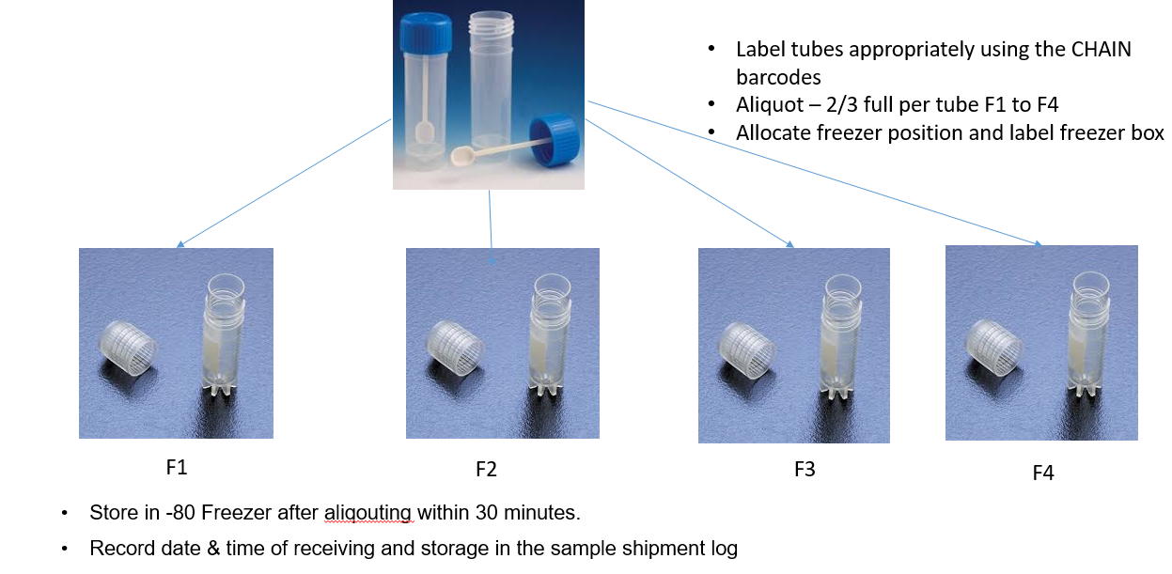

- Document history
Version 1 | Author | Approved by | Signature | Dated
1.02 CHAIN PB-SAM Whole Stool and Rectal Swab Processing SOP | Caroline Tigoi | Robert Bandsma | 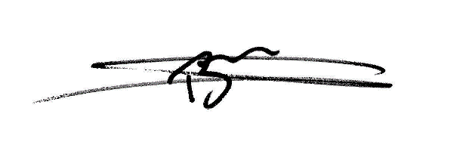 | 24-01-2021

- Site training record
All sites are required to maintain a master copy of this SOP that documents the site staff that have been trained on this SOP.
Document History
Version No. | Trained staff initials | Signature of trained staff | Date | Trainer’s Initials
1.01 | KDT | Example row | 1st Jan 2016 | DM

