- INTRODUCTION AND PURPOSE
  - The purpose of this SOP is to specify procedures for basic physical assessment and examination of SAM patients prior to and after enrolment.
  - This trial is for children aged between 2 months to 59 months presenting to hospital with complicated severe acute malnutrition (SAM) requiring admission to hospital. SAM is defined using modified WHO criteria for SAM determined by MUAC, WHZ and/or presence of nutritional oedema. For the purpose of this study, severe malnutrition is: weight-for-height <-3 z scores of the median WHO growth standards and/or mid upper arm circumference <115mm (<110mm age below 6 months), or symmetrical oedema of at least the feet related to malnutrition (not related to a primary cardiac or renal disorder).

- RESPONSIBILITY
  - The SOP applies to clinicians and nurses who will be assessing patients prior to enrolment and after enrolment to PB-SAM study.
- DEFINITIONS
  - MUAC: Mid-upper arm circumference
  - SAM Severe Acute Malnutrition
  - CM: Centimetre
  - MM: Millimetre
  - Kg: Kilogram
  - Gr: Gram
- EQUIPMENT/MATERIALS
  - Length board
  - Calibrated weighing scale
  - Marker pen
  - MUAC tape
  - Pulse oximeter

- Clinical Eligibility Criteria
In addition to meeting the above anthropometric criteria for SAM, the patient needs to have two or more “features of severity” as specified in the table below
Clinical/Lab Feature | Criteria
Respiratory distress | “Subcostal indrawing” or “nasal flaring” or “head-bobbing”
Oxygenation | “Central cyanosis” or SaO₂ <90%
Circulation | Capillary refill >3 seconds
Conscious level (AVPU) | < “A”
Pulse | > 180 per min
Haemoglobin | < 7g/dl
Blood glucose | < 3mmol/L
White blood cell count | < 4 or > 17.5 x 10⁹/L
Temperature | <36 or >38.5ºC
Very low MUAC | MUAC <11cm

Below is an explanation of the different criteria.
Subcostal indrawing: the abnormal inward movement of lower anterior chest wall during inspiration.
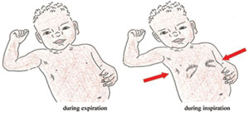

Nasal Flaring: the widening of nostrils while breathing.
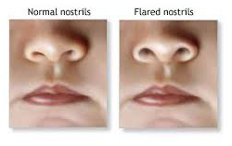
Head nodding: head moves forward each time child takes a breath.
Central cyanosis: abnormal bluish discoloration of lips or tongue.
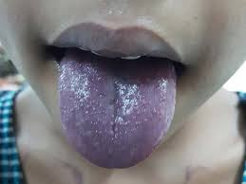
SaO2 <90%: oxygen level (oxygen saturation) of the blood is less than 90%.
Capillary refill >3 seconds: Use the nail bed in children with a dark skin: press-5 seconds and then count the seconds until the blood re-enters the capillary bed. Above 3 seconds is abnormal (Cave: cold hands due to wheather conditions).
Conscious level (AVPU): The “AVPU” scale (an acronym from "alert, verbal, pain, unresponsive") is a system by which a health care professional can measure and record a patient's level of consciousness.
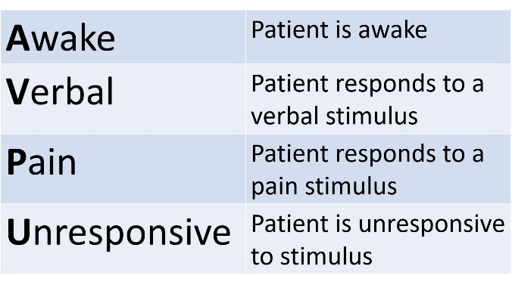

5.1 SPECIFIC PHYSICAL ASSESSMENTS
Physical assessment finding explanations and procedures are provided in alphabetical order.

Acidotic Breathing: It is a form of hyperventilation, which is any breathing pattern that reduces carbon dioxide in the blood due to increased rate or depth of respiration. In metabolic acidosis, breathing is first rapid and shallow but as acidosis worsens, breathing gradually becomes deep, labored and even gasping.

Axillary temperature: Place the tip of the thermometer in the centre of the armpit. Tuck the child's arm snugly (closely) against their body. Leave the thermometer in place for about 30 seconds or until you hear the “beep”. Remove the thermometer and read the temperature.

Crackles: This is a series of short, explosive sounds identified by auscultation. It is important to auscultate all lung fields on the chest, front and back. Crackles can also sound like bubbling, rattling, or clicking. They are more commonly picked up during breathing in, but they can happen when breathing out, too. You can have fine crackles, which are shorter and higher in pitch, or coarse crackles, which are lower. Either can be a sign that there’s fluid in the air sacs, for example caused by a pneumonia.

Fontanelle Assessment: Use the flat pads of your fingers to palpate (gently feel) the surface of the head. Ensure you make note of any retraction or bulging, as the normal fontanelle feels firm and flat (not sunken or bulging).
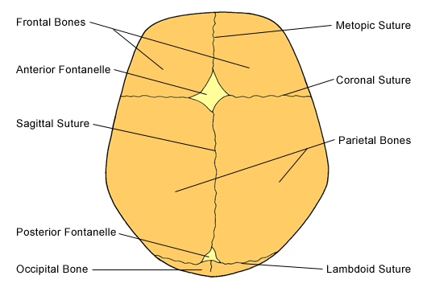

Frontal bossing: The development of an unusually pronounced forehead which may also be associated with a heavier than normal brow ridge.
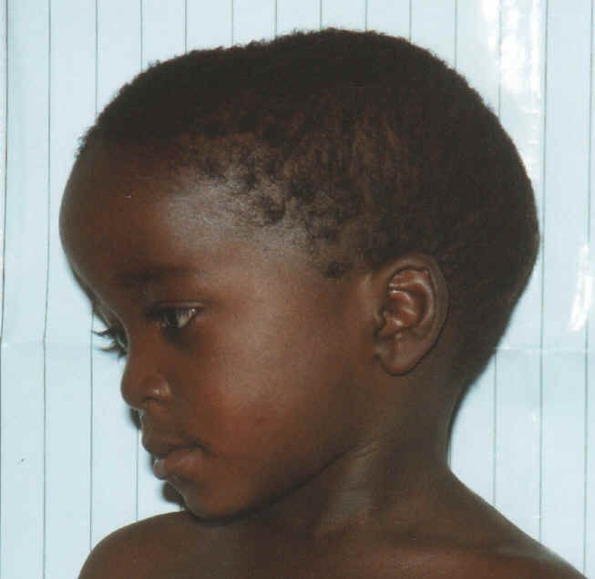

Grunting: A grunt is a short, deep animal-like sound, that is a sign of respiratory distress (until proven otherwise).

Oedema: Observe for edema of the foot, ankles and legs, arms, hands and face. Press firmly with your thumb for at least 2 seconds on the different extremities. If it leaves an indentation there is pitting edema.

Percussion: Place your non-dominant middle and index fingers directly onto the patient’s skin, with your distal interphalangeal joints held firmly against the patient’s chest. Using your dominant middle finger, tap the middle finger of your non-dominant hand (firmly placed on the patient’s chest) at the level of the distal interphalangeal joint. This is best performed by a quick flick of the wrist to achieve a solid strike on the finger. Tap 2-3 times in a row. Repeat on all areas of the chest. Dull percussive sounds are indicative of abnormal lung density, likely indicating: atelectasis, pleural effusion or pneumonia.

Posture: Decorticate posture is an abnormal posturing in which a person is stiff with bent arms, clenched fists, and legs held out straight. The arms are bent in toward the body and the wrists and fingers are bent and held on the chest. Decerebrate posture is an abnormal body posture that involves the arms and legs being held straight out, the toes being pointed downward, and the head and neck being arched backward. The muscles are tightened and held rigidly.
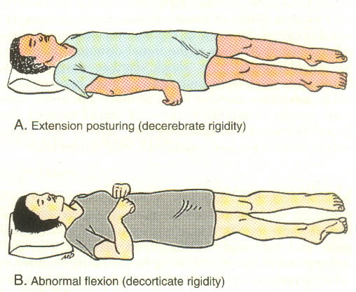

Rachitic rosary: The prominent knobs of bone at the costochondral joints of rickets patients are known as a rachitic rosary or beading of the ribs. The knobs create the appearance of large beads under the skin of the rib cage. Lift the arms upwards while child is lying down to observe this. This can also be documented on a chest-X-Ray
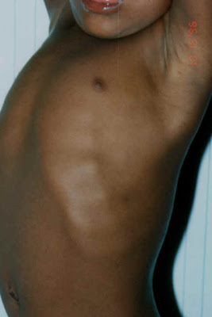

Respiratory rate: Make sure the child has been sitting or lying down for at least 2 minutes before taking the measurement. Count how many times their chest rises in 1 full minute.

SaO2: Make sure the child has been sitting or lying down for at least 2 minutes before taking the measurement. A measurement can be taken using a finger or a toe. Ideally the finger/toe is below the heart. Ensure the the probe is well positioned on the finger. The finger fits well and the probe is not too tight (which would constrict the circulation) or too loose (may fall off or let other light in). Once a reading is provided by the machine, document the heart rate that is measured and compare to a manually obtained heart rate. This should be similar, i.e., less than 20 beats per minute difference, otherwise the reading is not accurate. If no accurate reading can be obtained, warm the hands/feet with a blanket for example and try again. You can try different fingers/toes. Record whether the child was on room air or receiving oxygen at the time of the measurement.

Skin pinch: Ensure the child is flat on his back with his arms at his sides (not over his head) and his legs straight. Or, ask the mother to hold the child so he is lying flat on her lap. Use thumb and first finger to locate the area on the child’s abdomen halfway between the umbilicus and the side of the abdomen. Do not use your fingertips because this will cause pain. The fold of the skin should be in a line up and down the child’s body. Pick up all the layers of skin and the tissue underneath them. Hold the pinch for one second and release it. Look to see if the skin pinch goes back
• Very slowly (more than 2 seconds),
• slowly, (less than 2 seconds, but not immediately), or
• Immediately.
If the skin stays up for even a brief time after you release it, decide that the skin pinch goes back slowly.

Tone (muscle): Hypertonia is resistance to passive movement; it is not dependent on velocity. Hypotonia is a state of low muscle tone (reduced resistance to passive movement in a muscle), often involving reduced muscle strength. First, the muscle contracture at rest is assessed by manual palpation of the muscle in testing. Second, the limb is moved slowly through its passive range and later at various speeds or velocity and catch or the resistance to passive motion is assessed. Assessing tone of the upper extremities begins with passive range of motion. This is done by rotating each extremity at the shoulder, elbow and wrist and feeling the resistance and the range of movement. Too little or too much resistance reflects hypotonia or hypertonia. To assess head leg as a sign of hypotonicity, the baby is pulled by the arms to the sitting position. The head and the arms are observed during the manoeuvre. The arms should remain partially flexed at the elbow and the head may lag behind the trunk, but should not be fully flexed backwards.
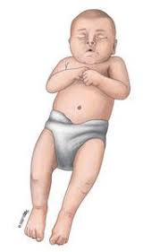
Figure: hypotonic (left) and hypertonic (right) infant

Wheezing: Wheezing is a high-pitched whistling sound made while breathing which can be identified using a stethoscope. It's often associated with difficulty breathing. Wheezing may occur during breathing out (expiration) or breathing in (inspiration).

- REFERENCES
  - PB-SAM Study Protocol
  - Basic Paediatrics Protocols, 2013 Edition (Kenya)
  - Hospital Care for children 2013

- DOCUMENT CHANGE HISTORY

Version 1 | Author | Approved by | Signature | Date
1.01 | Robert Bandsma/Isaiah Njago | Wieger Voskuijl |  | 04-02-2021

SOP AWARENESS LOG
I, the undersigned below, hereby confirm that I am aware that the accompanying SOP is in existence from the date stated herein and that I shall keep abreast with the current and subsequent SSP versions in fulfilment of Good Clinical Practice (GCP).

Number | Name | Signature | Date (dd/mmm/yyyy)
1.
2.
3.
4.
5.
6.
7.
8.
9.
10.
11.
12.
13.
14.
15.
16.

