SOP title CHAIN Issue Escalation SOP

Version 1.0

Date issued 24-02-2021

Next Review 24-02-2022

- Purpose
The purpose of this standard operating procedure (SOP) is to ensure that unresolvable issues in the data management environment are escalated as necessary and final outcome documented accordingly.

- Scope
This SOP describes the procedure for those issues raised as queries, bugs, feature enhancements or detected anomalies that cannot be sufficiently resolved without decisions from the CHAIN Leadership or overall Study PI.

- Abbreviations/Definitions
- Change – Any desired outcome expected to happen to an existing item.
- Issue – Anything causing undesired consequences. Issues can be categorized as: -
  - Data Query – An anomaly detected on the data either through routine checks or during an analysis.
  - Bug – An anomaly on a computer system causing it to malfunction on the affected functionality.
  - Feature request – A desired addition/enhancement that would improve the functionality of a part of a system.
- Data Management Environment - ALEA, KIDMS, & Reports Dashboard systems.
- UAT – User Acceptance Testing – A form of software feature testing that is geared to fit for purpose of the feature under testing.
- Production or production environment – The version of the system being used for real work/data entry.
- Type of Issues for escalation
This SOP specifically addresses issues that should not be handled as trivial or ignored because a
simple solution is not available. The following list provides a guideline on these issues: -
- Broken functionality on a system that is needed to be fixed but there are no immediate resources/solution to providing a solution.
- A data query on a historical event that is later found to be correct after database was locked for example. Unfixed queries that cannot be changed in the database.
- Requested variables/features that are not part of an approved data tool. Further discussions needed to elicit how to accommodate the request.
- Anything else that cannot be resolved by established mechanisms.

- Responsibility
The following is the responsibility matrix for issue escalations within the study.
Role | Responsibility | Scope
Site Staff (field, data entry, lab or clinical) | Identify and raise issues (data query, bugs, feature enhancements) to site data manager.  Receive data queries from site data manager or co-ordination data managers and work on their resolution. | Site
Site Data Manager | Compile list of issues from site staff and send to Network Data Management coordinators.  Informs site co-ordinator and or site PI on status of issues.  First point of escalation of issue from site. | Site
Co-ordination Data Manager | Receive and updates status of issues and resolve them if they should be resolved at co-ordination level.  Escalates issues to other network coordinators.  Specifically escalates to Data Co-ordination lead issues that require onward escalation.  For ALEA, advance bugs/feature requests to development team. | Network
Network Co-ordinators (Clinical, Lab, Communication, etc) | Provide subject matter expertise advice and direction on escalated issues management. | Network
Co-ordination Data Lead | Receive escalated issues from Co-ordination Data Managers and Site Data Managers.  Liaise with the appropriate team (IT, Lab, Clinical) to resolve issues.  Escalates unresolvable issues to CHAIN Leadership. | Network

- Procedure
  - Workflow
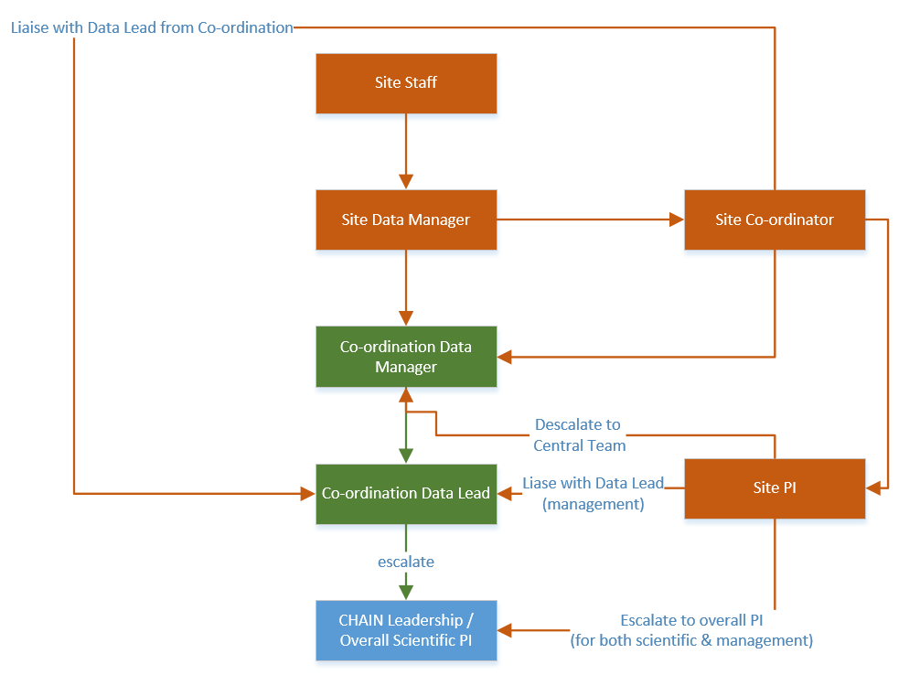
Fig 1: Showing Issue escalation workflow

  - Steps
- Site staff identify the need for a change on a part of a system on the data management environment or a query on the data itself. They raise this issue to their site data manager.
- Site data manager tries to resolve the issue using local resources.
  - Site data manager discusses the issue with the staff to see if the matter can be resolved locally. If not, he/she takes note (on OrangeScrum) and forwards it to the Co-ordination Data Manager.
  - Site data manager updates site co-ordinator and or site PI of the status of issues raised from the site. Highlights any escalated issues waiting for response.
  - Site data manager follows up with co-ordination data manager for resolution of issues. Conducts User Acceptance Testing (UAT) and participates in approving changes (especially those raised by them). Participates in closing any open OrangeScrum queries.
  - Site data manager receives updates (on completion of changes at production) from central coordination team and communicates to site staff.
  - Site data manager and site coordinator co-ordinates any training required to effectively implement the change. Updates site PI of the changes made.
- In the event issue is not resolved at step 2. Co-ordination data manager does the following: -
  - Logs query on data management team project on Orangescrum.
  - Participates in discussion of the same with Co-ordination data lead and other co-ordinators involved.
  - If Co-ordination data lead resolves the query, or query is resolved at co-ordination level, then, Co-ordination data manager corresponds feedback to site data manager. Closes any open Orangescrum task.
  - If not resolvable at this stage, Co-ordination data lead escalates the issue to Chain Leadership and Overall scientific PI.
- If issue is not resolved at stage 3, then co-ordination data lead does the following: -
  - Tables the issue as an agenda in the next Analysis Team meeting for CHAIN Leadership and Overall PI discussion.
  - May also opt to individually send an email around to overall study PI and discuss with him together with Study Co-ordinators and PI’s.
  - Communicates back feedback to Co-ordination data manager, site data manager and all users involved in the issue.
  - Updates documentation and documents final resolutions.
- Site PI and Site Co-ordinators may choose to discuss the issue directly with Overall study PI and inform co-ordination team of any progress made. This option may be utilized for site specific issues that require local solutions with the help of the overall study PI or CHAIN leadership.

- References
  - CHAIN PB-SAM_data-query-resolution-SOP-1.0

- Document history

Version 1 | Author | Approved by | Dated | SOP No:
1.0 | Narshion Ngao | Robert Bandsma | 24-02-2021

- Site training record
All sites are required to maintain a master copy of this SOP that documents the site staff that have been trained on this SOP.
Document History
Version No. | Trained staff initials | Signature of trained staff | Date | Trainer’s Initials
1.01 | KDT | Example row | 1st Jan 2016 | DM

SOP AWARENESS LOG
I, the undersigned below, hereby confirm that I am aware that the accompanying SOP is in existence from the date stated herein and that I shall keep abreast with the current and subsequent SOP versions in fulfilment of Good Clinical Practice (GCP).

Number | Name | Signature | Date (dd/mmm/yyyy)
1.
2.
3.
4.
5.
6.
7.
8.
9.
10.
11.
12.
13.
14.
15.
16.

