1.0 Purpose

The purpose of this document is to outline the data management procedures at the site(s) and the related responsibilities for the PB SAM study.

1. Study Objectives & Design

The objective of this study is to determine whether treating ill severely malnourished children with pancreatic enzymes or bile acids improves mortality. We will conduct a double blind, randomized clinical trial in a 2x2 factorial design in hospitalized severely malnourished children. We will treat participants with paediatric formulations of pancreatic enzymes, bile acids, both or placebo for 21 days. Participants will be followed up daily during their hospital stay and on day 21 and 60 after enrolment.

1. **Study sites**

Participating sites are:

1. Kilifi County Hospital, Kenya;
2. Coast General Hospital, Mombasa, Kenya;
3. Mbagathi Sub-County Hospital, Nairobi, Kenya;
4. Migori County Hospital and Ombo Mission Hospital, Migori, Kenya;
5. Queen Elizabeth Central Hospital (QECH) Blantyre, Malawi;
6. The International Centre for Diarrhoeal Disease Research Hospital, Dhaka, Bangladesh (ICCDR-B); and
7. Mulago National Referral Hospital, Kampala, Uganda.
8. Responsibilities

The roles and responsibilities in relation to data management are outlined in table below. The Data Manager is responsible for all day to day data management processes. The Senior Data Manager has oversight of the data management processes. The Data manager is the first line of contact and will ensure tasks are carried out appropriately, and in consultation with the Senior Data Manager where necessary. The Data Manager will liaise with the Study Statistician to ensure routine reports are produced within the required timelines, providing data as required.

Roles and Responsibilities for Data management

|  |  |
| --- | --- |
| **Personnel Responsible** | **Role** |
| Site Clinical Staff | Perform quality control peer review of paper CRFs between the clerking staff and a second clinician at the site. The second clinician checks for consistency and lack of errors & omissions before confirming the paper CRF as ready for data entry. |
| Site Data Manager | Data entry, checking and uploading data using [ALEA] and KIDMS databases. |
| Co-ordination Data Supervisor | Monitoring of query resolution and maintenance of study documents at coordination centre. First point of contact at the central coordination on data entry and queries support. |
| Co-ordination Data Manager | Both Laboratory and Clinical data managers for daily monitoring of data quality through generation of data queries, data extraction, and preparation of data for interim reporting. Responsible for cleaning activities with sites and implementing data quality checks/criteria at the central co-ordination team through the use of dashboards. |
| Study Statistician | Analysis of primary and secondary outcomes |
| Co-ordination Data Lead | Data and systems overall co-ordination. Service level agreements with suppliers and ensuring availability of systems for data management hosted by the central co-ordination team. Responsible for all data cleaning, querying and resolution activities.  Receives escalated queries from co-ordination data supervisor/data manager for onward discussion with Principal Investigator. |
| Principal Investigator | Overall quality of study data and for ensuring that all applicable staff members follow these DMP. |

1. Data Processes

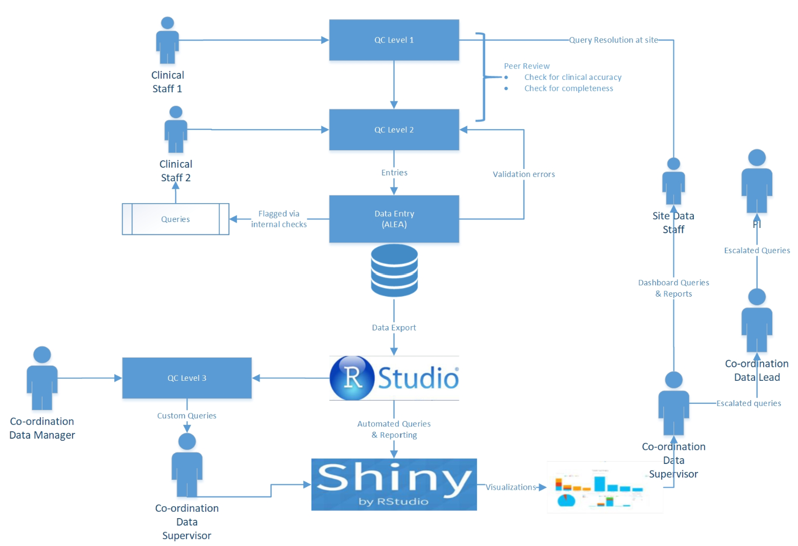

Figure. Data flow in PB SAM Study

* 1. Data Collection

The PB SAM study will adopt a data management approach of paper-based data collection and remote data entry into the study central database. Data collection will be done by completing the paper Case Report Forms (pCRFs) at each site by the site investigator/clinician. The pCRFs will be entered into the Central Data Management System (CDMS) at the site using electronic Case Report Forms (eCRFs) via remote data entry by the data entry clerks/ field workers.

* 1. **Data collection instruments**

Data will be collected on paper Case Report Forms. The table below highlights the crf names.

|  |  |  |  |
| --- | --- | --- | --- |
| CRF name | Time to fill | Who fills | Comments |
| PB-SAM Enrolment | During recruitment | Site clinician/field workers | Participant meta data, to be collected together with sample request form for samples collected at enrolment. |
| PB-SAM SAE | Whenever there is a serious adverse event. See protocol for guidance | Site clinician | Details of the SAE and any actions taken |
| PB-SAM Toxicity | Whenever there is a toxicity event. | Site clinician | Details of the toxicity claim/report |
| PB-SAM Daily Record | Once every day for the period of hospitalization | Site clinician/field worker |  |
| PB-SAM Discharge | During discharge event | Site clinician/field worker |  |
| PB-SAM D21 Follow up | During D21 follow up event | Site clinician/field worker |  |
| PB-SAM D60 Follow up | During D60 follow up event | Site clinician/field worker |  |
| PB-SAM Conclusion | When study exit has been triggered either through: death, withdrawal, study completion or lost to follow up after expiration of follow up period | Site clinician/field worker |  |
|  |  |  |  |

* 1. Accessing Database online

The link to the online database will be: https://acc.tenalea.net/cirua/DM/

Only authorized persons will be granted access to the right site/data area.

* 1. **Data Entry Procedures**

Data entry will be done at each site. Once the data entry to the eCRF is completed, the respective form should be marked as “Complete” by selecting “Complete” from the form status variable. Data entry should be done after each study event.

Data entry should be done **within 24hrs** of collection. Any backlogs will be monitored and sent to the site as queries.

* 1. **Study activity flowchart**



1. Quality Management
   1. QC of pCRFs at site

At site, the study clinician will review the pCRFs checking for missed items, inconsistencies, outliers or other errors. Following the QC process on a pCRF, if any additional errors are identified during the data entry process or later, the appropriate staffs who identify these errors will flag the error with a coloured tab. These errors will be corrected by the person who made the original entry by striking across the original entry, entering the correct information followed by her/his initials and current date.

* 1. Central QC of eCRFS

The quality of data will be checked at each of the participating sites, using appropriately chosen tools. Inbuilt data validation checks will be used for screening quality of data entry. Additional validation checks will be performed from the central data repository using data quality modules and routine data checks on data extracted using R statistical software.

1. Query Handling
   1. Sending/Receiving queries

* All Queries will be generated by the Co-ordination Data Manager (Clinical and Lab) using R scripts and visualised in a shiny Dashboard.
* The queries on the dashboard will be posted in a Task Management Tool (Orange scrum) by Co-ordination Data Supervisor for sites to resolve.
* Sites will review and resolve all query on a weekly basis. Any concerns the Co-ordination Data Manager may have with the efficiency of this process will be noted and discussed at the Data Managersweekly meetings.
  1. Handling query responses
* The respective site data managers will resolve all the discrepancies/queries raised in the Orangescrum platform.
* All query resolution will be tracked and monitored and action taken within **five working days**.

1. Reporting
   1. **Regular Reports**

Reports will be automatically generated on the shiny dashboard. Accessing the dashboard is through the following link: <http://reports.chainnetwork.org>***.***

A screenshot of a cell phone

Description generated with very high confidence

* 1. Reporting Tools

|  |  |
| --- | --- |
| ALEA API | To connect to the ALEA database for automatic extraction |
| Rmysql | For direct connection to Mysql database in the case of non-redcap implementations |
| R/Rstudio | Writing business rules and reports |
| Shiny server | Putting together the output in a web |
| Apache | Hosting the webapp through proxy server (adding a layer of security |

1. Data Cleaning

The Data cleaning team will extract data from database from in select domains. Interim data extractions will be undertaken on monthlybasis or as required by investigators. The table below highlights the data cleaning activities conducted on every extraction.

Post Queries

The interim and final analyses will be performed by the Study Statistician assigned using STATA and R software. Database lock will be agreed in advance with the Study Analysis Group to ensure this is done when data entry and query resolution is as complete as possible. Password protected copies of all CSV files will be stored electronically within the curation folders.

1. Communication procedure

|  |  |
| --- | --- |
| Queries | These will be communicated via Orangescrum and Shiny Dashboard. |
| Skyping | One on One calls between Site Data managers and Central team will be made via skype/Zoom to discuss any challenges or feedback. |
| Emails | Emailing list for all site data managers will be available for quick communication on urgent information. |
| Weekly meetings | Weekly meetings for all site data managers will be done to give weekly updates, feedback and discuss challenges. |
| TGHN Platform | All updated CRFs, SOPS will be centrally available on the TGHN platform. <https://chain.tghn.org/chain_pb_sam/pb-sam-clinical-crfs/> |
| Reports to Leadership | Reports will be communicated via dashboard and also through Data analysis calls |

1. Database Closure/Lock

The study database will be locked before the final analysis. All data will be cleaned prior to database lock and queries resolved where possible. Any un-resolvable queries will be closed as ‘closed-unresolved/unobtainable’.

1. **Data Backup and Recovery Procedures**

The KWTRP have implemented a database replication, which keeps a real-time copy of the main database on a remote/slave server. With this in place, if something happens to the primary database, it will be much easier to get the database back up and running with current information.

The fail-over/slave server will be maintained for restoration of the clinical system in the event of a disaster that destroys the primary database server. The server will immediately take over normal data query operations. There is very minimal data loss, with this setup in place, as up to the last 5 minutes of data can be recovered.

1. Data Storage and Archiving

The study database will be archived on the Kemri-wellcome Trust servers according to the unit ICT policies after database lock***.*** Guidance will be provided on the correct procedures to undertake to be able to access the archived data.

After study conclusion, the binders will be transported to the central storage facility (CTF in Kenya). Other participating sites will store and archive their source document according to participating institutions laid out clinical study data storage and archiving policies. Copies of all completed eCRFs/CRFs and source documents will be archived for a minimum of 5 years following completion of the Study. The Documents should be stored in such a way that they are complete, accurate and remain legible. Any alterations made should be traceable.

CRFs and source documents should be archived in an appropriate locked room, cupboard or filing cabinet with adequate fire protection (sprinkler systems), protection from water, humid conditions and pests. The room, cupboard or filing cabinet should have secure access by authorised personnel only.

**14.0 Document history**

|  |  |  |  |
| --- | --- | --- | --- |
| Version | Author | Approved by | Dated |
| 1.02 PB SAM Data Management SOP | Narshion Ngao | Robert Bandsma | 15-02-2021 |
|  |  |  |  |
|  |  |  |  |

**15.0 Site training record**

All sites are required to maintain a master copy of this SOP that documents the site staff that have been trained on this SOP.

|  |  |  |  |  |
| --- | --- | --- | --- | --- |
| Document History | | | | |
| Version No. | Trained staff initials | Signature of trained staff | Date | Trainer’s Initials |
| 1.01 | KDT | Example row | 1st Nov 2020 | DM |
|  |  |  |  |  |
|  |  |  |  |  |
|  |  |  |  |  |
|  |  |  |  |  |
|  |  |  |  |  |
|  |  |  |  |  |
|  |  |  |  |  |
|  |  |  |  |  |
|  |  |  |  |  |
|  |  |  |  |  |
|  |  |  |  |  |
|  |  |  |  |  |
|  |  |  |  |  |
|  |  |  |  |  |
|  |  |  |  |  |
|  |  |  |  |  |

**SOP AWARENESS LOG**

I, the undersigned below, hereby confirm that I am aware that the accompanying SOP is in existence from the date stated herein and that I shall keep abreast with the current and subsequent SOP versions in fulfilment of Good Clinical Practice (GCP).

|  |  |  |  |
| --- | --- | --- | --- |
| Number | Name | Signature | Date (dd/mmm/yyyy) |
| 1. |  |  |  |
| 2. |  |  |  |
| 3. |  |  |  |
| 4. |  |  |  |
| 5. |  |  |  |
| 6. |  |  |  |
| 7. |  |  |  |
| 8. |  |  |  |
| 9. |  |  |  |
| 10. |  |  |  |
| 11. |  |  |  |
| 12. |  |  |  |
| 13. |  |  |  |
| 14. |  |  |  |
| 15. |  |  |  |
| 16. |  |  |  |