- Purpose
The purpose of this standard operating procedure (SOP) is to ensure that data are accurately recorded on the PB SAM study’s electronic Case Report Forms (eCRFs) and managed according to the PB SAM study’s protocol, European Union data protection laws, ICH GCP and FDA 21 CRF Part 11.

- Scope
This SOP describes the procedures for the PB SAM study data entry and checking. Information on dealing with data queries is given in the PB SAM Data Query v2.0 SOP.

- Responsibility
Clinical study staff will be responsible for ensuring the required data are collected from source documents and accurately recorded and checked on the Clinical database. Clinical study staff are responsible for ensuring that data are handled and processed in alignment with data protection regulations.

- Personal Identifiable Information
  - All personal identifiable information collected on the PB SAM study subjects will be treated as confidential information, and should be handled in accordance with the terms of the European Union data protection laws.
  - Anyone processing personal data must comply with the seven principles (Rouse, 2008):
- Notice: Subjects should be given notice when their data are being collected.
- Purpose: data collected should be used only for stated purpose(s) and not for any other purposes.
- Consent: personal data should not be disclosed without consent from its subject(s).
- Security: the collected, personal data should be kept safe and secure from potential abuse, theft, or loss.
- Disclosure: subjects should be informed of the party or parties collecting their data.
- Access: subjects should be allowed to access their personal data and allowed to correct any inaccuracies.
- Accountability: subjects should be able to hold data collectors accountable for not following the seven principles.

- Patient Identification Number (PIN)
  - Each country has a unique number:
e.g. Country 10 = Kenya

  - All patients (eligible only) will be allocated a unique patient identification number (PIN) on the Clinical database. The identification number will consist of 5 digits; the first 2 digits correspond to the country number and the last 3 digits are the sequential patient number e.g. 10-001 is for the first patient in Kenya.
  - The PIN will be in the same format for enrolled patients regardless of their cohort.
  - For non-enrolled (ineligible) patients, each site will maintain their screening log offline, however, all sites will use the same format of the screening log for standardization.
  - The PIN should be recorded on the Screening and Enrolment Log and used in all correspondence; names should not be used in any data transmissions or correspondence.

- Data entry, checking and uploading using Clinical database
  - Clinical database set up
    - With the exception of the lab eCRF which go to KIDMS, all data for the PB SAM study are to be entered onto the Clinical database found at this link: https://acc.tenalea.net/cirua/DM/
    - Only users assigned a data entry role can enter and change data values in the Clinical database.
    - The electronic Case Record Form (eCRF) for each patient consists of a patient dossier page with a listing on the left sidebar of all the forms to be filled. Some forms have a plus (+) on it to show that multiple instances of the form can be collected (e.g. daily reviews) for repeating instruments.
  - Accessing Clinical database
    - User profile permissions must be granted by the Central Data Team to be able to gain access to the clinical database. Each user will have a unique username and password to enter the database. All passwords must be stored in a secure place and never shared with anyone else. Should you forget your password or enter it incorrectly and lock yourself out of the database, please email – chainsupport@kemri-wellcome.org to reset your password.
  - Creating new subjects on the Clinical database
    - All new patients must be entered on the clinical database. To do this:
- Login to clinical database using your username and password credentials.
- Select PB SAM Study from the list of projects under “All” study listing.
- Then click on “Patients” tab and finally click on “Add new patient” button.
- Select clinician name or search name of the clinician (who did data collection) from the search input field.
- Select and enter patient initials in the registration form. Click on Submit to complete creating the new subject dossier.
    - Appendix 1: Study subjects list.
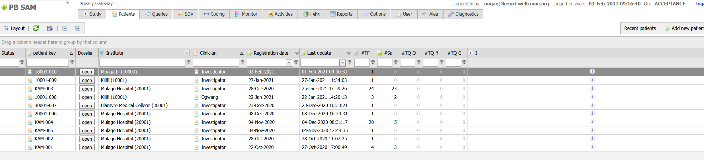
Figure 1: study subjects list
Appendix 2: Subject/Patient Dossier page, showing all forms to be entered listed on the left pane. Notice that some of the sections have been collapsed for easy navigation.
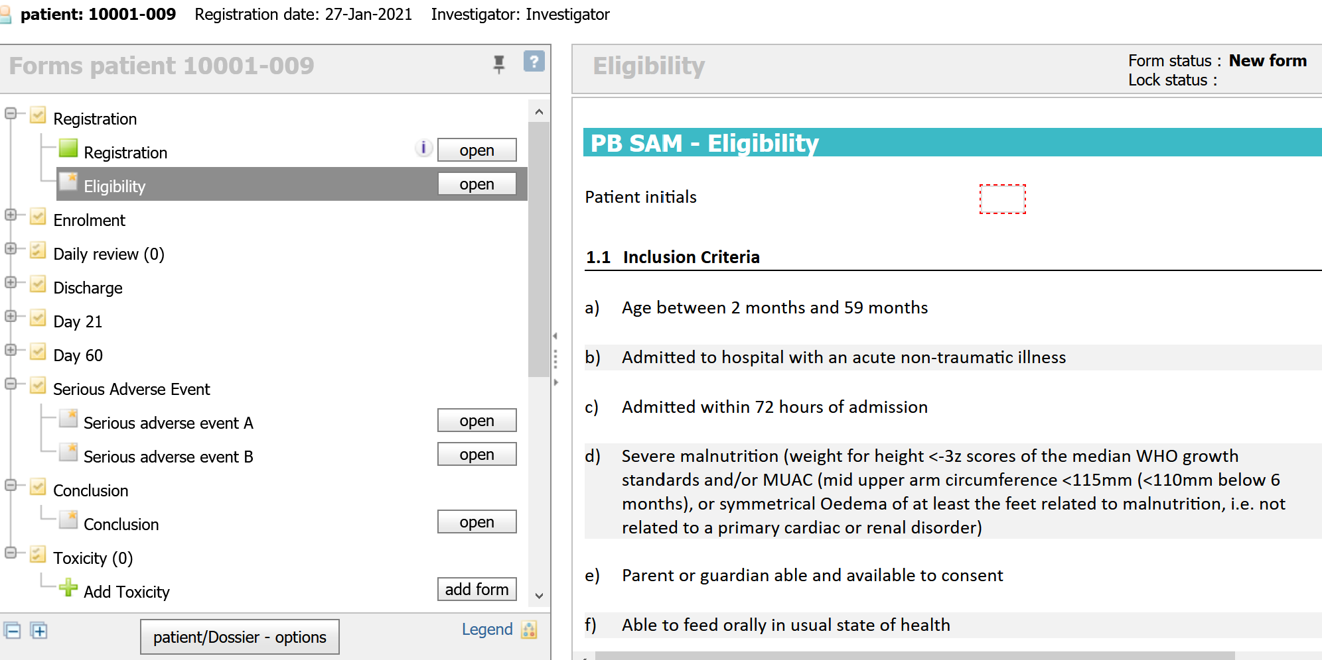
Figure 2: Patient dossier page

  - Entering data on eCRFs
    - All data entry must be done using the Clinical database. To do this:
- Click on “Add New Patient” button on the top right of the patients page. If editing an existing record, select the record ID from the existing list.
- Enter data as per original source document by selecting the form on the left pane and then entering data on the form details for the current form you are entering.
- Upon completing the data entry, click on Save button below the form to save the current form status and Submit button to finally submit the data as complete.
- Navigate to the next form by selecting it on the left pane.

  - Checking data entry errors
    - Before data is entered in the database, all CRFs for the subjects should be reviewed by a second clinician. Both first and second clinicians must acknowledge the forms are ready for entering into the database by appending their name on the form as “Data Collected By” and “Data Reviewed By” respectively.
    - During data entry, check on the audit trail and discrepancies panel (on the right of the screen) for any errors thrown and work on them.
- Resolvable errors may be resolved by first changing the values on the paper CRF by the data collector upon verifying the correct information from the subject/patient and then signing off changes according to GCP.
- Unresolvable errors may be left on the form as is with the discrepant highlighted in red. Do not change the values to suppress any errors without being consistent with the paper CRF entries.
    - After data entry, a reviewer (second data clerk) should review the entered eCRFs and confirm consistency with paper CRF entries. Where errors are found, they can be resolved to align the electronic record with the paper CRF.
    - Verifying data entry accuracy
    - Open the CRF onto the PB SAM Study database and select the form you want to verify.
    - Visually audit the on-screen data, referring to the original source document.
    - If data are inaccurate, inform the data entry staff for amendments to be made.
    - Save the eCRF(s).
    - Verification of data should be done on each incoming patient CRF.

    - Raising manual data queries
Manual queries can be raised on the following items: -
- On a specific field on the form of a patient.
- On a form level
- On the patient level.
- Raising a query on a field of a form
  - Select the field on the form where you want to raise a manual query.
  - On the right pane, click on Queries and then click on the plus sign (+) to add a new query.
  - Enter the query priority, subject and text.
  - Click on Ok to log the query.
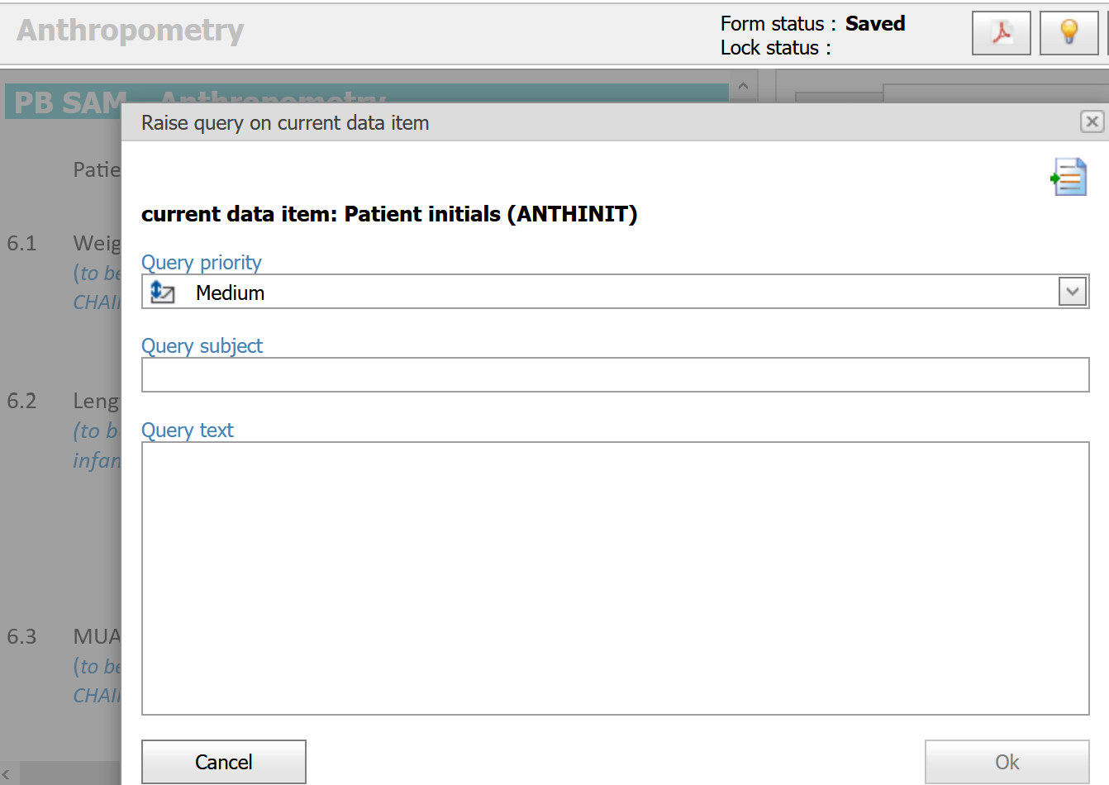
Figure 3: Raising manual queries.
    - Opening data queries during data entry
- From the patients list, under patients tab, check the column #TQ-O for open queries on the patient forms.
- Open the patient dossier and on the forms panel, you will see the forms with queries flagged with a red “i”.
- Open the form and navigate to the fields with red borders.
- Resolve, and submit the forms for further error checking and saving.

  - Timely Data Entry
    - It is a policy to ensure that data is entered within 24hrs of collection. Ensure:
- Site data are always backed up.
- New study definitions, new reports, updated users/passwords/roles, new discrepancies and any new system updates are available to users.
- New or modified patient data and new or modified discrepancies are available to online users so that central monitoring activities can be completed.

  - Data Entry Rules and Instructions
The following rules must be adhered to when entering data:
    - Abbreviated text or summaries
No abbreviations or summaries of text data will be permitted, and any ambiguous abbreviations/wording provided by site will be queried.

    - Entering lab values
Laboratory values given as < on laboratory results printout forms will be entered as number e.g. 0 or a negative number on the database.

    - If a patient has mistakenly been entered twice
It is not possible to delete a patient from clinical database, the best option if the patient has been entered twice is to "re-use" the duplicate patient record by overwriting the fields with new data (recording ‘Data entry error’ as the reason for change).
When this is not possible the PB SAM study’s Central Data Manager should be informed. The Central and Site Data Managers will then resolve and document the procedures to be followed to allow for these changes.

    - Entering partial dates
This functionality is currently not supported. Most questions that deal with dates e.g. date of birth of a participant will ask whether the data captured is the “True date” or “Estimated”.

    - De-selecting radio buttons
Click on the Clear answer link below the options for the question.
Example:
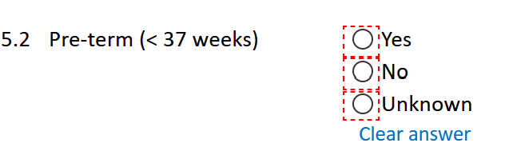

    - Mistakenly opening eCRFs which do not require data entry
It is not possible to delete erroneous eCRFs from the PB SAM study database. If you open an eCRF which does not require data entry, do not save the form and select the close form to close the form, or select close patient dossier to close the entire patient CRF.
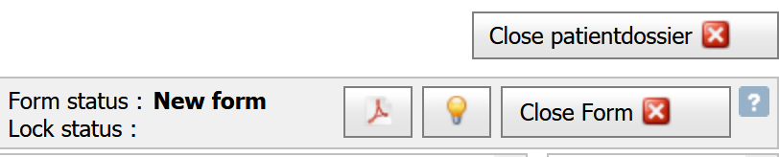

    - Incomplete eCRFs and data fields
- Incomplete form – appears with a half green box on the forms panel
- Complete form – appears with a full green box on the forms panel
- Pending form – appears with a grey box on the forms panel
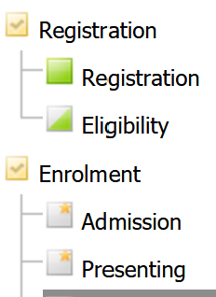
    - Entering eCRFs for ineligible patients
Information for ineligible, including non-consenting, patients WILL NOT be entered in the database, as stated in the protocol.
    - Overruling database warnings
Clinical database does not prevent acquisition of data that is out of range. It provides warning messages regarding out-of-range values but these can be overridden.

All database warnings may be over ruled if deemed necessary. To overrule any database warning, just ignore it and go ahead and save the form.

    - Protocol Deviations
It is important to remember that overruling database warnings or setting data to unobtainable values may result in a protocol deviation.
If warnings are overruled or data are unobtainable, please be sure to check the relevant SOPs, protocol and if necessary complete the Protocol Deviation and Violation log and report findings to the clinical study co-ordinator. This is required in addition to recording the reason for overruling the warning on Clinical database.

  - Online access to Clinical database
The online version of the database can be accessed using the following link https://acc.tenalea.net/cirua/DM/

  - Suggestions for database modifications
Should you note that an additional database modification is required. For example, a daily medication is not listed on the drop down menu and you would like it to be added. Please notify the PB SAM Study Central Data Manager and, if appropriate, a request will be launched with the database administrator to complete the modification.

- Document history
Version | Author | Approved by | Signature | Dated
CHAIN data entry SOP v1.02 | Narshion Ngao | Robert bandsma |  | 15-02-2021

- References
- Rouse, M (2008) EU Data Protection Directive (Directive 95/46/EC) [Online] Available from: http://techtarget.com/definition/EU-Data-Protection-Directive [Accessed: 31st August 2016].
- PB SAM Data Query SOP V1.0
- PB SAM Data and Safety Monitoring Plan SOP V1.0
- PB SAM Database Delegation Log V1.0

SOP AWARENESS LOG
I, the undersigned below, hereby confirm that I am aware that the accompanying SOP is in existence from the date stated herein and that I shall keep abreast with the current and subsequent SOP versions in fulfilment of Good Clinical Practice (GCP).

Number | Name | Signature | Date (dd/mmm/yyyy)
1.
2.
3.
4.
5.
6.
7.
8.
9.
10.
11.
12.
13.
14.
15.
16.

