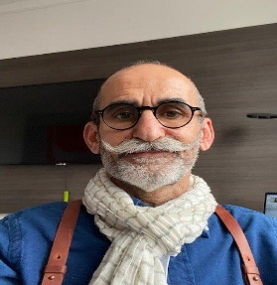
Dr Fadi Meroueh (M) is the CHUM PI of the project and is currently a Hospital Practitioner and Head of the Health Unit of the Villeneuve-les-Maguelone prison, which is a part of Montpellier’s University Hospital. Healthcare ethics: Over his 23 years of experience in healthcare in prison, he witnessed major reforms of the legal framework of detained person’s healthcare. Addictions and Hepatitis C: The eradication of Hepatitis C within the prison of Villeneuve-les-Maguelone is a major achievement and the first of its kind in Europe and North America. Continuity of care: Preparation for release is also one of the biggest issues. Most patients find themselves without social security rights and without housing upon release. In order to ensure a continuity of care between prison and the outside, Dr. Meroueh also have a weekly activity in an associative addiction center called “Arc-en-Ciel” in Montpellier. He holds there visiting hours dedicated to the management of Hepatitis C for PWID. He also is an expert consultant for various French and European organizations.

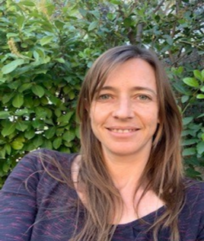
Sylvie Broussous, PhD (F) is the group leader of the European unit at the Department of Research and Innovation at CHUM. This team comprises 2 project managers and 2 assistant project managers who currently carries out management and financial follow up of 22 EU-funded research projects including 1 project in coordination. She has 7 years of experience in the field of clinical research within national and European projects at CHUM. She holds a PhD degree in Medicinal Chemistry and has worked as a researcher for 7 years.

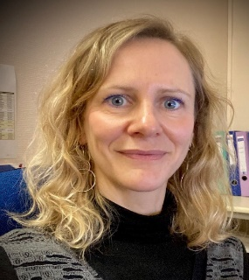
Eva Murauer, PhD (F) works as a project manager of European research projects at the Department for Research and Innovation at CHUM since almost 4 years. In this position, she provides support to set up European research projects and carries out management of currently 8 EU-funded collaborative research projects with regards to all administrative matters including reporting activities, contract negotiations, and regulatory issues. She holds a PhD degree in Molecular Biology and has 13 years of experience in academic research.

Camille Ballester, MD (F) is a General Practitioner at the Health Unit of the Villeneuve-les-Maguelone prison of CHUM since almost three years, where she is responsible for dermatology and chronic diseases. Besides, she has a University Diploma in extra-hospital infection and in addiction.

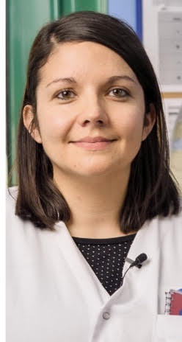
Aurélie Mieuset, MD (F) is a General Practitioner at the Health Unit (HU) of the Villeneuve-les-Maguelone prison of CHUM since four years, where she is responsible for smoking cessation and hepatitis screening. Besides, she has diploma and professional experience in general and tobacco addictology. She has worked at the Health Unit of Nîme’s prison, in an addiction service of CHU and liberal medicine before being practitioner in the CHUM.

