Stakeholder Mapping Tool for Applying Research to Policy and Practice for Health (ARCH)

Authors: Wema Mtika, Helena Wilcox, Nicole Feune De Colombi
09 April 2021 | The Global Health Network
https://doi.org/10.48060/tghn.5

Abstract
This tool contains a step-by-step guide to stakeholder mapping in research uptake. This methodology has been adapted from several methodologies identified in a stakeholder mapping methodology scoping exercise.

Contents
Abstract……………………………………………………………………………………………...2
Purpose of stakeholder mapping………………………………………………………………….4
Part 1: Meaning of Research Uptake……………………………………………………………..4
Part 2: Stakeholder Identification and Snowballing……………………………………………..5
Part 3: Power Interest Matrix………………………………………………………………………5
Part 4: Stakeholder Mapping Output……………………………………………………………...6
References………………………………………………………………………………….............8

Purpose of stakeholder mapping
To build a common understanding on significant stakeholders within the research uptake landscape and who may impact on programme success.
- To categorise stakeholders according to their (potential) role in the landscape and to understand methods of engagement
- To set a plan for engaging with stakeholders throughout the project

Part 1: Meaning of Research Uptake
What does research uptake mean to you?
Our current working definition of research uptake characterises this as the ecosystem in which research findings are transformed into recommendations and taken up into policy and practice, including the systems, people, and processes of research uptake.
This is a working definition, and we warmly invite your perspectives on terminology and definitions.
Comments:

Part 2: Stakeholder Identification and Snowballing
Make a list of stakeholders you know that are involved in research uptake under the categories in the table below (1–8). You may add an extra category(s). Fill in their governance level, interest, and ways in which they interact with research uptake (for example, this could be influencing others, generating knowledge, knowledge brokering). Please be as specific as possible with this exercise.

Part 3: Power Interest Matrix
Using the stakeholder ‘power-interest’ matrix and interpretation (6) below, where would you place the stakeholders, you have listed in 1? Note down the reason why in the table below.
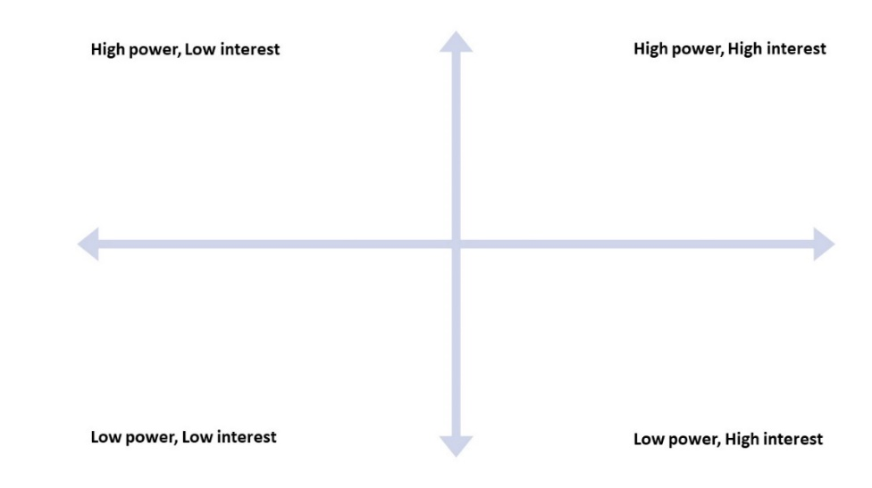

- High power/influence and high interest: these are “key players” and are considered a high priority to be fully engaged in the project
- High power/influence and low interest: these are “context settlers” and should still be kept satisfied, but not to a great extent
- Low power/influence and high interest: these are “subjects” and may point out areas of improvement. They may become influential by collaborating with other influential stakeholders
- Low power/influence and low interest: these are the “crowd”, and there is little need for consideration and engagement. A constant check on their levels of power and interest should constantly be checked nevertheless, in case it changes

Part 4: Stakeholder Mapping Output

Stakeholder group | Stakeholder name/ organisation | Governance level (country/ region/ international) | Key interest (topic/ health area) | Interactions with research uptake | Power-interest level | Why
Researchers
Policy makers
Policy Networks
Healthcare workers
Other stakeholders
Any other comments or observations from the listing

References
1. Petruney T, Harlan S V., Lanham M, Robinson ET. Increasing Support for Contraception as HIV Prevention: Stakeholder Mapping to Identify Influential Individuals and Their Perceptions. Shea BJ, editor. PLoS One [Internet]. 2010 May 24 [cited 2020 Oct 23];5(5):e10781. Available from: https://dx.plos.org/10.1371/journal.pone.0010781
2. Makan A, Fekadu A, Murhar V, Luitel N, Kathree T, Ssebunya J, et al. Stakeholder analysis of the Programme for Improving Mental health carE (PRIME): Baseline findings. Int J Ment Health Syst [Internet]. 2015 Jul 8 [cited 2020 Oct 23];9(1):1–12. Available from: https://link.springer.com/articles/10.1186/s13033-015-0020-z
3. Reed MS, Curzon R. Stakeholder mapping for the governance of biosecurity: a literature review. J Integr Environ Sci [Internet]. 2015 Jan 2 [cited 2020 Oct 16];12(1):15–38. Available from: http://www.tandfonline.com/doi/abs/10.1080/1943815X.2014.975723
4. Slabá M. Stakeholder profile and stakeholder mapping of SMEs. Littera Scr [Internet]. 2016 [cited 2020 Oct 22]; Available from: http://journals.vstecb.cz/category/littera-scripta/9-rocnik/1_2016/
5. Puri S, Fernandez S, Puranik A, Anand D, Gaidhane A, Quazi Syed Z, et al. Policy content and stakeholder network analysis for infant and young child feeding in India. BMC Public Health [Internet]. 2017 Jun 13 [cited 2020 Nov 9];17(S2):461. Available from: http://bmcpublichealth.biomedcentral.com/articles/10.1186/s12889-017-4339-z
6. Ginige K, Amaratunga D, Haigh R. Mapping stakeholders associated with societal challenges: A Methodological Framework. In: Procedia Engineering. Elsevier Ltd; 2018. p. 1195–202.
7. Katz R, Graeden E, Abe K, Attal-Juncqua A, Boyce MR, Eaneff S. Mapping stakeholders and policies in response to deliberate biological events. Heliyon [Internet]. 2018 Dec 1 [cited 2020 Nov 6];4(12):e01091. Available from: /pmc/articles/PMC6310771/?report=abstract
8. Khan SB. Translation of the shortened dental arch research into clinical practice: a stakeholder mapping approach. BDJ Open [Internet]. 2020 Dec 1 [cited 2020 Nov 13];6(1). Available from: /pmc/articles/PMC7387451/?report=abstract

