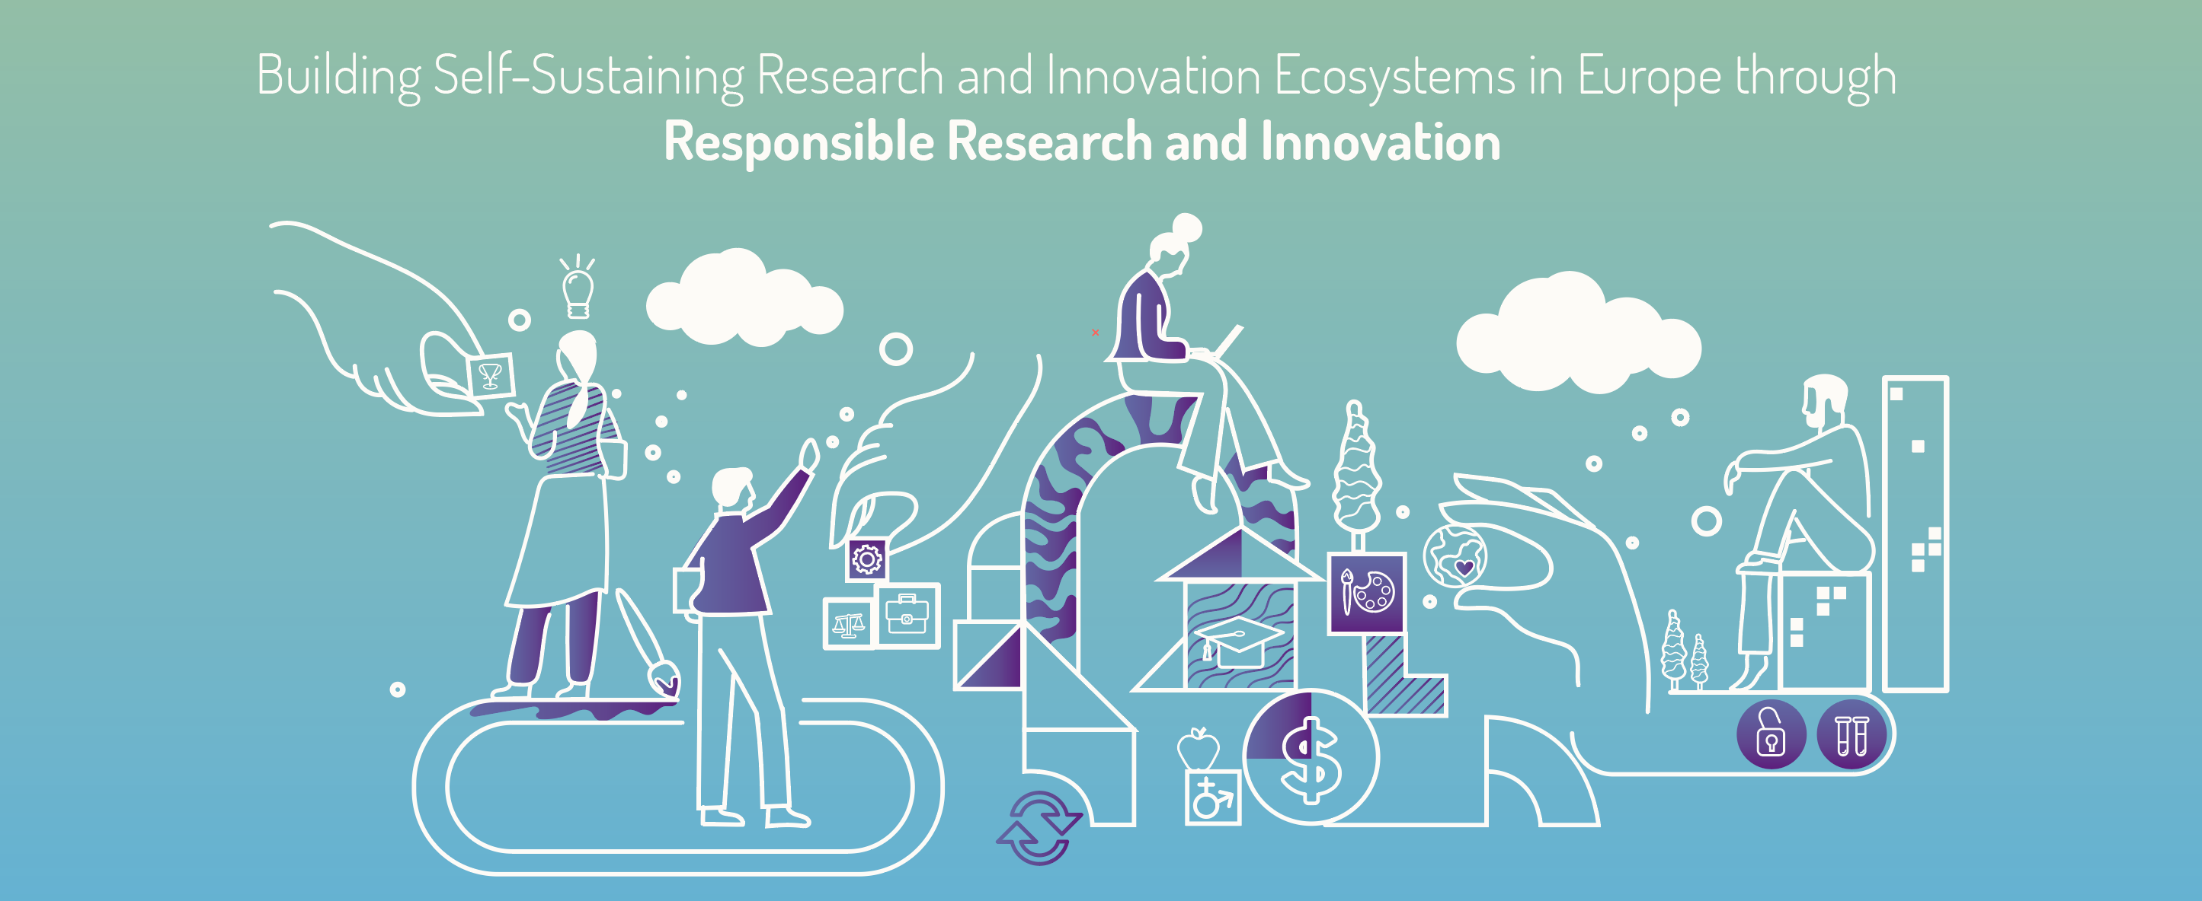
CEPI Sponsored DSMB Training Course

Background. The Coalition for Epidemic Preparedness and Innovation (CEPI) through the Safety Platform for Emergency vACcines (SPEAC) project, has funded the development of a training program for potential Data and Safety Monitoring Board (DSMB) participation which will prioritize participants from low and middle-income countries (LMIC). CEPI has an expanding portfolio which is currently funding the development of several vaccines for Lassa fever, Chikungunya, Rift Valley fever, MERS, Nipah and COVID-19. Since trials for these vaccines as well as others will be conducted in countries where these diseases occur—the goal of this new training program is to support the training of local or regional professionals who would have the competence to serve on DSMBs. The aim is to have qualified potential DSMB members from target disease countries available to participate in study DSMBs.

We are looking for interested and qualified people to take advantage of this free training opportunity. The DSMB training course is eight weeks long with an estimated two hours per week of online training that can be completed at your own pace as well as one hour per week of a live session with a facilitator where participants can ask questions and discuss any issues. Each offering of the course will have up to ten participants, and it will be offered periodically throughout the year. At the end of the course there will be a brief examination and a certificate of completion will be issued.

Our first course is coming soon. The deadline for application is Friday April 9, 2021.
The initial session of the course will begin in May of this year and will target participants from Africa. Future sessions will target other geographic regions. Limiting sessions to select time zones helps us schedule live sessions at times that are convenient for most people.

If you are interested in participating, please contact Maria Pia Aristimuño at
pia@wedo-projects.com Please provide your full name, current institution where you work, and a one sentence summary of why you would like to participate. Those who cannot be accommodated in the first session of the course will be put on a list for the next sessions.

Thank you.

