Authors: |       
Nada Ahmed, University College London, UK
Dr Anna Bateson, University College London, UK
Dr Linzy Elton, University College London, UK
Professor Timothy D McHugh, University College London, UK
Eloise Rose, University College London, UK

Storage & Removal of Waste
REVIEW INTERVAL | Every Two Years
COPIES | 2
LOCATION OF COPIES | - SOP & Policy Folder: insert location  - Quality Folder: insert location

Document Review History
Edition No. | Review Summary | Reviewed By  & Date | Authorised By  & Date | Date of Issue

Record of Amendments
Edition No. | Amendment | Amended by  & date | Authorised by & date

INDEX OF CONTENTS

Introduction 3
Purpose and Scope 3
Responsibility 3
References 4
Statutory Obligations: 4
Definitions 4
Related documents 5
Waste definition……………………………………………………………………… 5
Clinical / Healthcare waste 5
Treated Microbiological waste 6
Disposal of Waste From The Biosafety level 2 Laboratories (BSL2) including Health and Safety instructions: 7
Disposal Of Waste From The Biosafety level 3 Laboratories (BSL3) including Health and Safety instructions: 7
Pipettes………………………………………………………………………………………………9
Paper waste. 10
Cardboard waste 10
Sharps bins 11
Dispo-Safe jars 11
Molecular waste 12
Chemical waste 12
Ethidium bromide waste 12
Disposal of equipment 13
Batteries and printer cartridges 13
Radioactive waste 14
Genetically Modified (GM) Waste 14
Glass bottles and gas canisters 14
Removal of Clinical Waste from the department to the Clinical Waste Bins. 15
ACTION IN THE EVENT OF AUTOCLAVES BEING OUT OF COMMISSION 16
Routes of waste disposal guide 17
manual handling 19
Supply of waste packaging 20

Abbreviations
BSL2 | Biosafety level 2
BSL3 | Biosafety level 3
MSC | Microbiological safety cabinet
GM | Genetically modified

Introduction

PURPOSE AND SCOPE
The purpose of this document is to ensure that insert your institute and department here staff are aware of their responsibilities with regard to the storage and disposal of laboratory waste and to comply with the health and safety policy to prevent injury to themselves and fellow workers throughout the laboratories.

Different types of waste are produced within the offices and laboratories, this guidance includes:
- Clinical waste- derived from patient sources
- Microbiological waste- from bacterial or cell cultures, this may include GM organisms
- Sharps
- Chemical waste
- Confidential paper waste
- Non confidential paper waste
- Glass bottles

This document gives guidance on the routes that are available for insert your institute and department here for the disposal of such waste.

Should any of these instructions be thought to be confusing, impractical or impossible, suggestions should be made to make the laboratory a safer place in which to work, these should be discussed with senior laboratory staff or with the Health and Safety officer and raised at the weekly laboratory meeting.

RESPONSIBILITY
The Centre Director is responsible for ensuring the implementation and maintenance of this procedure.
Under the Health and Safety at Work act (1974), and the HSE/EEC regulations, all employees are required to take reasonable care for the health and safety of themselves and of others, who may be affected by their acts or by their omissions. They are also required to co-operate with the employing authority, so far, as is necessary to fulfil the obligations of the act.

This procedure must be read and understood by all staff of the department and should be read in conjunction with the Health & Safety Policy (insert document name here).

insert your department here has a local Health and Safety Officer appointed (insert name here) and a departmental Health and Safety Officer (insert name here). It is the individual’s responsibility to raise day-to-day issues with their supervisor or appointed H&S staff with respect to waste disposal.
Each individual working in the insert your institute and department here and undertaking this procedure is responsible under Clinical Governance & the Health and Safety at Work Act for the Quality of work performed and the safety of themselves and others. Each individual must complete the induction process prior to working in the laboratories (insert document name here).

REFERENCES
(Copies of these references are located in the Quality Folder)

- UCL Medical School Royal Free Campus: Guidance for Waste
producers at UCL: How to Dispose of Routine Chemical Wastes (Available from UCL Estates and Facilities services). http://www.ucl.ac.uk/estates/waste/hazardous/chemical-waste-proc.pdf

- Safe working and the prevention of infection in clinical laboratories and similar facilities 2003 ISBN 978 0 7176 2513 0

STATUTORY OBLIGATIONS:

Satisfactory implementation of this procedure will assist the department and the Trust in complying with the following regulations:

- Hazardous Waste Regulations 2005
- Environmental Protection Act 1990
- Health and Safety at Work Act 1974
- Management of Health and Safety at Work Regulations 1999
- Environmental Protection (Duty of Care) Regulations 1991
- The Carriage of Dangerous Goods and Use of Transportable Pressure Equipment Regulations 2004
- The Chemicals (Hazard Information and Packaging for Supply) Regulations 2002
- Control of Substances Hazardous to Health Regulations 2002
- Controlled Waste Regulations 1992

DEFINITIONS

Autoclave: An autoclave is a device used to sterilize equipment and supplies by subjecting them to high pressure saturated steam at 121 °C for around 15–20 minutes depending on the size of the load and the contents

Sterilization: To make free from live bacteria or other microorganisms.

Movement of material out of a laboratory
The movement of live microorganisms or biologically active microbial material out of the laboratory should be kept to a minimum and be restricted to what is necessary for the work being done. The Clinical lead of the Department, service manager, and H&S person are responsible for instructing those working in the Department on what is acceptable practice in this regard.

Categories of Pathogens and Biosafety levels
Microorganisms are classified into four hazard groups (ACDP guidelines), and appropriate levels of containment are assigned to each hazard group (See Health & Safety Policy insert document name here.

Related documents
- Health & Safety Policy insert document name here
- Induction manual laboratory staff insert document name here
- Safe handling of MTB and other HG3 organisms and material containing them insert document name here
- Safe handling of HG2 organisms and material containing the (RA012771)
- UCL Medical School Royal Free Campus: Guidance for Waste
Producers at UCL: How to Dispose of Routine Chemical Wastes (Available from UCL Estates and Facilities services). Copy maintained in the Quality Folder (http://www.ucl.ac.uk/estates/waste/hazardous/chemical-waste-proc.pdf)

WASTE DEFINITION

A number of different waste types are generated by and leave the department. This includes
- Clinical waste.
- Treated Microbiological waste
- Non-contaminated paper waste.
- Sharps
- Chemical waste
- Domestic waste

Waste, which may consist of hazardous chemicals or micro-organisms, comes under the Control of Substances Hazardous to Health (COSHH) Regulations 2002. This means that the disposal process must be risk assessed and suitable precautions used. If existing waste disposal systems do not provide adequate protection, then additional measures need to be employed and the risk assessment documented. Other legislation requires that waste be disposed of by specific routes and receive the required treatment.

Clinical / Healthcare waste

Specifically this refers to patients samples (assessed as low microbial load) that can be removed from the department contained in clinical waste bags and transported using the large clinical waste system this should NOT normally happen unless the departmental autoclaves are out of action for a protracted period of time. All clinical waste is usually made safe by autoclaving before transportation. Use only approved clinical waste bags, which must never be filled more than 3/4. If the contents are extra heavy the load must be double bagged. Leaking or punctured bags must not leave the laboratory area. A used bag must be sealed using the approved cable tie and placed in the large yellow waste bins provided. Never leave bagged waste in a public area.

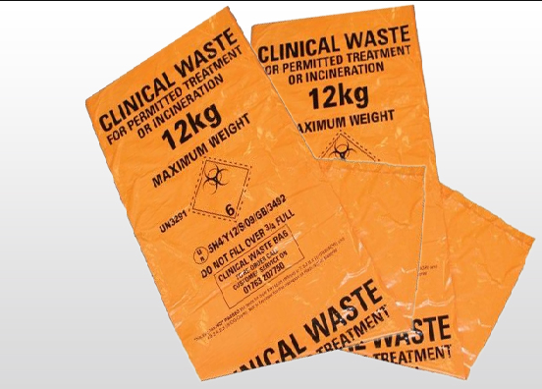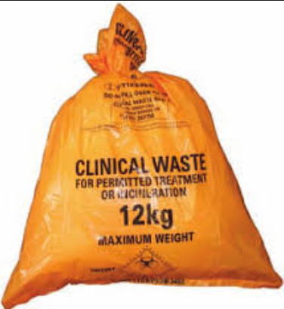

All clinical waste bags that are removed from the department must be identified with an approved cable tie for traceability. The cable ties provided to the department are issued with numbers that allow these items to be identified as having originated from the insert your institute and department here.

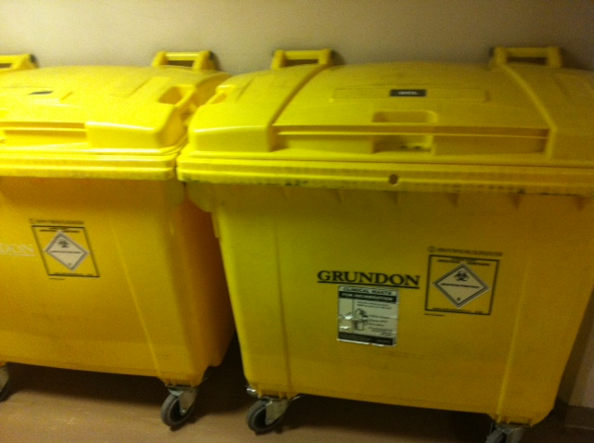

The clinical waste bins outside the department must always be locked for security.

Treated Microbiological waste

ALL microbial waste is made safe by autoclaving before leaving the laboratory. It can then be removed from the department contained in clinical waste bags and transported using the large clinical waste system bins. Liquid waste generated from the autoclaving process can be disposed of down the sluice in insert location here.

The task of autoclaving waste and packing it for removal from the department is performed by trained members of staff according to the procedures described in Operation of autoclaves (insert document name here). Competency assessment records are kept as evidence of training and understanding of these procedures and the relevant safety aspects (insert document name here).

Disposal Of Waste From The Biosafety level 2 Laboratories (BSL2) including Health and Safety instructions:

Please also refer to for full details of the control measures for this process: Safe handling of Hazard Group 2 organisms and material containing the (insert document name here)

Storage of Waste Prior to disposal: please amend to describe your laboratory procedures

Waste should be autoclaved at least once per week, even if it doesn’t make up a full load.

In all receptacles, waste must be no more than two thirds full
- Swabs and loops into Dispo-Safe jars.
- Liquid waste into Dispo-Safe jars with lid seal and Vernagel
- Disposable glassware: non-toxic or had residue removed – domestic recycling
- Non-hazardous aerosols – domestic recycling
- Small contaminated (not chemical contamination) glass into the sharps bins
- Chemically contaminated glass – dispose of via small chemicals route
- Metal discard bins with autoclave bags for plates & other items
- ORANGE Clinical waste bags in large waste pedal bins for general laboratory waste (e.g paper towel and laboratory generated cardboard) .

Transport of waste within the department:
- Must be performed in the safest possible manner to avoid accidental contamination of the corridor areas.
- Laboratory coats should always be worn for this procedure.
- Waste culture plates, fluid samples, blood samples and other contaminated discard must be transported in an autoclave tin. These should be stored safely in the allocated space in the Autoclave & Media Laboratory prior to autoclaving.
- Trolleys should be used for the transport of heavy items
- Waste must be made safe prior to transportation because gloves are not allowed in corridors

Once BSL2 waste has been autoclaved it is transferred into ORANGE bags. This is taken off site for external autoclaving. No chemicals of any type may be in this waste. Addition of chemicals to this waste results in contamination of this waste stream.

Disposal of Waste From The Biosafety level 3 Laboratories (BSL3) including Health and Safety instructions:

A detailed account of the storage and disposal of waste in BSL3 laboratories is described in the Overview of Biosafety level 3 Laboratory insert document name here and Safe handling of M. tuberculosis and other Hazard Group 3 organisms and material containing them (insert document name here).

All waste in the Biosafety level 3 (BSL3) laboratories is to be autoclaved immediately on leaving the laboratory. Discard bins with lids & catches are used within this area for storage before transporting directly to the autoclave for safe disposal; the lids must be in place and secure with the bins NO MORE than 2/3rds full. Only tins with lockable lids should be used.

The autoclave is to be empty and waiting for the waste before it leaves the BSL3 accompanied by a qualified member of staff. Waste from the BSL3 is on no account to be left in the corridor or anywhere outside the BSL3 laboratories. The member of staff operating the BSL3 laboratory will transport the waste on a trolley to the autoclave room and load the autoclave. After loading the autoclave the trolley should be wiped-down with tristel.

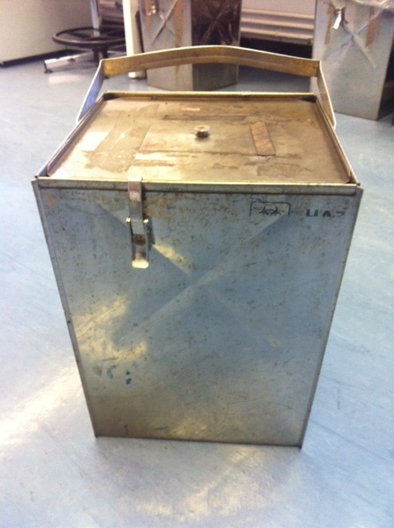
NB: only large metal tins with secure fastening lids must be used for waste in the Biosafety level 3 Laboratory.

Liquid media must not be decanted unless essential for the procedure. Should decanting be necessary, this should be performed by gently tipping the liquid into a Dispo-Safe jar containing Vernagel in the MSC. These jars must include a plastic lid seal and must remain upright at all times. These jars must be sealed whenever they are not in use. Should any droplets be visible on the rim of the vial following decanting, these must be wiped with a tissue soaked in Tristel, which must then be discarded into the Dispo-Safe jar. Following decanting these vials must be placed into a separate Dispo-Safe jar inside the MSC before sealing and removal to double autoclave bags inside large metal tins with lids.

Large numbers of vials (e.g. LJ slopes and MGIT tubes) that have not been decanted may be placed (with their lids secure) directly into Dispo-Safe jars containing Vernagel prior to transfer to double autoclave bags inside large metal tins with lids. These Dispo-Safe jars should not have water added because it makes them too heavy.

Plastic loops, pastettes, pipette tips and sample tubes are placed into plastic sweetie jars containing Vernagel inside the Safety Cabinet.
When a Dispo-Safe jar is to be discarded, enough water must be added to ensure that the waste within the sweetie jar is solidified before removal from the safety cabinet (NB one sachet of Vernagel is sufficient to solidify approximately 1.2L of liquid). Add 2 sachets of Vernagel to the Dispo-Safe jar prior to use. Dispo-Safe jars must not be more than 2/3 full. Further Vernagel sachets must be added if the waste is not fully solidified.
Dispo-Safe jars are then to be placed in double autoclave bags inside metal tins. Dispo-Safe jars must be placed in separate metal tins from other waste.
No sharps are allowed in the BSL3 laboratories. However, sharps bins are allowed for glass slides. These are to be placed in a sharps bin, which must be closed, but not sealed, when not in use.
Sharps bins are to be sealed before autoclaving within the BSL3 These MUST be autoclaved prior to removal from the department. Following autoclaving the sharps bins are discarded to the yellow bins.
The top of all bags removed from Biosafety level 3 must be loosely tied to allow the penetration of steam.
After autoclaving BSL3 waste is transferred into YELLOW bags. This is because the BSL3 waste may contain some chemical waste from sample processing. These bags go directly for incineration.
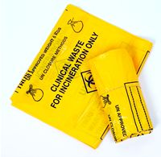
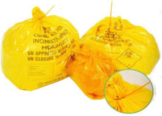

All clinical waste bags that are removed from the department must be identified with an approved cable tie for traceability. The cable ties provided to the department are issued with traceable numbers that allow these items to be identified as having originated from the UCL CCM.

Pipettes

Serological pipettes are disposed of into the cardboard waste boxes
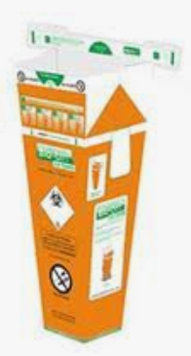

When full these are transferred to a double autoclave bag and autoclaved. Following autoclaving they are transferred to ORANGE bags.

Long serological pipettes cannot be used in the BSL3 because they do not fit in the Dispo-Safe jars. Shortie pipettes must be used because fit in the Dispo-Safe jars.

Paper waste
Paper waste from laboratory areas must be regarded as contaminated waste and treated as clinical waste, as above.

Paper waste that contains confidential information, particularly patient details must be shredded prior to leaving the department. There is a paper shredder in insert location here

Paper items that are required to be kept and that have been in the BSL3 laboratories can be ovened out (see insert document name here).

Staff should make every effort to ensure that any paper waste containing confidential / patient information is disposed of by this route and NOT as domestic waste. This may include printed emails and other abandoned printouts

Cardboard waste
Non-contaminated cardboard waste should be crushed at source and delivered to the large blue bin in the corridor. From here, it is removed by the domestic staff to the allocated metal container by the waste lifts outside the department.

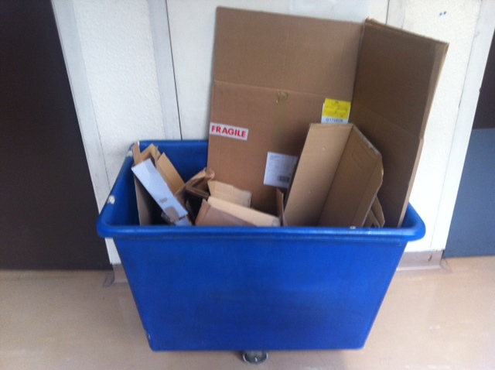

It is NOT the duty of the domestic staff to crush these items. All cardboard boxes must be crushed/reduced before placing in the blue bin.

Sharps bins

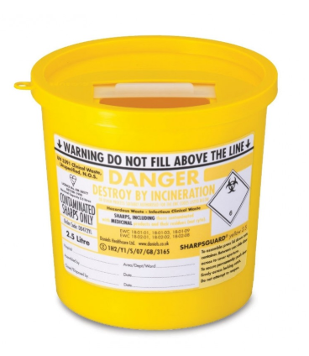Sharps bins must be assembled according to the instructions printed on the side of each container. Care must be taken to ensure the lid is snapped into place. The label details MUST be completed.

Sharps containers must never be filled above the indicated line and the closure must be snapped shut and the label completed before discard. Used bins may be removed to the insert location here and placed in the designated area prior to being removed to the large yellow clinical waste bins outside the department. There is a single designated clinical waste bin which is labelled for sharps and yellow bags only. It is essential that only ‘Sharps’ are disposed of into a designated containers i.e.

These items include:
- Glass slides.
- Broken glass
- Scalpels

No fluid should be discarded into these bins. They are not designed to contain fluids.

Dispo-Safe jars

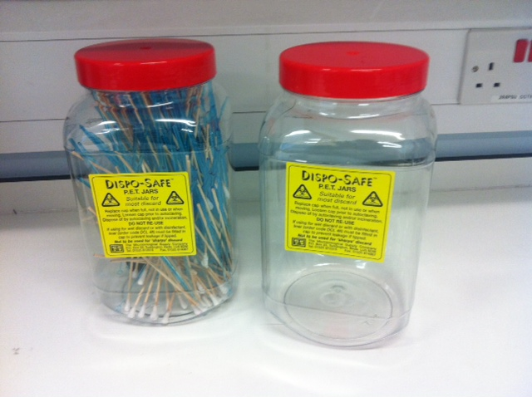

Dispo-Safe jars must be assembled according to the instructions printed on the side of each container.

These containers are used throughout the department for the disposal of contaminated swabs, loops, tips and other small items. They must not be used for the disposal of sharps. The cap should be replaced when the jar is full (never more than ¾), not in use or when moving.

Inside safety cabinets, Dispo-Safe jars are used for the disposal of small volumes of fluid waste. Verna gel sachets (x2) should be added to these jars prior to use. The fluid waste, swabs and loops etc will solidify as the fluid is added. These items must also have a cap-liner applied to the inner lid.

Molecular waste
Waste materials contaminated with amplified products (amplicons) from molecular processes should not be autoclaved within the department. Specifically, this refers to pipette tips, reaction tubes, plates and other small disposables from insert location here. These items are disposed of into Dispo-Safe jars that are labelled “Molecular waste. Do not autoclave.” These jars are then discarded directly into YELLOW clinical waste bags for removal from the department.

Chemical waste
Hazardous chemicals are used to a minimum in the department. Elimination or replacement of a hazardous chemical with a safer substitute is always considered before use. Waste chemicals are collected in glass dewars and stored in insert location here. UCL uses an approved contractor for their removal. The associated form is provided by them ‘UCL LAB Small Chemical Wastes Collection Template’ and should be used to record all items for waste disposal. A designated member of the UCL CCM team will take responsibility to register and submit the completed collection template online. They will receive a work order number and a specific date of collection for the items. They will ensure the arrangements are in place for a named staff member to attend the collection time. All chemicals for waste disposal must be in correctly labelled containers. Each item for disposal should be identified correctly on the collection template indicating the name of the chemical, solid or liquid, volume or weight, the number of receptacles and the exact location. All items will be confirmed against the collection template at the time of collection and only the items listed should be removed.

Waste containers with toxic chemical residues are discarded via the UCL Lab small chemical waste route as above.

Chemical waste MUST NOT be disposed of via the ORANGE waste bag stream, regardless of whether it is autoclaved or not. Chemicals are not allowed in the ORANGE waste stream.

Ethidium bromide waste

Ethidium bromide solution should be handled and disposed of as HAZARDOUS waste.

Please refer to Post PCR Analysis (insert document name here) for full risk assessment details.

Ethidium bromide on gloves, pipette tips, test tubes, paper towels, buffer etc., should be transferred to Dispo-Safe Jars. Destaining bags, containing charcoal are added to the ethidium bromide gel tanks overnight. The tank is labelled as to when inactivation commenced. The buffer can then be tipped down the dirty sink and destaining bag added to the Dispo-Safe jar. ALL ethidium bromide waste is then transferred into clinical waste bags for incineration. This waste must NEVER be autoclaved. DO NOT TRANSFER INTO ORANGE BAGS WHICH ARE AUTOCLAVED OFF-SITE. ALWAYS TRANSFER TO YELLOW BAGS.

All gels containing ethidium bromide are disposed of in Dispo-Safe jars and handled at all times with nitrile gloves. Dispo-Safe jars are labelled to indicate that they contain ethidium bromide.

Disposal of equipment

All laboratory equipment for disposal must be decontaminated prior to disposal and evidence of this supplied in the form of an Equipment Decontamination Form (insert document name here). ‘Dump the Junk’ should be contacted to arrange removal.
All electrical equipment must be collected securely and the following process must be followed:
- Computers: contact IT services to wipe the hard drive. Once this is complete please fill out an equipment for disposal form via ‘Dump the Junk’
- Fridges: contact estates for degassing. Once this is complete please fill out an equipment for disposal form via ‘Dump the Junk’
- Photocopiers and bulky electrical: ‘Dump the Junk’

Batteries and printer cartridges

Batteries must not be autoclaved. Batteries for disposal must be decontaminated with Your validated disinfectant, e.g. Tristel and placed in the designated box in the media room. These batteries are taken to UCL Immunology where they will be safely disposed of by UCL.

- Batteries: Are collected in the Media Laboratory in a labelled container “Used Batteries”. These are taken to the collection point in Immunology where the UCL waste management team collect them.

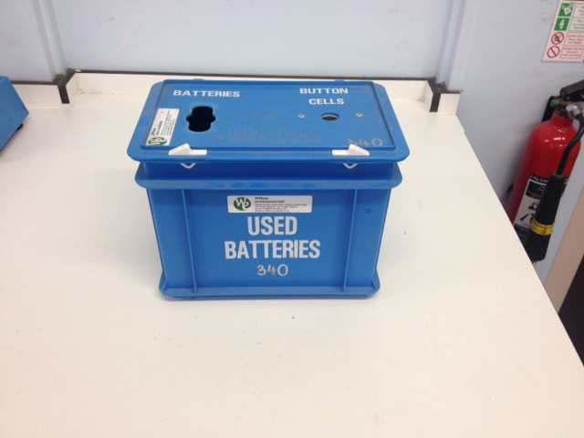

- Expired printer cartridges: There is a recycling point for used printer cartridges in UCL Immunology. Alternatively ‘Dump the Junk’ will also collect them on request if there are a large number.

Radioactive waste

The storage and disposal of radioactive waste is not addressed here since there are currently no sources of this waste type within the department. If any radioactive waste is planned to be generated in the future it will require a full risk assessment and the handling of the waste determined as part of that.

Genetically Modified (GM) Waste

The storage and disposal of GM waste follows the same pathway as microbiological waste in that it is always treated (autoclaved) prior to removal from the department.

Full details would always be supported by a separate and individual risk assessment approved by the GM Committee.

Glass and gas canisters

Intact glass bottles (empties) which contained non-hazardous chemicals (e.g. ethanol) can be rinsed thoroughly and the label erased with black ink. These can then go via the domestic recycling route.

Glass that has contained toxic chemicals is discarded via the laboratory small chemicals route as described above.

Broken glass which has no chemicals present is discarded into the sharps bins. Please contact facilities for advice on removal of broken glass contaminated with hazardous chemicals.

Non-toxic aerosols can be disposed of via the domestic recycling route. Toxic aerosols need to be disposed of via the small chemicals route as described above.

Removal of Clinical Waste from the department to the Clinical Waste Bins.

The removal of clinical waste from the department to the collection point at the large clinical waste bins located in the corridor near the waste lifts is a task performed by the member of staff assigned to the autoclave rota. The Laboratory Manager oversees that this is done. Although these bins are in a relatively secured area from the general public there is a duty to ensure that they are locked at all times.

- The waste must be contained within designated clinical waste bags and secured with tie-grips.
- YELLOW and ORANGE bags MUST be separated into separate bins. They are sent to different disposal routes off-site and mixing bags will result in a non-conformance.
- The tie grips are labelled with numbers allocated by the Estates team and can be traced to the source as Microbiology.
- The bags should not be overfilled or too heavy.
- Sharps containers for removal must have the label details completed which also indicates the source. These containers must be sealed to prevent re-entry or loss of contents. These MUST be discarded with YELLOW bag waste and not put into the bins containing ORANGE bag waste.
- The safely contained and labelled waste should be loaded on a trolley for transport to the waste bins.
- The key for the bins is located on the wall of the Autoclave & Media (2/437) laboratory on a labelled hook at the exit.
- The waste should be delivered directly to the large yellow clinical waste bins near the waste lifts.
- One bin is labelled and allocated specifically for the disposal of the sharps containers and YELLOW bags. ORANGE waste bags must never be placed in this bin.
- Separate bins are available for the disposal of ORANGE clinical waste bags. Likewise, sharps containers must never be placed in these bins.
- All clinical waste bins should always be found in a locked condition and locked after use.
- Faulty bins e.g. those that do not close properly should be reported to the Facilities team for removal.
- Serious issues concerning the collection of clinical waste should be addressed to the Trust waste manager in addition to the RFH Estates team. Contact details are displayed in the Autoclave & Media Laboratory (2/437).
- Incidents relating to waste mismanagement should always be recorded at (https://www.ucl.ac.uk/safety-services/risknet)
- The UCL CCM will conduct a routine examination audit of the clinical waste pathway from the point of removal from the autoclaves to the point of departure from the Trust to ensure compliance with waste removal regulations.

ACTION IN THE EVENT OF AUTOCLAVES BEING OUT OF COMMISSION

Waste from BSL3 can be stored safely in the appropriate discard bins for short periods of time within the BSL3 laboratory; however this must be reviewed on a daily basis.

There are 2 autoclaves and therefore it is unlikely that both will be simultaneously out of commission. In the unlikely event that this does occur and for a protracted period then a risk assessment must be made looking at various alternative options, one of which may require the transfer of samples to another department. This must be discussed with the Health & Safety Officer and the Centre Director.

Waste from BSL2 can be stored safely in the appropriate bins for short periods of time within the BSL2 laboratory, however this must be reviewed on a daily basis.

If the autoclaves are out of commission for a protracted period then a risk assessment must be made looking at various options.

Clinical waste (patient samples) can be safely discarded into the ORANGE bags then disposed of into the large yellow clinical waste bins for disposal by licensed contractors (these must be kept locked).

Routes of waste disposal guide

Black bags

Yes
- Packaging material.
- Hand towels.
- Paper.
- Empty containers – plastic (as long as they are not contaminated).

No
- Anything contaminated with infectious or chemical agents etc.
- Chemicals in general.
- Batteries.

YELLOW Clinical Waste Bags

Yes
- Laboratory waste which has been autoclaved.
- Laboratory waste which does not require autoclaving.
- Ethidium bromide contaminated waste
- Molecular waste
- Small amounts of non-toxic chemicals

No
- Sharps (this includes loose pipette tips)
- Microbiological waste (unless previously inactivated by autoclaving), eg cell cultures containing Hazard Group 2 organisms (or greater). Patient samples known or likely to contain Hazard Group 2 (or greater) biological agents.
- Genetically modified material, unless already inactivated using a verified route.

YELLOW Clinical Waste Bags
Yes

- Waste with ethidium bromide contamination
- Small numbers of non-toxic chemicals
- Autoclaved BSL3 waste

No
- Chemicals classified as toxic, carcinogenic, mutagenic, toxic to reproduction, corrosive etc.
- Sharps
- Genetically modified material, unless already inactivated using a verified route.

ORANGE Clinical Waste Bags

Yes
- Laboratory waste which has been autoclaved.
- Laboratory waste which does not require autoclaving.
- Clinical waste eg low risk patient samples such as empty 24 hour urine containers and fixed human material.

No
- Sharps (this includes loose pipette tips)
- Microbiological waste (unless previously inactivated by autoclaving), eg cell cultures containing Hazard Group 2 organisms (or greater). Patient samples known or likely to contain Hazard Group 2 (or greater) biological agents.
- Genetically modified material, unless already inactivated using a verified route.
- Any chemicals

Sharps Boxes

Yes
- Needles.
- Scalpels.
- Slides
- Broken glass

No
- Liquids in general.
- Chemicals in general.
- Gloves.
- Packaging.

Dirty Sink / sleuce

Yes
- Approved disinfectants
- Dilute solutions not containing heavy metal salts.
- Low quantities of water-soluble / miscible organic chemicals (e.g. alcohol).
- Solutions at Neutral pH.

No
- Heavy metals.
- Flammable substances.
- Solvents.
- Organic chemicals in general (see above for exception).
- Strong acids or alkalis.
- Oxidising agents e.g. Histoclear.
- Alkaline metals e.g. sodium and potassium.
- Microbiological material (unless disinfected).
- Genetically modified material, unless de-activated by means of a validated method.

manual handling
Staff involved in the procedures of waste collection and disposal are particularly at risk of manual handling-associated injuries.

Manual handling is any activity involving the use of muscular force (or effort) to lift, move, push, pull, carry, hold or restrain any object, including a person or animal. It covers more than lifting heavy weights and affects more than the back. Manual handling also includes the repetitive activity seen in assembly work; the sustained muscle exertion required to restrain or support a load; and the effort needed to maintain the fixed postures that occur in the back and neck while typing. Injuries often occur due to wear and tear, accumulated from frequent periods of manual handling activity that stress the body, such as repetitive work or heavy lifting. The effects of these injuries often become more disabling as workers become older.

The Trust Ergonomics and Manual Handling Service runs a non-patient handling course for all staff who undertake inanimate load handling (See Freenet). This course forms part of the mandatory training for all staff in the Trust and attendance is managed locally by the departments Education officer and Health and Safety Officer.

Staff involved in the procedures of waste collection and disposal may attend the manual handling course if required.

Supply of waste packaging

The following packaging is supplied free of charge by Facilities:
Orange and yellow bags. On request, either collected or delivered to a central point. Additional types of packaging for clinical wastes are available depending upon specific requirements.
Yellow lidded sharps bins. On request, either collected or delivered to a central point.
Cable ties. Distributed in batches to department or sub division of. Can be obtained from the domestic cleaning staff.
Clear and black bags. Exchanged by the domestic team.
Additional supplies are available on request.
All other waste packing is to be purchased by the waste producer or provided by the NHS.

