Authors:
Dr Linzy Elton, University College London, UK
Alp Aydin, Quadram Institute, UK
Dewi Owen, University College London, UK
Eloise Rose, University College London, UK

How to QC a flow cell

Before you start sequencing, you will need to ensure that the flow cells you have bought have a good number of active pores. If, when you QC your flow cell, it has less than 800 active pores, contact Oxford Nanopore and they will send you a replacement.
Turn on the computer/laptop and run the MinKNOW software. Take the flow cell out of the packaging and place it into the MinION. MinKNOW will recognise the flow cell in the MinION

Check the available box

At the bottom left of the page, click on check flow cells

A new box will appear. Click
Go to the flow cell section and click jump to run and then click on the date

This will bring you to the working MinKNOW page. At the top you should see that the MinION is heating up to 37°C. To help it reach that temperature quicker (it times out after 10 minutes if this temperature hasn’t been achieved), warm it in your hands of place it on a mouse mat

Once it reaches temperature, you will see the channels panel appear. The flow cell is now being QC’d | 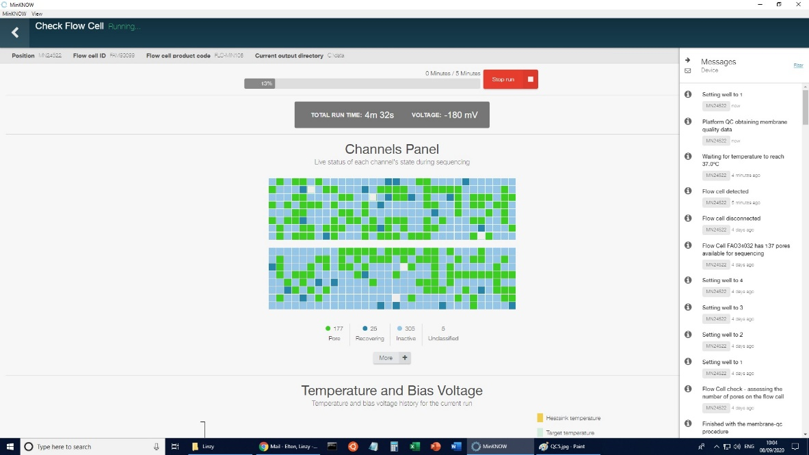
To see the related information, click on the envelope in the top right corner of the screen. This will open up a side window. Once the process is finished, you will see the number of active pores displayed in this window.

It is advisable to write (using a sticker) on the plastic case of the flow cell the flow cell number, date of QC and how many active pores there are for future reference | 