Neonates born to confirmed or suspected COVID-19 mothers
Executive summary
Introduction
Neonatal infection with SARS-CoV-2 is expected to be mild, with shortness of breath the main presenting symptom. Vertical transmission is unproven. However, this is based on limited data and all infection prevention control procedures should be followed to limit onward transmission of SARS-CoV-2 from exposed or infected neonates. There is currently no evidence supporting transmission of SARS-CoV2 in the breast milk but close proximity during breast feeding may be associated with transmission.
Aim to keep the mother and baby together as much as possible unless there is a clinical need to separate them. This is to ensure breast milk feeding and bonding. Kangaroo mother care (KMC) can be provided, all of which are important to prevent neonatal illness and death from other conditions.
Target User
- Nurses
- Doctors
Target area of use
- MRC Clinical Services Department
- Other health facilities

Key areas of focus / New additions / Changes
Clinical care of neonates with suspected or confirmed COVID19 disease
Limitations
The evidence base for managing COVID-19 infections is growing exponentially as we see more cases. For the most up to date information please see the links in the reference section below as our understanding and response to this disease will change over time.

Presenting symptoms and signs

Well (asymptomatic) neonate:
- Well (asymptomatic) baby and well mother: Consider the best place for care to be provided and according to national guidelines. This may be in an inpatient setting or at home in self isolation. Encourage the mother to continue expressing milk with another relative feeding the baby, if possible. If this is not possible, encourage the mother to wear a face mask whilst breastfeeding.
- Well (asymptomatic) baby and unwell mother: If mother is too unwell to care for the newborn, he/she should be in the care of a family member. This does not need to be in hospital if the family can ensure self-isolation for 14 days. If this is not possible the neonate may require admission to hospital or a self-isolation facility whilst awaiting testing.
Advise the mother to look out for signs of fast breathing, difficulty in breathing/feeding and fever or hypothermia and to contact health workers if any concerns.
Testing for SARS-CoV-2 will be conducted according to national policy.

Unwell / symptomatic neonate
The usual causes of neonatal illness and mortality (complications of prematurity, bacterial infection and intra-partum related birth asphyxia) may still be present in neonates born to mothers with suspected or confirmed COVID-19. These should be considered in any unwell baby and all other treatments provided as per standard neonatal protocols.
Respiratory symptoms are the main clinical feature in neonates, particularly fast breathing. Other non-specific signs of illness (fever, hypothermia, lethargy, poor feeding, vomiting) may also be present and mimic sepsis.

Investigations
- Testing for SARS-CoV-2 virus will be conducted according to national guidelines
- FBC: WBC may be normal or low. If high suspect bacterial infection. Pay attention to neutrophil: lymphocyte ratio. If this is high it is a poor prognostic indicator in adults. Prognosis in neonates is not established.
- Blood culture – should be done to identify bacterial sepsis, as the conditions may present in similar way
- Chest X-ray – radiologic signs are non-specific in neonates and CXR should be avoided unless for a specific indication which will change management (e.g. pneumothorax, pleural effusion etc).

Management

Respiratory support
- Prone (lying on abdomen) position is associated with better lung aeration and reduced oxygen requirement. Manage neonates in prone position as much as possible, with their heads turned to the side and arms/legs in flexed position.
- Provide oxygen via nasal cannula to maintain SPO2 >90% (>88% for preterm neonates).
- Avoid potentially aerosolising techniques if possible (E.g. suctioning, CPAP).
- If a neonate requires CPAP for clinical reasons (Silverman score ≥4 or persistently hypoxic despite oxygen – see appendix), ensure that the patient is managed in a separate area and all staff wear PPE whilst dealing with the baby.

IV fluids
- Provide routine maintenance fluids according to age and weight, as per standard care.
- If signs of suspected infection treat as per usual protocols, with cautious use of fluid boluses.

Feeding
- Provide expressed breast milk as soon as possible as per standard neonatal care.
- Follow standard feeding regimes, including use of gastric tubes and cup feeding.

Kangaroo Mother Care
- Continue KMC for preterm / LBW neonates (<2kg) as long as the baby and mother are well.
- With-holding KMC is likely to result in worse outcomes than from COVID19
- Ensure adequate spacing (3 m) between beds if more than one mother / baby pair are receiving KMC.

Other treatments
- Provide all other treatments as needed, according to the likely diagnosis. Consider antibiotics early as the clinical signs of COVID19 may be very similar to bacterial sepsis.
- Avoid using nebulised medications.
- There is currently no evidence for the benefits of steroids, diuretics or anti-virals in neonatal COVID19 disease.
- Any use of other medications should be part of a clinical trial.

Key Issues for Nursing care

Wear PPE during all clinical encounters, especially during suctioning, bag-valve-mask ventilation, management on CPAP. Dispose of nappies in a hygienic manner and assume to be contagious until more evidence is available
Ensure hands are washed thoroughly with soap and running water for a t least 20 seconds before and after caring for (feeding, examining, changing) each neonate. Teach care giver to do the same.

Figure 1. Overview of how to manage neonates born to mother with suspected / confirmed COVID-19
Ensure universal precautions:
• Disposal of nappies with biologic waste
• Wearing of PPE (contact & droplet), especially for aerosolising procedures
• Strict hand washing
• Mother to wear mask during breastfeeding / KMC if mother is positive & neonate negative or until test results known
Newborn born to suspected/confirmed COVID-19 mother
Asymptomatic
Symptomatic
Fever/Hypothermia. Lethargy, poor feeding , vomiting
Well mother?
Yes
No
Nurse in location according to local guidelines
Express breastmilk and have a relative feed the newborn
Provide care in a self-isolating facility (could be at home) for 14 days (with relative if possible)
Test for COVID-19 according to local policy
Consider usual causes of neonatal morbidity and mortality. Maintain high index of suspicion
Investigate and manage as per protocol:
- Resp support
- IV fluids
- Feeding
- Antibiotics until sepsis excluded or empirical treatment
- KMC unless clinical reason to stop

References
UNICEF guidance re. breastfeeding https://www.unicef.org.uk/babyfriendly/infant-feeding-during-the-covid-19-outbreak/
COVID and KMC: https://kangaroo.care/blogs/covid-19/guidelines

Written by: | Name: Elizabeth Ledger | Date: 09 April 2020
Reviewed by: | Name: Helen Brotherton | Date: 09 April 2020
Reviewed by: | Name: Baderinwa Abatan | Date: 10 April 2020
Version: | Change history: | Review due date:
1.0 | New document | 10 April 2022
Review Comments (if applicable)

Appendix I. Silverman score & care pathway for neonatal CPAP in resource limited settings
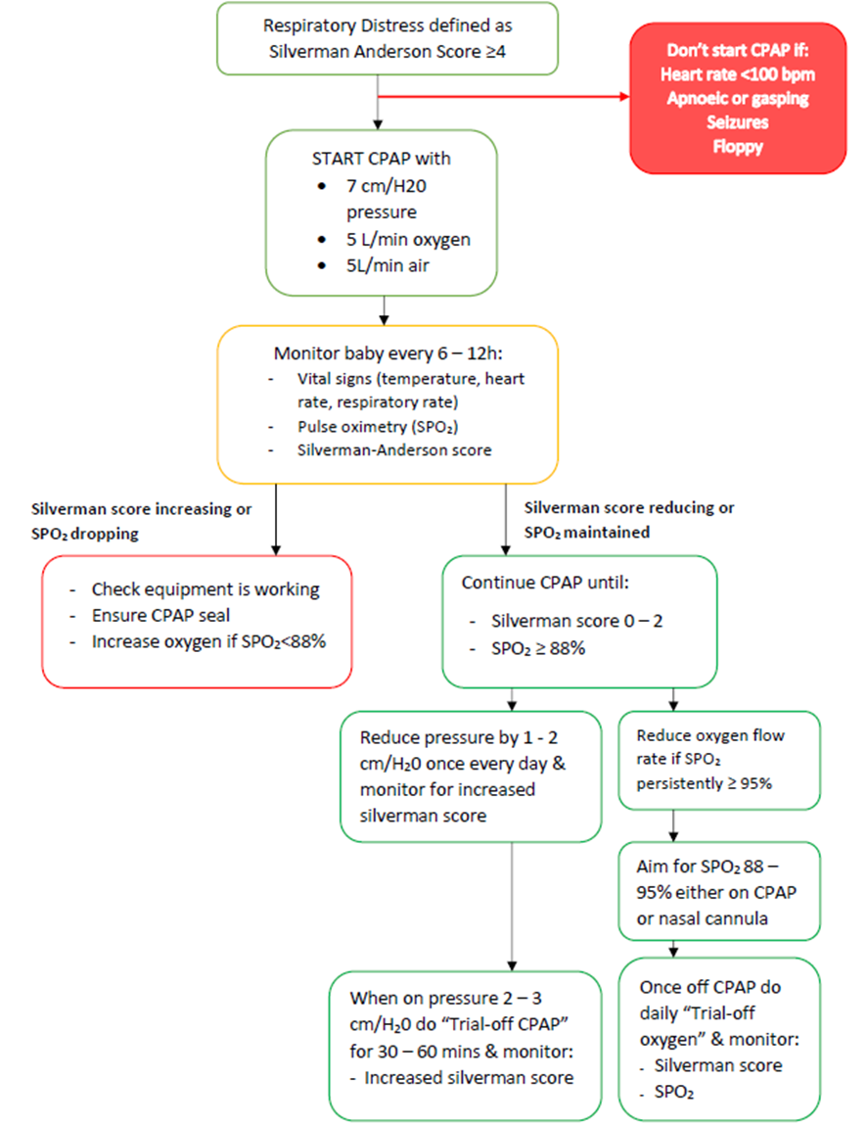

Silverman-Anderson score

Score | Movement of abdomen & chest | Subcostal recession | Xiphoid retraction | Nasal Flare | Grunt
0 | Synchronised | None | None | None | None
1 | Abdomen lag on inspiration | Just visible | Just visible | Minimal | Stethoscope only
2 | See-Saw | Marked | Marked | Marked | Naked ear

