Collection of respiratory samples from Patients with or suspected of having an Airborne High Consequence Infectious Disease (eg COVID-19) and Transportation of such Samples to the High Consequence Infectious Diseases Diagnostics Laboratories (HCIDDL)

Document type | Identification code | Implementation date
Standard operating procedure | SOP-AIR-007 | 17 February 2020

Version Number: |  | 1.0
1st Review Date: |  | 2 Years after effective date stated above
Reviewed and no changes required? (Please check the textbox to indicate if no changes are required after reviewing document. Initial and date in the appropriate review section) |  | Initials: | Date:
 |  | 2nd Review Date: (2 Years after the 1st review)
 |  | Initials: |  | Date:
 |  | Valid until: (2 years after 2nd review)

 | Name and job title | Signature* | Date*
Author | Behzad Nadjm  Consultant Clinician
Reviewer  (Optional) | Natalie Hofmann  Manager, Molecular Diagnostics Laboratory
Approver | Karen Forrest  Head of Clinical Services
* to be hand-written to indicate approval

Document | Specific location
Master | Quality department
Electronic | Intranet
Confidential, unauthorised copying prohibited

Purpose
  - This procedure describes the collection of respiratory samples from patients with, or suspected of having an Airborne High Consequence Infectious Disease (AHCID) and transportation of such samples to the laboratory.

Scope
2.1 This SOP MUST be enforced for ALL AHCID Treatment Centre (TC) staff handling and managing patients with or suspected of having AHCID.

Responsibilities
3.1 The head of Clinical Services Department (CSD) is responsible for the oversight and running of the clinical services department in which the TC is sited.
3.2 The lead AHCID doctor is responsible for training and overseeing the adherence to this SOP
3.3 All TC staff are required to observe all the applicable practices and procedures detailed in the SOP, attend training/drill sessions and report all incidents/accidents to the AHCID lead doctor.

Procedure
Section | Description | Person(s) Responsible
4.1.1 | Call the HCID Diagnostics Lab staff on the extension numbers listed below, 30 minutes before sample collection, so that the diagnostic lab can be prepared for sample reception.  - Primary Contact: Natalie Hofmann, ext 3CX 2147  - Secondary Contact: Sheikh Jarju, ext 2188, mobile 7097513  - Alternate Contact: Ousman Secka, ext 3CX 2144  - Alternate Contact: Davis Nwakanma, ext 3CX 4010  There is no point in collecting samples outside of working hours. For weekend/bank holidays the consultant on call should discuss with the HCID Diagnostics lab staff (contact details above) and agree a plan. Sputum should have been produced by the patient into a plain specimen container before the healthcare staff enter the room. Note that induced sputum is never performed. | TC Staff
4.1.2 | Assemble the following comprehensive set of equipment needed for the sampling from the store.  - 2 small transparent self-sealing plastic bags, (2 extra small self-sealing plastic bags if sputum has been obtained); 1 large self-sealing bag.  - 2 viral swabs with at least 1 ml of transport medium. Use only synthetic fibre swabs with plastic shafts.  - If collecting a blood sample please consult SOP-AIR-003 for instructions  - The WHO minimum data form  - HCID Diagnostics Lab Test Request Form  - A rigid box (cooler) for specimen transportation.  - 10% bleach spray  - Tissues  - Marker pen, fine tip pen and adhesive plain stickers | TC Staff
4.1.3 | A triple package system is used, with each layer disinfected with 10% bleach solution (See Note 1)  - The first layer (transport medium) is the only one that enters the high-risk area.  - All samples will be placed into a large self-sealing bag in the patient’s room, this bag will be later discarded.  - The combined nasopharyngeal and throat swab or sputum pot is then put into the second layer (the small self-sealing bag for vacutainer) in the low risk area after the swab container/sputum pot has been decontaminated with 10% bleach.  - Finally, the first self-sealing bag is decontaminated prior to removal from the anteroom and placed into the 3rd package (the second self-sealing bag) outside the anteroom and then into a hard specimen transfer box (e.g. cooler). | TC Staff
4.1.4 | The doctor labels the HCID Diagnostics Lab Test Request Form (should contain the WHO minimal dataset correctly, outside the side room), and puts it in the plastic bag provided, then into the cooler box which is left outside with the staff who will take the sample to the lab.  If there is more than one patient, pre-label the tubes and write a list to follow as the patients are bled. | TC Staff
4.2 | Respiratory sample collection is done in the negative pressure room following the procedure specified below. Two clinical staff in full PPE with the addition of a second pair of gloves should be involved: | TC Staff
4.2.1 | Assess SAFETY RISK to you versus patient benefit before attempting to swab. There are situations when NOT to attempt sampling, for example inadequate PPE available or a combative patient. | TC Staff
4.2.2 | Ensure appropriate lighting and set up so equipment is easily within reach. | TC Staff
4.2.3 | Discuss the procedure with the patient. Tell them that the process may make them sneeze or cough, if this happens they should turn away and cough/sneeze into the tissues that you give them. | TC Staff
4.2.4 | Instruct your buddy to hold the labelled transport medium bottle. Note that both swabs (nasopharyngeal and pharyngeal) will be broken off into one transport medium bottle. | TC Staff
4.2.5 | Nasopharyngeal:  - Enter a thin, flexible swab several centimetres with a slow steady motion along the floor of the nose (straight back, not up) until the posterior nasopharynx has been reached (distance from nostrils to external opening of ear)  - Once resistance is met (the swab should pass into the pharynx relatively easily), rotate the swab several times and withdraw the swab  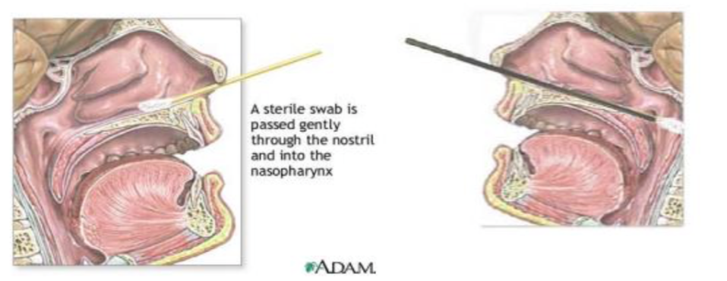  - Put the swab in the transport medium, rotate several times and break off (it will snap off)  - Replace lid whilst waiting for the throat swab.  Throat swab  - Using a wooden spatula depress patient’s tongue or ask them to stick their tongue out  - Quickly but gently rub the swab over the pillars of the fauces (area between uvula and in front of the tonsils)  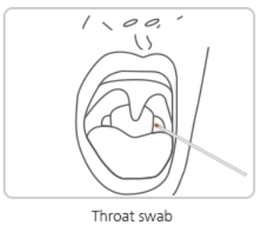  - Put the swab in the same transport medium that has the nasopharyngeal swab tip, rotate several times and break off (it will snap off)  - Replace the lid and place in the large self-sealing plastic bag. | TC Staff
4.3 | Procedure for specimen packaging.
4.3.1 | Remove the samples from the bag and discard the bag in clinical waste. Remove outer gloves. Decontaminate the sputum pot (if received) and the transport medium bottle with 10% bleach and wipe down with paper towel.  If the labelling has come off or become hard to read, affix a self adhesive label with the patients name, hospital number and date of birth on the tube.  Put each sample (sputum/combined nasopharyngeal/throat swab) separately in the second container (i.e. in separate self-sealing bags) with some tissue paper, seal it and then spray outside of bag. | TC Staff
4.3.2 | Remove your PPE as per recommendation and leave the ante room
4.3.2 | Place each self-sealing bag directly in another, seal it.  Label this self-sealing bag with the patient’s name, date of birth and hospital number.
4.3.6 | Place each double packaged self-sealing bag in the cooler box. Wash your hands. The cooler box should contain paper towels to soak up any spillage. The cooler is then covered. | TC Staff
4.3.7 | Phone the laboratory service for sample pickup:  Primary Contact: Edward Demba; 7957046, BCX ext 4050  Secondary Contact: Ebrima Jallow; 7985515

Appendices

Appendix number | Title (as referenced on the appendix)
Appendix 01 | Document Version History

Attachments
Attachment number | Title (as referenced on the attachment)
None

References
WHO Biosafety Guidance Related to the Novel Coronavirus (2019-nCoV)https://www.who.int/docs/default-source/coronaviruse/laboratory-biosafety-novel-coronavirus-version-1-1.pdf?sfvrsn=912a9847_2 Accessed 13 Feb 2020

WHO Laboratory testing for 2019 novel coronavirus in suspected human cases. https://www.who.int/publications-detail/laboratory-testing-for-2019-novel-coronavirus-in-suspected-human-cases-20200117 Accessed 13 Feb 2020

Appendix 01 Document Version History

Version number | Change history | Author | Date
1.0 | New Document | B. Nadjm | 17 February 2020
1.1 | References to Ebola lab removed and changed to High Consequence Infectious Diseases Lab | B Nadjm | 5 March 2020

