SOP Ref No CHAIN Data Entry SOP

SOP title CHAIN Network Study Data Entry

Version 1.1

Date issued 28Sep2016

Valid until 30Jun2017

Author(s) Name: Caesar Olima

Signature:

Date: 31Aug2016

Approved by Name:

Signature

Date

Modification history

Version No | Date | Author(s) | Date reissued to previous recipients

Standard Operating Procedure

- Purpose
The purpose of this standard operating procedure (SOP) is to ensure that data are accurately recorded on the CHAIN study’s electronic Case Report Forms (eCRFs) and managed according to the CHAIN study’s protocol, European Union data protection laws, ICH GCP and FDA 21 CRF Part 11.

- Scope
This SOP describes the procedures for the CHAIN study data entry and checking. Information on dealing with data queries is given in the CHAIN study CHAIN Data Query V1.0 31stAug2016.

- Responsibility
Clinical study staff will be responsible for ensuring the required data are collected from source documents and accurately recorded and checked on the REDCap database. Clinical study staff are responsible for ensuring that data are handled and processed in alignment with data protection regulations.

- Personal Identifiable Information
  - All personal identifiable information collected on the CHAIN study subjects will be treated as confidential information, and should be handled in accordance with the terms of the European Union data protection laws.
  - Anyone processing personal data must comply with the seven principles (Rouse, 2008):
- Notice: Subjects should be given notice when their data are being collected.
- Purpose: data collected should be used only for stated purpose(s) and not for any other purposes.
- Consent: personal data should not be disclosed without consent from its subject(s).
- Security: the collected, personal data should be kept safe and secure from potential abuse, theft, or loss.
- Disclosure: subjects should be informed of the party or parties collecting their data.
- Access: subjects should be allowed to access their personal data and allowed to correct any inaccuracies.
- Accountability: subjects should be able to hold data collectors accountable for not following the seven principles.

- Patient Identification Number (PIN)
  - Each country has a unique number:
Country 10 = Kenya
  - Each centre has a unique number:
Site 001 = Kilifi County Hospital
Site 002 = Mbagathi Hospital

  - All patients (both those that are eligible to take part in the study and screen-failures) will be allocated a unique patient identification number (PIN) by REDCap. The identification number will consist of 8 digits; the first 2 digits correspond to the country number, the second group of 3 digits correspond to the site number and the last 3 digits are the sequential patient number e.g. 10-002-001 is for the first patient at site 002(Mbagathi) in Kenya.
  - The PIN will be in the same format for enrolled patients regardless of their cohort.
  - For non-enrolled (ineligible) patients, the PIN will be prefixed by S (to denote "Screening ID"), e.g. S202-001.
  - The PIN should be recorded on the Screening and Enrolment Log and used in all correspondence; names should not be used in any data transmissions or correspondence.

- Data entry, checking and uploading using REDCap database
  - REDCap database set up
    - All data for the CHAIN study are to be entered onto the REDCap database.
    - Only users assigned a data entry role can enter and change data values in the REDCap database.
    - The electronic Clinical Record Form (eCRF) for each patient consists of a number of visits (columns) for which the relevant eCRF forms are available (as rows across the columns).

  - Accessing REDCap Database
    - User profile permissions must be granted by the REDCap administrator/Central Data Manager to be able to gain access to the REDCap database. Each user will have a unique username and password to enter the database. All passwords must be stored in a secure place and never shared with anyone else. Should you forget your password or enter it incorrectly and lock yourself out of the database, please email – colima@kemri-welcome.org to reset your password.

  - Creating new subjects on the REDCap database
    - All new patients must be entered on the REDCap database. To do this:
- Login to REDCap using your username and password credentials.
- Select CHAIN Network Study from the list of projects under “My Projects”
- Select “Add/Edit Records” from the menu under the header “Data Collection”.
- Select create add new record.
- Select and event for which you’d like to capture the data.
    - Appendix 1 lists options of data collection used by REDCap.
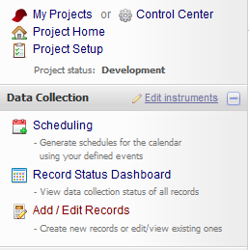
Appendix 1 lists options for scheduling subject data entry for events used by REDCap.

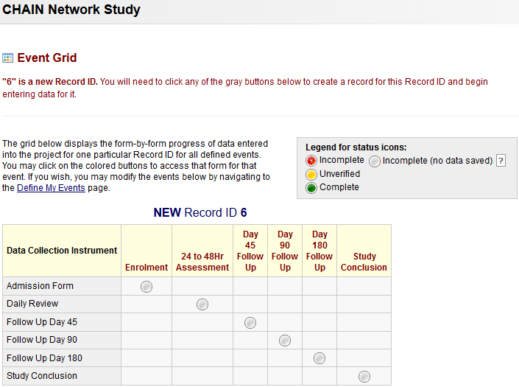

  - Entering data on eCRFs
    - All data entry must be done using the REDCap database. To do this:
- Login to REDCap using your username and password credentials.
- Select CHAIN Network Study from the list of projects under “My Projects”
- Select “Add/Edit Records” from the menu under the header “Data Collection”.
- If editing an existing record, select the record ID from the existing list.
- Select and event for which you’d like to capture the data.
- Enter data as per original source document using the stylus or keyboard.
- Upon completing the data entry, select the Form Status from the question labelled “Complete?”.
- Save the form.

  - Checking data entry
There are two familiar methods of preventing and identifying data entry errors:
Single data entry: the data entry person enters the data once. Afterwards the same person visually compares the entries with the original source document. The data entry person will then correct the errors. Single data entry should be considered when there is extensive range checking built into the database and further checks are run after data entry.
- Double data entry: data is entered twice and the computer compares entries to identify mismatches along with values outside of the allowable range. The data entry person will then correct the errors. This is the most common method used in data management.

    - Procedure for single data entry
    - Enter the CRF onto the CHAIN Network Study project selected from the list of my projects in REDCap.
    - Visually audit the on-screen data, referring to the original source document.
    - If data are inaccurate, amend the data.
    - Save the eCRF(s).
    - Verification of data should be done on each incoming case or sample by sample cases

    - Raising manual data queries
- Next to the field data, click on the bubble icon as highlighted in the Figure below.
- From the pop-up window, select Open Query options. You can optionally select a user to assign this query.
- Add some useful comments to the query that will be helpful in its resolution.
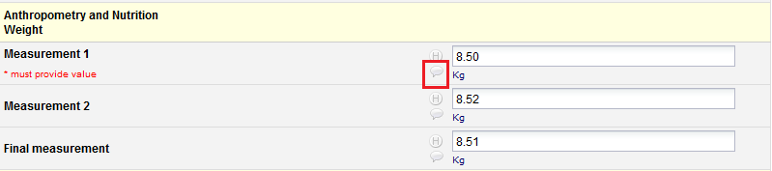
Figure 1. Identifying records for data review

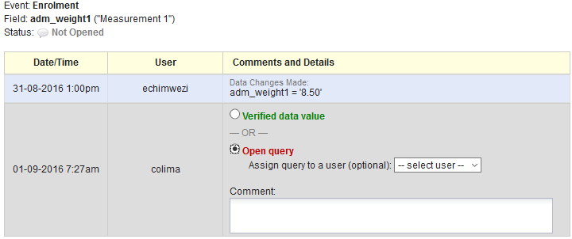
Figure 2. Open query and add comments detailing why the query has been opened.

    - Procedure for double data entry
REDCap supports a strict implementation of the DDE process, a formal procedure that requires inputting each and every field twice. In order to successfully perform DDE, you must have three different individuals on your team to handle each of the different roles.
Two different individuals on the project must perform the roles of Double Data Entry 1 (DDE1) and Data Entry 2 (DDE2), and a third person performs the role of Reviewer. The Reviewer is not allowed to perform one of the Data Entry roles and vice versa. The Reviewer must resolve any conflicts that may arise between DDE1 and DDE2.
The DDE process requires reconciling any and all differences before saving a value to the database. DDE does not ignore any divergence between DDE1 and DDE2 whether it is insignificant or not. The Reviewer must resolve any discrepancy between two fields such as extra spaces, variations in capitalization, missing punctuation, etc. As a result, every and all differences will be identified and adjudicated by the Reviewer.
- Data Entry validation and range checks are set and required fields indicated, etc, where appropriate.
- Data is entered by two data entry clerks, each working independently of the other, compared by a third person, who identifies and reconciles discrepancies.

    - Resolving data entry discrepancies

Insert bullet pointed steps and screenshot

Insert screenshot
Figure 1. Identifying data entry discrepancies

Figure 2. Resolving data entry discrepancies

Insert screenshot

  - Timely Data Entry
    - Timely data entry of data is required to ensure:
- Site data are always backed up.
- New study definitions, new reports, updated users/passwords/roles, new discrepancies and any new system updates are available to users.
- New or modified patient data and new or modified discrepancies are available to online users so that central monitoring activities can be completed.

  - Data Entry Rules and Instructions
The following rules must be adhered to when entering data:
    - Abbreviated text or summaries
No abbreviations or summaries of text data will be permitted, and any ambiguous abbreviations/wording provided by site will be queried.

    - Entering ‘Other doses’ including unplanned
Dosage field
The dosage field should report the actual dose administered and not the intended dose. To enter dosages other than 0.3 mg/tablets etc:
- Select ‘Other dosage’.
- Calculate and enter the actual dose that was given onto the REDCap database.
- Specify the reason – ‘Doctors request’ or ‘Other’.
- If ‘Other’ specify reason in free text box.

    - Entering lab values
Laboratory values given as < on laboratory results printout forms will be entered as insert number e.g. 0 on the database.

    - If a patient has mistakenly been entered twice
It is not possible to delete a patient from REDCap database, the best option if the patient has been entered twice is to "re-use" the duplicate patient record by overwriting the fields with new data (recording ‘Data entry error’ as the reason for change).
When this is not possible the CHAIN study’s Central Data Manager and/or programmer should be informed. The Central and Site Data Managers will then discuss and document the procedures to be followed to allow for these changes.

    - Unlocking patient records
If all fields are disabled, it's possible there may be a "database lock" on the data.
The user should select "Database lock administration" from the Task List and see if a lock is listed for that patient (this can happen if a patient record is left open and the laptop is switched off, for example). If so, the lock can be removed by the user who originally opened the patient (as listed in the Database Lock Administration window). Beware that database locks should only be removed if the subject is definitely not still open, otherwise data corruption could occur.

    - Entering partial dates
This functionality is currently not supported. Most questions that deal with dates e.g. data of birth of a participant will ask whether the data captured is the “True date” or “Estimated”.

    - De-selecting radio buttons
- Click on the reset link next to the options for question.

    - Populating new eCRFs
All eCRFs for each Study Day must be completed, or confirmed as not done/unobtainable before the eCRFs for the next Study Day will appear (Figure 2).
Figure 2. The CHAIN study event grid showing Daily Review Form has been completed. By looking at the Legend for status icons, one can quickly identify which forms have data entry started and not completed and ones with incomplete (or have no data saved) .

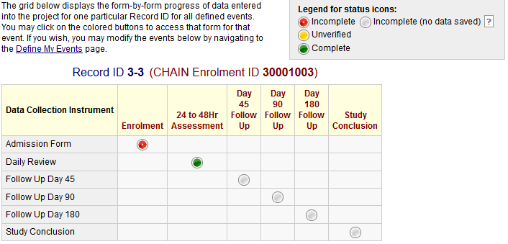

    - Mistakenly opening eCRFs which do not require data entry
It is not possible to delete erroneous eCRFs from the CHAIN study database. If you open an eCRF which does not require data entry, do not save the form select the cancel button labelled “- - cancel - -” can icon instead.
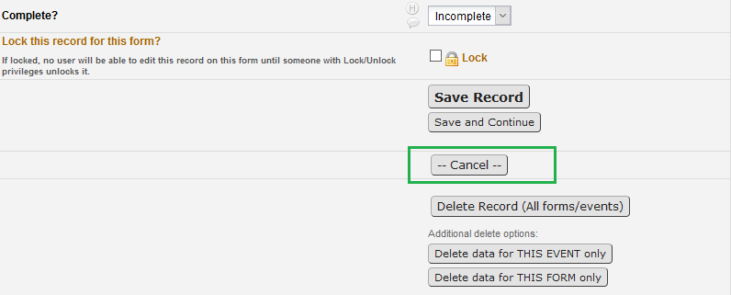

If you mistakenly select the save icon the eCRF will now appear incomplete of complete depending of the previously set/edited form status. The form can then later be reused to capture data for another study participant. Alternatively, the data previously captured for the event on the form can be reset – deleted and entered again by selecting the options, as highlighted in the Figure x below
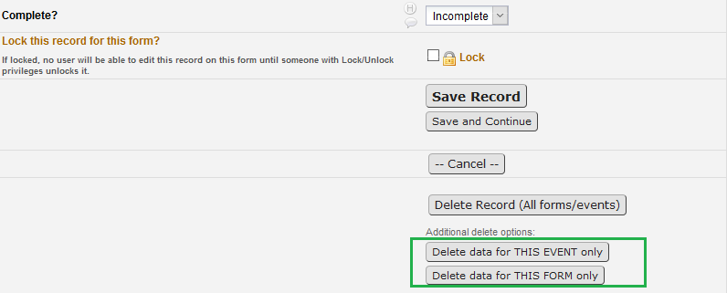
    - Incomplete eCRFs and data fields
Incomplete eCRFs are flagged with . If a CRF item is deemed incomplete (e.g. unable to obtain the information, the visit/test was not done or if a patient has not attended their visit) the associated eCRF and/or fields should be changed to ‘incomplete.
- From the Data Collection menu, select “Add/Edit Records”
- Select the record you would like to edit from the dropdown list.
- Select the event and form to edit.
- Move to the bottom of the page (eCRF)
- Select – “Incomplete” on “Completion?” under Form status heading (see Figure 3)

Unobtainable data can be re-amended to incomplete data at any time by following the same steps and selecting ‘Incomplete’ from the Form status at the bottom of the eCRF.
Figure 3. Setting form data to incomplete on REDCap.

    - Entering eCRFs for ineligible patients
Information for ineligible, including non-consenting, patients WILL NOT be entered in the database, as stated in the protocol.
    - Overruling database warnings
REDCap does not prevent acquisition of data that is out of range. It provides warning messages regarding out-of-range values but these can be overridden.

All database warnings may be over ruled if deemed necessary. To overrule any database warning click on ‘Close’ (Figure 4).

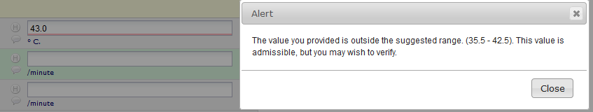
Figure 4. Overruling a warning on REDCap database

Click in the bubble icon (Figure 5) next the field you have just overruled. Complete the reason for the overruling the warning (Figure 6) and click on close.
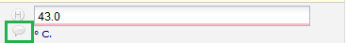
Figure 5. Click on highlighted icon to view the data resolution workflow, add comments for overruling the warning.

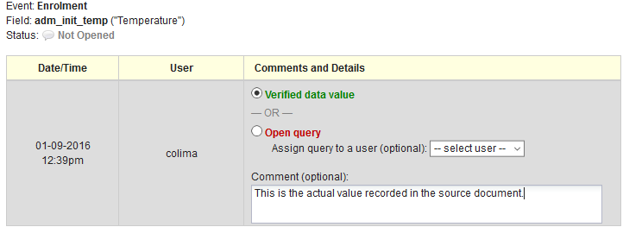
Figure 6. Enter the reason for overruling a warning on REDCap database.

    - Protocol Deviations
It is important to remember that overruling database warnings or setting data to unobtainable may result in a protocol deviation.
If warnings are overruled or data are unobtainable, please be sure to check the relevant SOPs, protocol and if necessary complete the Protocol Deviation and Violation log and report findings to the clinical study co-ordinator. This is required in addition to recording the reason for overruling the warning on REDCap database.

  - Online access to REDCap database
The online version of the database can be accessed using the following link http://redcap.kemri-wellcome.org

  - Suggestions for database modifications
Should you note that an additional database modification is required. For example, a daily medication is not listed on the drop down menu and you would like it to be added. Please notify the CHAIN Study Central Data Manager and, if appropriate, a request will be launched with the database administrator to complete the modification.

- References
- Rouse, M (2008) EU Data Protection Directive (Directive 95/46/EC) [Online] Available from: http://techtarget.com/definition/EU-Data-Protection-Directive [Accessed: 31st August 2016].
- CHAIN Data Query SOP V1.0
- CHAIN Data and Safety Monitoring Plan SOP V1.0
- CHAIN Database Delegation Log V1.0

