Document no: Reviewed and Approved by:

Replaces document: Date of original: 15/1/13

Applies to: Microbiology laboratory Date of revision:

Created by: Date for review: January 2015 Page 1/13

---------------------------------------------------------------------------------------------------------------------------------------------------------------------------------

**1 Aim**

To isolate, quantify and permit presumptive identification and differentiation of the major microorganisms causing urinary tract infections (UTIs). For further information please consult the HPA and NICE guidelines (Investigation of Urine, HPA and Urinary tract infection in children, NICE)

**2 Principle**

All urines undergo a dipstick test and/or microscopy depending on the method used locally to look for the presence of white blood cells, red blood cells, nitrites and bacteria. All children under 3 years of age should have a microscopy performed.

A known volume of urine is cultured in order to allow quantification of the number of organisms in the original urine, although because of imprecisions in the method this is usually referred to as ‘semi-quantitative’ culture.

The UTI chromogenic medium (Oxoid *Brilliance*™ UTI Clarity™ agar) contains two specific chromogenic substrates. The different dyes produced by the organisms leads to different urinary isolates appearing as different coloured colonies after overnight incubation at 37ºC in air.

**3 Method**

**3.1 Dipstick**

Perform a urine dipstick or microscopy (depending on your laboratory) on all urine samples arriving in the microbiology laboratory.

**If the urine dipstick/microscopy is positive or one of the following points are true, culture the urine:**

a. Sample screened by counting chamber has over 10 WBC/mL (for children), 100

WBC/mL for adults

b. Follow up of patients on treatment. c. Urinary tract obstruction

d. Follow up after removal of indwelling catheter.

e. Child of less than 3 years who has suspected urinary tract infection f. Pregnant woman

g. Suspected melioidosis patient – culture on Ashdown’s medium

Document no.: Page 2/13

-----------------------------------------------------------------------------------------------------------------------------------------------------------------------------------

3.2 **Kova glasstic slide counting chamber – a Neubauer chamber can also be used**

**(follow local guidelines)** (with 10 grids, Cat. No. 87144, below as per kit instructions): Tip the closed urine pot over to mix carefully then use a capillary tube to place unspun urine into one chamber, leave the chamber on the bench for one minute for the cells to settle

Using a low power microscope objective (x10) decide whether the cell numbers are low

or high

If the cell numbers are low, count 36 small grids in the chamber

If the cell numbers are high, count 10 small grids in the chamber

**3.2.1 Figue 1 - Kova Glasstic slide**

**3.2.2 Figure 2 - Counting chamber on the Kova slide**

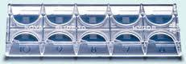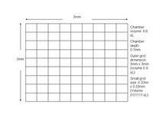

**3.2.3 Table 1 – Calculating the number of cells/****l using Kova glasstic slide**

Multiply the average cells per grid by x90

Follow table for the cell numbers to report:

**Low cell count samples (total number of cells in 36 small squares or 4 complete quadrants)**

**High cell count samples (total number of cells in 10 squares)**

|  |  |  |  |  |  |
| --- | --- | --- | --- | --- | --- |
| Number  of cells in 36 small squares | cells/l | Cells/mL | Number  of cells in 10 small squares | cells/l | Cells/mL |
| 1 | 1/36*90 = 3 | 2,500 | 1 | 1/10*90 = 9 | 9,000 |
| 2 | 5 | 5,000 | 2 | 18 | 18,000 |
| 3 | 8 | 7,500 | 3 | 27 | 27,000 |
| 4 | 10 | 10,000 | 4 | 36 | 36,000 |
| 5 | 13 | 12,500 | 5 | 45 | 45,000 |

Document no: Page 3/13

---------------------------------------------------------------------------------------------------------------------------------------------------------------------------------

|  |  |  |  |  |  |
| --- | --- | --- | --- | --- | --- |
| 6 | 15 | 15,000 | 6 | 54 | 54,000 |
| 7 | 18 | 17,500 | 7 | 63 | 63,000 |
| 8 | 20 | 20,000 | 8 | 72 | 72,000 |
| 9 | 23 | 22,500 | 9 | 81 | 81,000 |
| 10 | 25 | 25,000 | 10 | 90 | 90,000 |
| 11 | 28 | 27,500 | 20 | 180 | 180,000 |
| 12 | 30 | 30,000 | 25 | 225 | 225,000 |
| 13 | 33 | 32,500 | 30 | 270 | 270,000 |
| 14 | 35 | 35,000 | 35 | 315 | 315,000 |
| 15 | 38 | 37,500 | 40 | 360 | 360,000 |
| 16 | 40 | 40,000 | 50 | 450 | 450,000 |
| 17 | 43 | 42,500 | 60 | 540 | 540,000 |
| 18 | 45 | 45,000 | 70 | 630 | 630,000 |
| 19 | 48 | 47,500 | 80 | 720 | 720,000 |
| 20 | 50 | 50,000 | 90 | 810 | 810,000 |
| 25 | 63 | 62,500 | 100 | 900 | 900,000 |
| 30 | 75 | 75,000 | >100 | >900 |  |
| 40 | 100 | 100,000 |  |  |  |
| 50 | 126 | 125,500 |  |  |  |
| >50 | >100 |  |  |  |  |

**3.2.4 Figure 3 - Cells in urine**

White blood cells bacteria

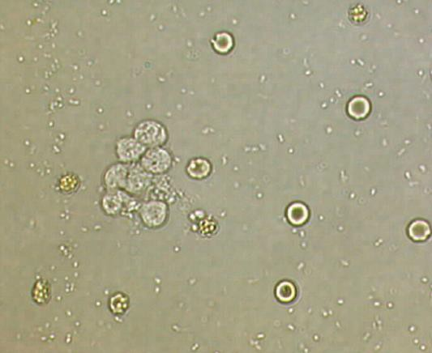

red blood cell

Document no: Page 4/13

---------------------------------------------------------------------------------------------------------------------------------------------------------------------------------

Epithelial cells/squames

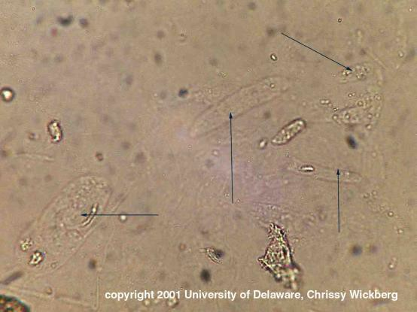

Hyaline casts

**3.3 Urine culture**

1. Describe the appearance of the urine (clear or cloudy) and colour and note this in the laboratory book and on the computer

2. Turn the urine pot over to mix it carefully and remove the top of the container.

3. Dip the end of a sterile 1l loop into the urine and remove it vertically making sure that there is no urine up the loop as this would mean that a greater volume was cultured

4. Spread the entire volume over the surface of a *Brilliance* UTI Clarity agar plate by making a single streak across the centre, if many samples are being processed use half a plate per sample. Spread the inoculum evenly at right angles to the primary streak as shown

**3.3.1 Figure 4 – spreading urine on plate**



5. Incubate the plate aerobically at 35-37°C for at 18-24 hours.

Document no: Page 5/13

---------------------------------------------------------------------------------------------------------------------------------------------------------------------------------

6. After inoculation, estimate the number of bacteria by counting the number of colonies on the surface of the media. One colony = 1000 cfu/ml (1x106 cfu/L)

**4 Interpretation**

**4.1 Interpretation**

Culture results are categorised on the basis of quantity and purity of growth. Below a recognised threshold (105cfu/mL) the likelihood is that the organisms grown are contaminants, particularly if more than one type of organism is present. Above the threshold it is more probable that a true bladder infection is occurring.

**4.1.1 Table 2 – Number of colonies on plates**

|  |  |  |
| --- | --- | --- |
| **Number of colonies in 1****L (on plate)** | **Interpretation** | **Report** |
| 1-9 | <10 4 CFU/ml | No significant growth |
| 10-99 | 10 4 -105 CFU/ml | 10 4 -105 CFU/ml |
| ≥100 | ≥10 5 CFU/ml | ≥10 5 CFU/ml |

On day one, if there is a pure growth of 10-100 or over 100 colonies, sub culture the isolate. For cultures that contain 2 organisms, one in low numbers (<100 colonies) and the other over

100 colonies, then only the predominant organism is sub cultured because the organism of lower numbers is unlikely to be causing disease.

Document no: Page 6/13

--------------------------------------------------------------------------------------------------------------------------------------------------------------------------

4.1.2 Growth on UTI clarity media



Document no: Page 7/13

---------------------------------------------------------------------------------------------------------------------------------------------------------------------------------

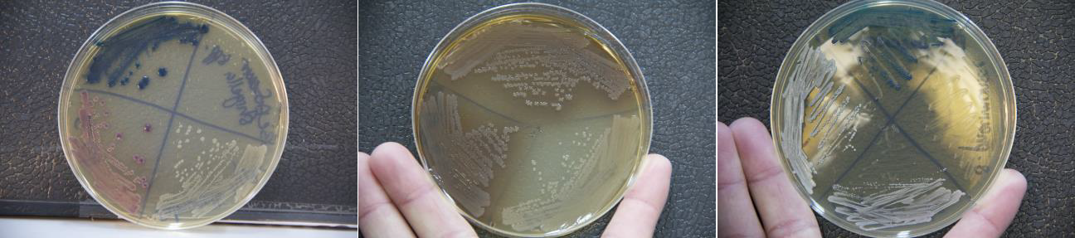

|  |  |  |
| --- | --- | --- |
| *E. coli* (pink) | *Proteus* species (brownx2) | *Enterococcus* (small dark blue) |
| *K. pneumoniae* (large dark blue) | *Shigella* species (white) | *Staphylococcus* species (white) |
| *S.* Typhi (white) |  |  |

**4.1.3 Table 3 Interpretation of growth**

|  |  |  |  |  |
| --- | --- | --- | --- | --- |
| **Organism** | **β-galactosidase** | **β-glucosidase** | **TDA** | **Colony colour** |
| *E. coli* | + |  |  | pink |
| Enterococci |  | + |  | blue/turquoise |
| Klebsiella and other Coliforms | + | + |  | dark blue/purple |
| *Proteus/Morganella/Providentia* spp |  |  | + | brown halo |
| Pseudomonads |  |  |  | green/blue translucent |
| Staphylococci |  |  |  | white/cream |
| *S. saprophyticus* |  |  |  | pale pink/white |
| Streptococci |  |  |  | white |

**5 Confirmatory testing**

For the significant organisms consult the MOPSOP_004_Sensitivity testing document for the organism specific sensitivities.

**5.1.1 Table 4 – Confirmatory testing**

|  |  |
| --- | --- |
| **Organism** | **Identification method** |
| GNB | *E. coli*, pink colonies: no further testing  *K. pneumoniae* and other coliforms confirm using your laboratory methods such as short biochemical set or alternative (e.g. API  20E)  *Pseudomonas* species confirm as *P. aeruginosa* using Columbia agar (green colonies) and growth at 42°C  *Proteus* species confirm with swarming and your laboratory |

Document no: Page 8/13

---------------------------------------------------------------------------------------------------------------------------------------------------------------------------------

|  |  |
| --- | --- |
| specific tests such as LDC | |
| Staphylococci | Catalase  Coagulase/Staphaurex test  DNAse agar depending on your laboratory method  Novobiocin disc if CoNS (*S. saphrophyticus* is resistant) |
| Streptococci | Catalase  *Enterococcus* species: growth on MacConkey, bile esculin agar and 6.5% NaCl/TSB or/and grouping test depending on your laboratory  Other streptococcus: sub onto blood agar for haemolysis and follow as per haemolytic reaction |
| Other organisms (eg yeasts) | Only if they are thought to be clinically relevant, please consult  the microbiology doctor |

**6 Reporting**

**6.1 Reporting of results from microscopy (see figures 2 and 3 and table 2 below)**

1. Report the **number** of WBC, RBC/ml in urine using the counting chamber.

2. Comment on the presence of epithelial cells, bacteria, casts or yeasts following the following counts:

a. No epithelial cells = none seen

b. 1-3 in 10 or 36 small grids = occasional c. 3-15 10 or 36 small grids = +

d. 15-30 10 or 36 small grids = ++

e. >30 10 or 36 small grids = +++

f. seen under other cells (cannot count) = present (modified from the Urines

Microscopy (M-SOP-85) from Oxford University Hospitals)

3. Report the presence of *Trichomonas vaginalis.*

4. Casts are solidified protein which are cylindrical in shape as they are formed by the kidney tubules

5. If culture not indicated report "Culture not done because cell counts are below significant levels".

Document no: Page 9/13

---------------------------------------------------------------------------------------------------------------------------------------------------------------------------------

Reporting results from culture

**6.1.1 Table 5 - Interpretation of growth**

|  |  |
| --- | --- |
| **No bacterial growth** | No growth |
| **Single organism** | |
| <10 4 CFU/ml | No significant growth |
| 10 4 -105 CFU/ml | Identify and report sensitivity (but write **“?significance**”) |
| >105 CFU/ml | Identify and report sensitivity; Report **Growth of >105 of ……** |
| ***Two organisms*** | |
| Both <10 5 CFU/ml | No significant growth, please repeat if appropriate |
| One >10 5 CFU/ml | Identify and do sensitivities on the predominant organism; **Mixed growth including >105cfu/ml xx (organism) identified ?significance**, report sensitivity of the one >10 5 cfu/ml |
| Both >10 5 CFU/ml | Identify and do sensitivities on both organisms; **Mixed growth of >105cfu/ml xx (organism) identified ?significance** and report sensitivity for both |
| **More than two organisms** | Mixed growth of more than two organisms  (please repeat if appropriate). |

|  |  |  |
| --- | --- | --- |
| **7** | **Quality assurance**  Performed weekly: |  |
|  | **Positive control:**  *E. coli* ATCC 25922 | **Expected Results (48 hrs)**  Good growth; pink colonies |
|  | *Pseudomonas aeruginosa* ATCC 27853 | green/blue translucent |
|  | **Negative control:**  Uninoculated medium | No change |

**8 Limitations**

Store the dehydrated medium at 10-30°C and use before the expiry date on the label.

Label plates with the date of preparation and store the prepared medium at 2-8°C. The shelf life after preparation is **two weeks after which plates should be discarded.**

Only use the media if it has passed QC

Organisms with atypical enzyme patterns may give anomalous results; e.g. white colonies may occasionally prove to be *E. coli* on further examination.

**9 References**

NICE Guidelines. Urinary tract infection in children, diagnosis, treatment and long -term management. Clinical Guideline, August 2007.

Document no: Page 10/13

------------------------------------------------------------------------------------------------------------------------------------------------------------------------------- Health Protection Agency. UK Standards for Microbiology Investigations: Investigation of Urine. Issued by the Standards Unit, Microbiology Services Division, HPA. Bacteriology, B41, issue no. 7.1. Issue date 13.08.12.

Oxoid information page for *Brilliance™* UTI Clarity™ agar Code: CM1106

Cheesbrough M. District Laboratory Practice in Tropical Countries, Part one. Second edition update. 2010. Published by Cambridge University Press.

Kova slide manufacturer’s protocol.

Standard Operating Procedures from LOMWRU, SMRU and AHC.

Document no: Page 11/13

---------------------------------------------------------------------------------------------------------------------------------------------------------------------------------

**10 Synopsis/Bench aid**

Urine in sterile



container



Invert to mix

Kova slide microscopy



Count **number** of WBC and RBC

Note the presence of epithelial cells, bacteria, Casts, yeasts and *Trichomonas*

*vaginalis* (+ to +++)



1l of urine cultured onto UTI clarity agar

O/N incubation air 35-37°C



Follow up as per colour of colonies

Document no: Page 12/13

---------------------------------------------------------------------------------------------------------------------------------------------------------------------------------

**11 Table 6 – Risk assessment**

|  |  |
| --- | --- |
| COSHH risk assessment - University of Oxford COSHH Assessment Form | |
| **Description of procedure**  See Urine culture and microscopy | **Substances used**  No chemical substance |
| **Quantities used** | **Frequency of use**  Daily |
| **Hazards identified**  Autoclaved liquid  Potentially infectious material in  sample  Potentially pathogenic bacteria | **Could a less hazardous substance be used**  **instead?**  No |
| **What measures have you taken to control risk?**  Good laboratory practice, including use of gloves, protective glasses and PPE  Working within class II BSC depending on availability at local laboratory, avoid  creating aerosols, transfer all category 3 organisms (such as *Salmonella Typhi* and  *Burkholderia pseudomallei*) to BSC | |
| **Checks on control measures**  Observation and supervision by senior staff | |
| **Is health surveillance required?**  No | **Training requirements:**  GLP |
| **Emergency procedures**:  Report all incidents to Safety Adviser  Eye wash for splashes | **Waste disposal procedures**:  All inoculated plates are autoclaved prior to  disposal |

Document no: Page 13/13

---------------------------------------------------------------------------------------------------------------------------------------------------------------------------------------------------------------------------------------------------

**12 Competency Assessment**

|  |  |  |  |  |  |  |  |  |
| --- | --- | --- | --- | --- | --- | --- | --- | --- |
| Competency Assessment Form: | Employee/Position: | | | | | | | |
| Supervisor/Position: | | | | | | | |
| **Assessment methods:**  O = Observation  V = Verbal  W = Written | **Level of competency:**  1 = Not competent  2 = Competent if supervised  3 = Competent and can perform independently  4 = Competent and can perform independently and is able to assess the competency of others | | | | | | | |
| **Activity** | | **Date** | **Method** | | | **Level** | **Employee**  **signature** | **Employer**  **signature** |
| **O** | **V** | **W** |
| 1. Has read and understood the SOP | |  |  |  |  |  |  |  |
| 2. Has read and understood the risk assessment and all  aspects of health and safety related to this SOP | |  |  |  |  |  |  |  |
| 3. Is competent in describing and recording CSF  macroscopic appearance. | |  |  |  |  |  |  |  |
| 4. Is competent in carrying out CSF cell counts using a  chamber, including differentiating between WBC and  RBC. | |  |  |  |  |  |  |  |
| 5. Is competent in performing Gram stain on CSF samples  and interpreting the results. | |  |  |  |  |  |  |  |
| 6. Knows when and how to concentrate a CSF sample. | |  |  |  |  |  |  |  |
| 7. Is competent in setting up culture for CSF samples. | |  |  |  |  |  |  |  |
| 8. Is competent in interpreting and knowing how to follow-  up CSF cultures. | |  |  |  |  |  |  |  |
| 9. Is competent in reporting CSF results on the laboratory  system. | |  |  |  |  |  |  |  |
| **CAF Comments:** | | | | | | | | |