# Aim

To describe the processing of clinical specimens for identification of *Burkholderia pseudomallei* infection.

# Principle

*Burkholderia pseudomallei* is an important environmental pathogen in SE Asia. The organism is associated with a variety of clinical syndromes including sepsis, pneumonia, abscesses, and suppurative parotitis (especially in children). Untreated, mortality is high.

Samples for *Burkholderia pseudomallei* isolation may come from a number of sources, including blood, throat swabs, sputum, urine, and abscess material. Different isolation approaches are required to achieve optimal opportunities to isolate the agent.

A latex agglutination reagent is produced in-house by MORU, and has a very high sensitivity and specificity (99%), enabling rapid presumptive identification of *B. pseudomallei.*

# Method

## Pus, sputum, sterile fluids, swabs

Inoculate and streak the following media for isolation of *B. pseudomallei* when the clinical team has melioid culture:

* Ashdown agar (ASH)
* Selective Broth for *B. pseudomallei* (SB)

Incubate all plates and broth for 4 days at 35 - 37°C inspecting for growth daily.

After 48 hours of incubation, subculture selective broth onto Ashdown agar. Incubate this plate for a further 48 hours at 35 - 37°C inspecting for growth daily.

## Urine

Plate unspun (neat) urine directly half of an Ashdown agar plate using a 1μl inoculating loop.

Centrifuge the urine at 3,000 rpm for 5 minutes and plate one drop of deposit onto the other half of the plate using a 1μl inoculating loop.

Streak the plates in three directions (see Urine culture SOP, MIC-006).

Incubate the plate for 4 days at 35 - 37°C inspecting for growth daily. Follow table 1 for culture result reporting.

**Table 1.** Interpretation of quantitative urine culture

|  |  |
| --- | --- |
| **Number of colonies in 1μL** | **Interpretation / Report** |
| 1-9 | 103 CFU/ml |
| 10-99 | 10 4 - 105 CFU/ml |
| ≥100 | ≥10 5 CFU/ml |

If colonies are only seen on the side of the spun deposit, report as only seen from the deposit.

## Blood cultures

Process blood cultures as described in SOP MIC-003. Identify suspected *B. pseudomallei* as outlined below.

# Interpretation

## Identification of Burkholderia pseudomallei

### Colony morphology

*B. pseudomallei* colonies on blood agar are typically small, smooth and creamy in the first 48 hours. On further incubation, this appearance changes to give dry, wrinkled colonies. *B. pseudomallei* is described as producing a distinctive musty or earthy odour, although sniffing of open plates should never be undertaken. The organism is motile, indole negative, oxidase positive, and resistant to colistin and gentamicin, features that aid identification. *B. pseudomallei* on Ashdown agar appears as very small (pin point) colonies by 18 h, and is usually purple, flat, dry and wrinkled (‘cornflower head’) after 48 hours of incubation.

Table 2 describes colony morphology on a variety of media.

**Table 2.** *B. pseudomallei* colony morphology

|  |  |  |  |  |
| --- | --- | --- | --- | --- |
| **Time** | **Sheep BA** | **MAC** | **ASH** | **SB** |
| **Note** | Incubate at 37°C aerobic  Incubate for at least 2 days, read daily | Incubate at 37°C aerobic  Incubate for at least 2 days, read daily | Incubate at 37oC aerobic  Incubate for 4 days, read daily | Incubate for 48 hours, then S/C to ASH  Note: Not necessary if direct plate culture is positive |
| **18-24 h** | ≤ 1mm creamy, coliform-like colonies, ± slight metallic sheen | Weak lactose fermenter, usually flat. May develop sheen | Pin point, clear, pale pink with visible sheen |  |
| **48 h** | 1-2 mm, definite metallic sheen, may begin to wrinkle, alpha haemolytic | May be quite red, flat colonies | 1-2 mm, pinkish-purple, flat, slightly dry with metallic sheen | A small, whitish pellicle will develop slowly  If seen, perform latex if direct culture was negative |
| **3-4 d** | Dry and wrinkled |  | Larger, usually dry, deeper purple, more wrinkled. Colonial variants are common, such as mucoid and dry, or different shades of purple |  |

Note: Growth is slower if other organisms are present. Growth of a single colony, or colonial variation is common.

### Follow-up of suspected B. pseudomallei isolates

#### Latex agglutination test

Pipette 2 x 10μl aliquots of latex reagent onto a clean glass slide.

Using a toothpick, touch the suspected colony and emulsify in the first latex solution aliquot.

Rock the microscope slide to mix and allow the reaction to occur.

Observe for agglutination (clumping with clearing of the background):

* Agglutination may be rapid or may take up to 20 seconds. Observe for at least 2 minutes before reporting the sample as negative.
* The negative control latex aliquot should remain milky with no clumping: agglutination in this aliquot invalidates the test.

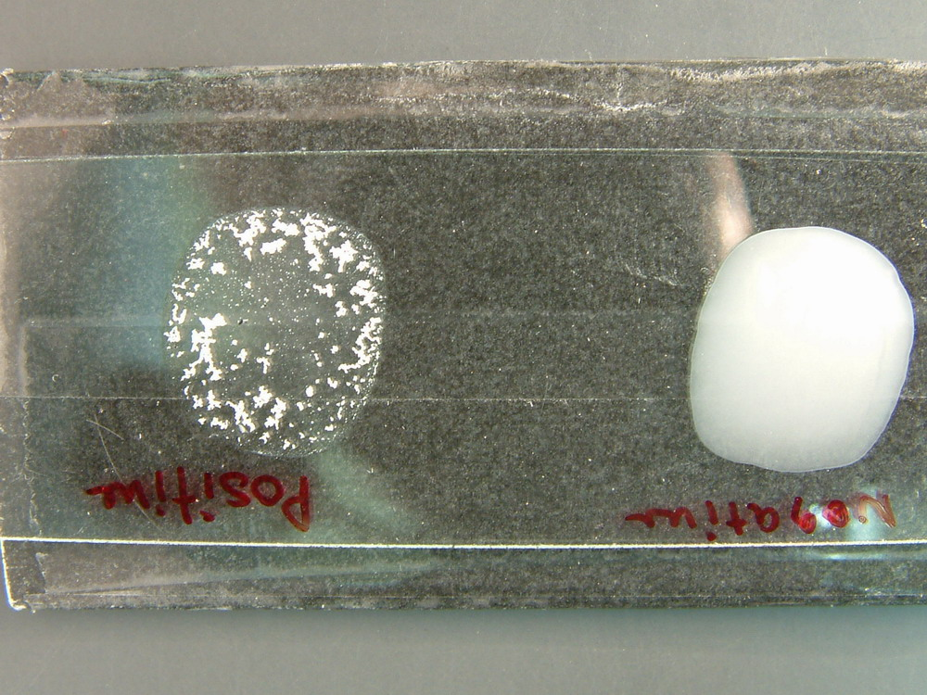

**Negative**

**Positive**

**Precautions:** *Burkholderia cepacia* might give a false positive latex result. *B. cepacia* is resistant to amoxicillin/clavulanic acid (AMC) and may be yellow in colour. If in doubt, use API 20NE for confirmation.

#### Further confirmation

Set up a TSI slope:

* *B. pseudomallei* should be K/NC; no gas; H2S negative.

Set up antimicrobial susceptibilities to aid identification (MH agar; 1.0 McFarland inoculum; incubate for 16 – 20h at 35 - 35°C in air): AMC, CN, and CT discs:

* *B. pseudomallei* should be resistant to CN and CT but susceptible to AMC.

If any results are discordant, set up an API 20NE (see SOP MID-002).

## Antimicrobial susceptibility testing

All *B. pseudomallei* isolates should have antimicrobial susceptibilities determined according to SOP MIC-001.

## Reporting

At the time of routine culture result reporting, report “*B. pseudomallei* culture pending”.

When all *B. pseudomallei* culture work is complete, make an additional report stating ether “*B. pseudomallei* isolated” or “*B. pseudomallei* NOT isolated”*.*

# Quality assurance

Media and identification tests should be quality controlled according to the relevant SOP.

# Limitations

Prior antimicrobial use may result in negative cultures.

# References

1. MORU SOP MBL3.8M. Isolation of *Burkholderia pseudomallei* from clinical samples (Version 1.3; August 2012).

# Synopsis / Bench aid



# Risk assessment

|  |  |
| --- | --- |
| **COSHH risk assessment - University of Oxford COSHH Assessment Form** | |
| **Description of procedure**  Culture of *Burkholderia pseudomallei* from clinical specimens | **Substances used**  Variable (may include Gram stain reagents; 3% hydrogen peroxide (catalase test); N,N,N',N'-tetramethyl-1,4-phenylenediamine (oxidase test); *B. ps* latex reagent (MORU); bioMerieux API reagents) |
| **Quantities of chemicals used**  Small | **Frequency of SOP use**  Daily |
| **Hazards identified**  1. Autoclaved liquid  2. Potentially infectious material in sample  3. Potentially pathogenic bacteria  4. Chemical exposure form bacterial identification tests | **Could a less hazardous substance be used instead?**  No |
| **What measures have you taken to control risk?**  1. Training in good laboratory practices (GLP)  2. Appropriate PPE (lab coat, gloves, eye protection)  3. Use of biosafety cabinet for reading of plates / follow-up of *B. pseudomallei* | |
| **Checks on control measures**  Observation and supervision by senior staff  Annual certification of biosafety cabinets and annual biosafety audit by MORU staff | |
| **Is health surveillance required?**  No | **Training requirements:**  GLP |
| **Emergency procedures**:  1. Report all incidents to Safety Adviser  2. Use eyewash for splashes  3. Clean up spills using 1% Virkon or chemical spill kit | **Waste disposal procedures**:  1. Sharps discarded into appropriate rigid containers for incineration  2. Infectious waste discarded into autoclave bags or 1% Virkon solution prior to autoclaving and subsequent incineration  3. Chemical waste disposed of according to manufacturer’s instructions |